Moorhead Police Department
FACT SHEET
NOTIFICATION OF RELEASE IN MINNESOTA

RISK LEVEL THREE In addition to level two notification (schools and daycares as well as establishments and Organizations that primarily serve individuals likely to be victimized by the offender), law enforcement may notify other members of the community whom the offender is likely to encounter.

The Moorhead Police Department is available to provide you with useful information on personal safety. The Moorhead Police Department may be reached at (218) 299-5121. To report criminal activity by this offender or any other ind ividu al, please call 911.

DAVID MARJ( HARMER

OID: 233937

Race: White He ight: 6' 3"
Weight: 225 Complexion: Fair
DOB: 05/31/1962

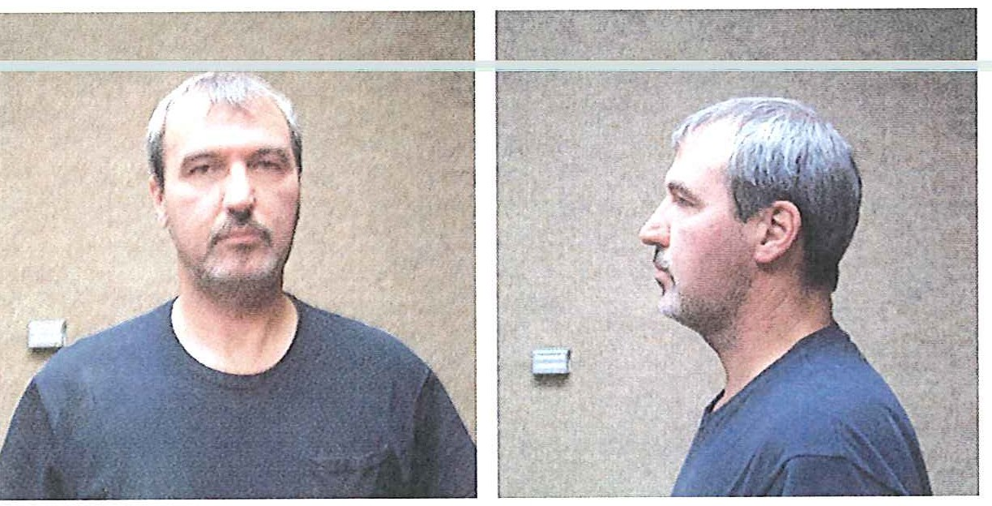
Hispanic: No Eyes: Brown Hair: Brown Build: Medium

Registration statute(s): Sex Offense, Non-MN Statute Investigating agency: Bay City, Ml Police Department
Release date: 01/11/2009
12/01/20IO 12/01/20 I0

Offender engaged in sexua l contact with a 14 year -old female victim. The contact included penetration. Offender gained compliance through physical force and use of a weapon. Offender gained access to victi m by taking advantage of her sleeping state. Offender and victim met for the first time on the same day as offense.

Address: 900 block of 18th Avenue North, Moorhead , MN 56560 Date of addres s change: 1 2/0 I /20 I0

The Moorhead Police Department is releasing this information pursuant to Minnesota Statutes 244.052. This statute authorizes law enforcement agencies to inform the public of a sexua l or pred atory offender ' s release from prison or a sec ure treatment fac ili ty when that Moorhead Police Department believes that the release of information will enhance public safety and protect ion.

The individual who appears on th is notification has been convicted of Criminal Sexual Conduct or another offense that requires registration with law enforcement pursuant to Minnesota Statut es 243.166 or 243.167.

This offender is 1101 wanted by the police at this time and has served the se11te11ce imposed on him / her by the court. This notification is not intended to increase fear in the community. Law enforcement believes that an informed public is a safer public.

The Moorhead Police Department , the sup ervis ing release agent, and the Minnesota Department of Corrections may NOT direct where the offender does or does not reside, nor can these agencies direct where he/she works or goes to school. The risk level of this offender has been determined based largely on his/her potential to re-offend based on his/her previous criminal behavior.

Convicted sexual and predatory offenders have always been released to live in our communiti es. It was not until the passage of the Registration Act that law enforcement had an ability track the movement of these offenders after their initial release. With the passage of the Community Notification Act law enforcement may now share informa tion about many of these offenders with the public. Abuse of this information to threaten, harass or intimidate a registered offender is un acceptab le and such acts could be charged as a crime. Such abuses could potentially end the ability of law enforcement to provide these notifications. If community notification ends the only person who wins is the offender. Many of these offenders derive their power from the opportunity that secrecy provides .

For questions about level three offenders and community notification, go to www.doc.state.mn.us and click on "Minnesota Level 3 Predatory Offender Locator

