PUBLIC WORKS

Request For Quote
For

Village Green Restroom
Near Hole #14

April 23nd, 2019

INTRODUCTION
This Request for Quote is for services to construct a restroom facility at the Village Green Golf Course for the City of Moorhead, MN.

This Request for Quote (“RFQ”) does not commit the City of Moorhead to enter into any agreement, to pay any expenses incurred in preparation of any response to this RFQ, or to procure or contract for any supplies, goods or services. The City of Moorhead reserves the right, without liability to the City of Moorhead, to cancel this RFQ and to reject any proposal that does not comply with this RFQ or applicable administrative rules, and to reject any and all responses received as a result of this RFQ upon a finding that it is in the public interest to do so.

SCOPE OF WORK
The City of Moorhead is requesting quotations for construction services to provide a restroom facility located on the Village Green Golf Course at 3421 30th Ave S, Moorhead, MN. The restroom will be located near Hole #14. The selected proposer will take the project from the provided conceptual plans to final completion. This will include any required plan development, detailing of materials, obtaining proper permits, coordination of construction forces, and delivery of the final product.

The restroom facility will be comprised of two unisex lavatory rooms, one mechanical room, and a covered patio. The facility will be on a concrete foundation with concrete block construction with primary finishes being maintenance free including a metal roof. The restroom will be for seasonal use and winterized during the off season. The water, sewer, and electric utilities will be previously brought into the location. Conceptual Plans and Site Location are shown in Attachment 1 and Attachment 2.

Final site conditions will be equal or better condition prior to construction. This includes proper grading, positive drainage, and acceptable condition of adjacent cart paths. The ground can be finish graded with topsoil and seeding will be completed by golf course personal. The adjacent cart paths and utilities will be protected from damage or included in quotation to repair upon completion of the project.

The restroom is scheduled to be completed in the summer of 2019. Final completion must be completed by 11/1/2019. Construction activities will need to allow continuation of golf activities and be mindful of the proximity with residential housing. This will include maintaining acceptable passing of golfers and securing of the jobsite to prevent injury of public. The area can experience 200-300 golfers per day.

PROJECT SITE MEETING
A project site meeting will be held on April 30th at 11:00 AM CT. The meeting will be held at the project site to review site conditions, discuss scope of work, and answer questions concerning the project. The approximate street address is 2765 Village Green Dr. Moorhead, MN 56560.

ANTICIPATED SCHEDULE
Advertisement of Request for Quote April 23nd, 2019
Project Site Meeting April 30th, 2019
Questions Due May 6th, 2019
Quotations Due May 10th, 2019
Selection of Proposer May 31st, 2019
Notice to Proceed May 31st, 2019
Final Project Acceptance Due November 1st, 2019

INCURRED COSTS
The City of Moorhead is not liable for any costs incurred in the preparation or presentation of their quotation. No billable work can proceed prior to negotiation and execution of Agreement and the receipt of a Notice to Proceed.

NON-RESPONSIVE
Quotations that are incomplete, conditioned or qualified, are not in conformity with the law, contain a statement by the Proposer reserving the right to accept or reject an award, or include any other irregularity shall be rejected as non-responsive if the irregularity is material and may be rejected as non-responsive if the irregularity is not material.

PROPOSAL VALIDITY PERIOD
If an Agreement is to be awarded, it shall be made within 60 calendar days after the submission deadline. Quotations shall be considered valid during this period.

TERMS FOR PROPOSING
By submitting a proposal, the Proposer certifies conformance to the applicable federal, state and local laws, acts, executive orders, statutes, administrative rules, regulations, ordinance and related court rulings concerning Affirmative Action toward Equal Employment Opportunities. All information and reports required by the Federal or Minnesota State or local Governments, having responsibility for the enforcement of the foregoing, shall be supplied to the Owner upon request for purposes of investigation to ascertain compliance with the foregoing.

PROPOSAL EVALUATION
Proposals will be evaluated based on Cost, Experience, and Approach to the project. Please include any other information in the proposal that would make you’re the best selection for this project. The City does not intend to conduct interviews for this project but reserves the right to request interviews of proposers.

QUESTIONS
Proposers must submit questions or requests for clarification via email to the Facilities and Fleet Manager, Paul.Fiechtner@cityofmoorhead.com. All clarifications or requests for information will be responded to all proposers via email. Any changes to the RFQ resulting from such questions will be made only via addenda to the RFQ. Deadline for final questions is May 6th, 2019.

PROPOSAL SUBMISSION
Proposals must include the following information.
- Name, address, email and phone number for the main proposal contact person.
- Experience: Please provide knowledge and experience with similar facilities.
- Approach: Please provide a summary of your approach to complete the project successfully.
- Timeline: Estimated timeline required to complete the project.
- Proposed Fee Structure: Provide Lump Sum cost with detailed breakdown of services. Assumptions or limitations of services in the quotes should be defined.

Proposals may be delivered in writing or via email to the contact info below.

City of Moorhead Public Works
Attn: Paul Fiechtner
Facilities and Fleet Manager
700 15th Ave N
Moorhead, MN 56560
Paul.Fiechtner@cityofmoorhead.com

RFQ
Village Green Restroom

ATTACHMENT 1

CONCEPTUAL PLANS

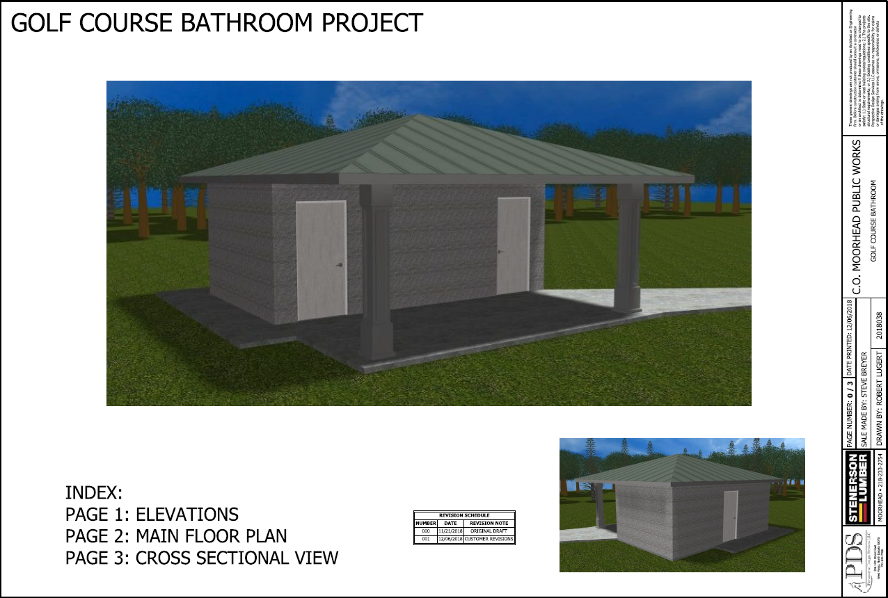
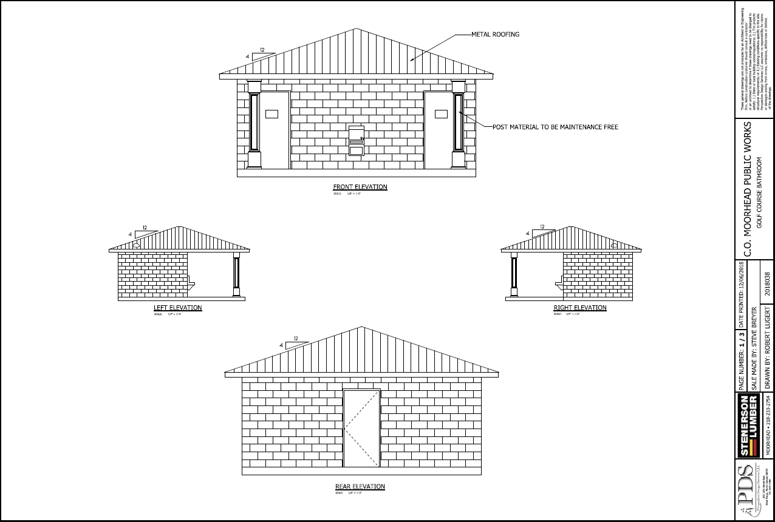
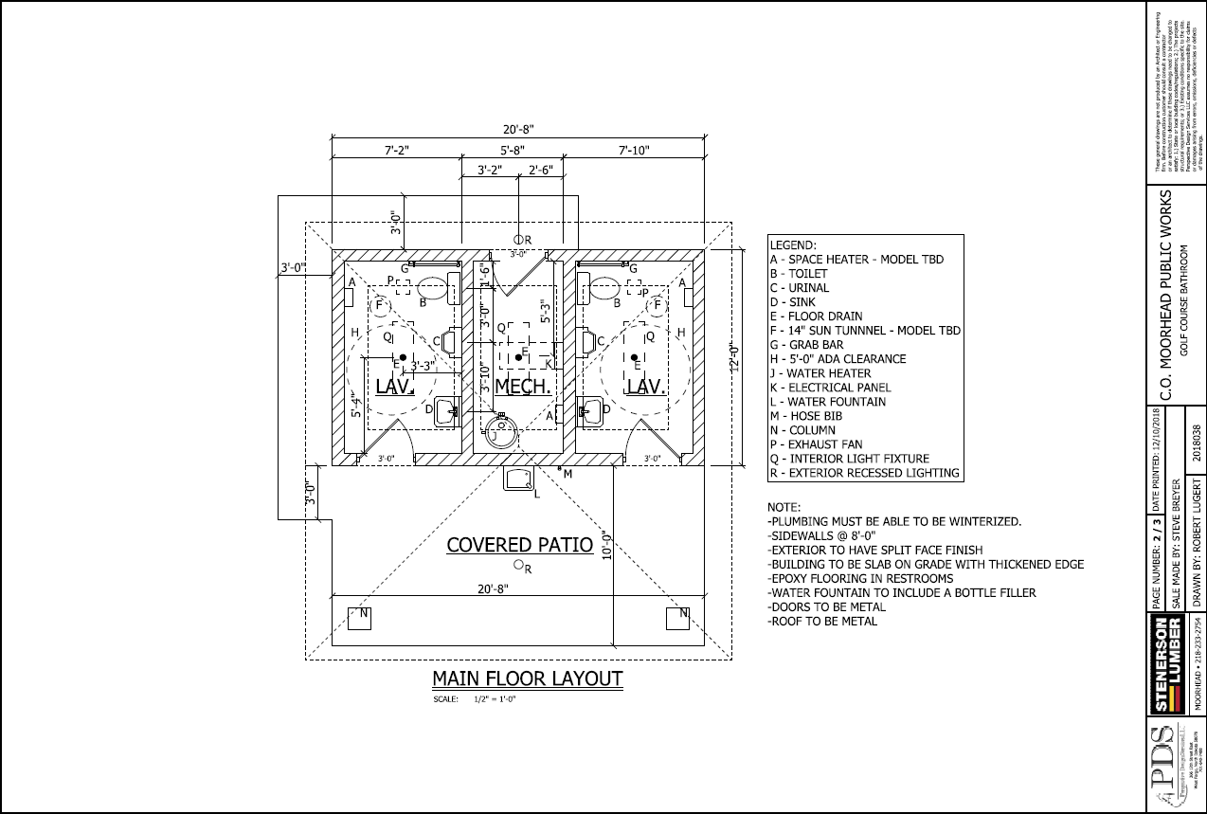

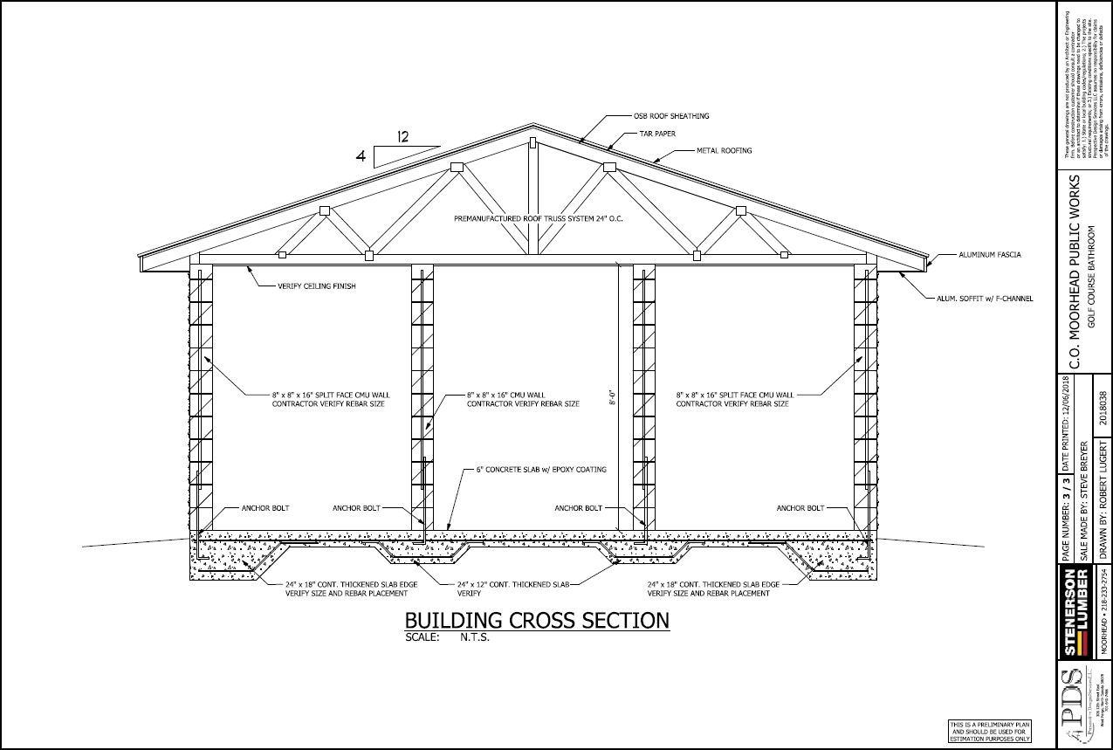

RFQ
Village Green Restroom

ATTACHMENT 2

PROJECT LOCATION

