CR-05 - Goals and Outcomes
Progress the jurisdiction has made in carrying out its strategic plan and its action plan. 91.520(a)
This could be an overview that includes major initiatives and highlights that were proposed and executed throughout the program year.

The year 2018 was the fourth year of a five-year Consolidated Plan cycle for housing and community development. The City of Moorhead’s 2018 CDBG expenditures were consistent with its Consolidated Plan and one-year action plan. The City prioritized its Community Development Block Grant (CDBG) resources on activities to maintain and create affordable housing opportunity, as well as eliminate slum and blight within the community as follows:
Single Family Home Rehabilitation Loan Program: Constituting the largest allocation of Moorhead's CDBG resources, this program addressed affordable housing preservation by completing safety, energy, and structural improvements to eleven housing units occupied by low-moderate income households.
Homelessness Objectives: To reach out to low-income people many of whom are primarily homeless, CDBG funds were utilized for the Opportunities Under Transit (OUT) program which provides discounted bus passes for extremely low income persons. Bus passes are to be used by people seeking jobs or going to and from work or job training. Fifty-nine people were issued discounted bus passes; 43 passes were used by people who were homeless, 30 were used by people with disabilities. In addition to the OUT program, CDBG funds were used to install a public transit shelter near Bright Sky Apartments which is a 43-unit permanent supportive housing bulding which was opened in 2018 and is owned and operated by Churches United for the Homeless. Use of public transit from the building is high and transit users had little shelter from weather conditions in the immediate vicinity.
Other Non-housing Community Development: The City continued a longstanding and important CDBG program in 2018, recreational opportunities for low income youth. In 2018, 19 kids participated in after school and summer programming at Romkey Park and 50 kids participated in programming through the "Play Outside Daily" truck, which offers portable recreation opportunities in Moorhead parks. Other activities included homebuyer education and slum and blight removal; 33 low to moderate income households attended homebuyer education and one hazardous/blighted property was demolished.
Non-homeless Special Needs Services: An accessible ramp was constructed at a housing unit occupied by a person with limited mobility and low income.
Comparison of the proposed versus actual outcomes for each outcome measure submitted with the consolidated plan and explain, if applicable, why progress was not made toward meeting goals and objectives. 91.520(g)
Categories, priority levels, funding sources and amounts, outcomes/objectives, goal outcome indicators, units of measure, targets, actual outcomes/outputs, and percentage completed for each of the grantee’s program year goals.

Goal | Category | Source / Amount | Indicator | Unit of Measure | Expected – Strategic Plan | Actual – Strategic Plan | Percent Complete | Expected – Program Year | Actual – Program Year | Percent Complete
AH1 Affordable Housing | Affordable Housing |  | Rental units constructed | Household Housing Unit | 15 | 3 | 20.00%
AH2 Affordable Housing | Affordable Housing | CDBG: $382597 | Homeowner Housing Rehabilitated | Household Housing Unit | 50 | 49 | 98.00% | 13 | 11 | 84.62%
AH3 Affordable Housing | Affordable Housing | CDBG: $0 | Homeowner Housing Added | Household Housing Unit | 5 | 2 | 40.00% | 1 | 0 | 0.00%
AH4 Affordable Housing | Affordable Housing | CDBG: $10200 | Public service activities other than Low/Moderate Income Housing Benefit | Persons Assisted | 0 | 0 |  | 0
AH4 Affordable Housing | Affordable Housing | CDBG: $10200 | Public service activities for Low/Moderate Income Housing Benefit | Households Assisted | 1300 | 409 | 31.46% | 35 | 33 | 94.29%
AH5 Affordable Housing | Affordable Housing | CDBG: $0 | Other | Other | 100 | 47 | 47.00% | 1 | 43 | 4,300.00%
HL1 Homelessness | Affordable Housing  Homeless | CDBG: $0 | Other | Other | 1 | 1 | 100.00% | 1 | 1 | 100.00%
HL2 Homelessness | Homeless | CDBG: $700 | Public service activities other than Low/Moderate Income Housing Benefit | Persons Assisted | 100 | 251 | 251.00% | 20 | 59 | 295.00%
HL2 Homelessness | Homeless | CDBG: $700 | Other | Other | 0 | 0
NH-3 Slum & Blight Removal | Non-Housing Community Development | CDBG: $ | Buildings Demolished | Buildings | 4 | 4 | 100.00%
NH1 Non-Housing Community Development Needs | Non-Housing Community Development |  | Public Facility or Infrastructure Activities for Low/Moderate Income Housing Benefit | Households Assisted | 0 | 0
NH1 Non-Housing Community Development Needs | Non-Housing Community Development |  | Public service activities for Low/Moderate Income Housing Benefit | Households Assisted | 2500 | 391 | 15.64%
NH2 Non-Housing Community Development Needs | Non-Housing Community Development | CDBG: $41200 | Public Facility or Infrastructure Activities other than Low/Moderate Income Housing Benefit | Persons Assisted | 0 | 18500 |  | 0 | 0
NH2 Non-Housing Community Development Needs | Non-Housing Community Development | CDBG: $41200 | Public service activities other than Low/Moderate Income Housing Benefit | Persons Assisted | 150 | 179 | 119.33% | 50 | 69 | 138.00%
NH2 Non-Housing Community Development Needs | Non-Housing Community Development | CDBG: $41200 | Other | Other | 0 | 0 |  | 1 | 0 | 0.00%
SN1 Non-Homeless Special Needs Services | Non-Homeless Special Needs | CDBG: $0 | Other | Other | 1 | 1 | 100.00% | 1 | 0 | 0.00%
SN2 Non-Homeless Special Needs Services | Non-Homeless Special Needs | CDBG: $2200 | Homeowner Housing Rehabilitated | Household Housing Unit | 10 | 4 | 40.00% | 1 | 1 | 100.00%
Table 1 - Accomplishments – Program Year & Strategic Plan to Date

Assess how the jurisdiction’s use of funds, particularly CDBG, addresses the priorities and specific objectives identified in the plan, giving special attention to the highest priority activities identified.
High priority needs identified in the 5-year plan include affordable housing, homeless services and prevention, and non-housing community development needs. The activities associated with these priority needs include rehabilitating or constructing affordable rental and homeowner housing, slum and blight removal, and after school and summer programming for kids living in low to moderate income households. These priority activities were funded by Moorhead’s CDBG program. Other CDBG activities include homebuyer education and installation of accessible ramps at low to moderate income households.
Activities listed in this section have successfully addressed the strategic plan priorities to date. The only activity in the strategic plan that has not yet been accomplished is rehabilitation of affordable rental housing, which is planned for 2019.

CR-10 - Racial and Ethnic composition of families assisted
Describe the families assisted (including the racial and ethnic status of families assisted). 91.520(a)

 | CDBG
White | 113
Black or African American | 14
Asian | 1
American Indian or American Native | 25
Native Hawaiian or Other Pacific Islander | 1

Total | 154

Hispanic | 16
Not Hispanic | 138

Table 2 – Table of assistance to racial and ethnic populations by source of funds

Narrative
Not all of the options for race are listed in the chart produced by HUD's online reporting system. HUD requires data reporting on the categories listed below, which is how the City of Moorhead has collected data. To adequately report on race and ethnicity of 2018 beneficiaries, numbers have been included here rather than in the chart provided by HUD:
- White = 113 (11 reported Hispanic/Latino ethnicity)
- Black/African American = 14
- Asian = 1
- American Indian/Alaskan Native = 25 (1 reported Hispanic/Latino ethnicity)
- Native Hawaiian or Other Pacific Islander = 1
- American Indian/Alaskan Native & White = 3
- Asian & White = 0
- Black/African American & White = 1
- American Indian/Alaskan Native & Black/African American = 0
- Other Multi-Racial = 15 (4 reported Hispanic/Latino ethnicity)
The racial composition of families assisted with CDBG funds is not representative of the entire racial composition of the community, CDBG is serving a more diverse population. According to the 2017 5-Year American Community Survey (ACS) Estimates:
93.1% of Moorhead’s population is White (65.3% of all CDBG beneficiaries are of this race);
3.6% is Black or African American (8.1% of CDBG beneficiaries are of this race);
1.2% is American Indian and/or Alaska Native (16.2% of CDBG beneficiaries are of this race);
and 4.9% is Hispanic or Latino (9.2% of CDBG beneficiaries are of this ethnicity).

CR-15 - Resources and Investments 91.520(a)
Identify the resources made available
Source of Funds | Source | Resources Made Available | Amount Expended During Program Year
CDBG | CDBG | 760,096 | 567,262
HOME | HOME
HOPWA | HOPWA
ESG | ESG
Other | Other
Table 3 - Resources Made Available

Narrative
Resources made available include the 2018 award ($238,889.00), program income ($241,544.49), and the 2017 year-end balance ($279,662.46).

Identify the geographic distribution and location of investments
Target Area | Planned Percentage of Allocation | Actual Percentage of Allocation | Narrative Description
Table 4 – Identify the geographic distribution and location of investments

Narrative
Romkey Park Neighborhood Recreation Programming is the only activity that is geographically targeted, though not specifically a "Target Area". It is located in a neighborhood with a significantly higher number of low to moderate income households (69.5%) than most other areas of the city. It also has a significantly higher number of households receiving food benefits (SNAP/19.8%). It is easy for kids to access programming after school and in the summer because for most of them, the park is in their neighborhood.
Leveraging
Explain how federal funds leveraged additional resources (private, state and local funds), including a description of how matching requirements were satisfied, as well as how any publicly owned land or property located within the jurisdiction that were used to address the needs identified in the plan.
None of the CDBG activities require matching funds; regardless, the CDBG funds were used to leverage and compliment other investments in the community. Minnesota Housing provides significant mortgage assistance in Moorhead every year. In 2018, there were 29 loans totaling $4,944,859. Over the course of nearly 30 years, Minnesota Housing has issued 740 loans totaling more than $76 million. While these programs do not specifically require matching resources, the CDBG contribution to the homebuyer education program leveraged these loans by meeting consumer educational requirements of these affordable housing products.
The City of Moorhead structures its housing rehabilitation assistance and acquisition of residential lots for homeowners as deferred no-interest mortgages so as to recycle the funds for future community development activities; repayments are reported as CDBG program income. The CDBG loan portfolio balance is $4,296,548.61 representing 240 outstanding loans. In 2018, there were 8 loan repayments totaling $135,638.00. There were no loans written off due to foreclosures.

CR-20 - Affordable Housing 91.520(b)
Evaluation of the jurisdiction's progress in providing affordable housing, including the number and types of families served, the number of extremely low-income, low-income, moderate-income, and middle-income persons served.

 | One-Year Goal | Actual
Number of Homeless households to be provided affordable housing units | 0 | 0
Number of Non-Homeless households to be provided affordable housing units | 0 | 0
Number of Special-Needs households to be provided affordable housing units | 1 | 0
Total | 1 | 0
Table 11 – Number of Households

 | One-Year Goal | Actual
Number of households supported through Rental Assistance | 0 | 0
Number of households supported through The Production of New Units | 0 | 0
Number of households supported through Rehab of Existing Units | 11 | 12
Number of households supported through Acquisition of Existing Units | 0 | 0
Total | 11 | 12
Table 12 – Number of Households Supported

Discuss the difference between goals and outcomes and problems encountered in meeting these goals.
AH1 Affordable Housing -Rehabilitate or construct 15 affordable rental housing units by 2019. Progress: 3 public housing units have been constructed.
AH2 Affordable Housing -Rehabilitate or construct 50 affordable housing units for homeownership by 2019. Progress: 49 owner-occupied homes have been rehabilitated.
AH3 Affordable Housing -Construct at least 5 affordable housing units for homeownership by 2019, specifically through partnership with Habitat for Humanity. Progress: 2 affordable housing units have been built by Habitat for Humanity, CDBG funds were used for site preparation (i.e., land acquisition, demolition of blighted house, and special assessments/infrastructure costs). The City of Moorhead provided Habitat for Humanity one additional vacant lot upon which an affordable housing unit will be built in 2019 or 2020.
AH4 Affordable Housing -Create homeownership opportunity for 1,300 households through use of down payment assistance and/or below market interest rate mortgages for first time homebuyers. Progress: 409 households have participated in homebuyer education.
AH5 Affordable Housing -Support and encourage the efforts of governmental and private agencies seeking to reduce the cost burden of low-income households through certificate and voucher programs by providing letters of support and technical assistance with background information upon request. While not within the City of Moorhead’s control, the City of Moorhead advocates that the number of rental subsidies available in Moorhead increases by at least 20 per year, or 100 over the five-year period. Progress: 43 new vouchers/subsidies were added in 2018. There were 15 new VASH HCV vouchers and 28 new HVC Mainstream vouchers.
SN2 Non-Homeless Special Needs Services – Rehabilitate affordable homes specifically through the construction of accessibility ramps or addition of assistive devices for households with a disabled household member. Progress: 4 owner-occupied homes have been rehabilitated to include accessibility ramps.
Discuss how these outcomes will impact future annual action plans.
Given the change in homebuyer education providers, achieving previous participation volume is proving unrealistic. Although the provider, Lakes & Prairies Community Action, has been part of the community for 50 years, it may take some time before the participant numbers achieve the level of the Village Financial Resource Center, who operated the program for decades. The Village had more funding sources and a metro-based audience. The City is closely monitoring this activity and working with the provider to increase numbers through additional communication and promotion channels.
Include the number of extremely low-income, low-income, and moderate-income persons served by each activity where information on income by family size is required to determine the eligibility of the activity.

Number of Households Served | CDBG Actual | HOME Actual
Extremely Low-income | 5 | 0
Low-income | 19 | 0
Moderate-income | 18 | 0
Total | 42 | 0
Table 13 – Number of Households Served

Narrative Information
In 2018, CDBG funded 11 owner-occupied home rehabilitation projects to improve housing units and to reduce housing cost burdens by providing much needed improvements and improving energy efficiency. Housing quality standards are prioritized as the first repairs made to all homes being rehabilitated under the CDBG home rehabilitation loan program. In 2018, none of the homes were considered seriously substandard. For those who are renting, seriously substandard housing conditions are not allowable under the City of Moorhead’s Rental Registration program – all units are inspected annually and code enforcement addresses deficiencies. Low-income renter households that contact the City and are experiencing “worst-case housing needs” are referred to local community action agencies that may be able to provide rental assistance, housing counseling, utility assistance, etc. Homeless or involuntarily displaced individuals are connected with local resources that can provide housing, housing counseling, and other necessary resources to stabilize their situation.
Regarding needs of person with disabilities, in 2018, one accessible ramp was built for a low income person who has limited mobility. We only had one applicant for the accessible ramp program. The City partners with Freedom resource Center which is a non-profit organization whose mission is to provide services that increase independence for people with disabilities. Households with a disabled member, that have needs beyond what CDBG programs can assist with, are referred for assistance to Freedom Resource Center or a local community action agency.
In 2018, no new affordable housing was constructed using CDBG assistance, but affordable housing was preserved through the Home Rehabilitation Loan Program.

CR-25 - Homeless and Other Special Needs 91.220(d, e); 91.320(d, e); 91.520(c)
Evaluate the jurisdiction’s progress in meeting its specific objectives for reducing and ending homelessness through:
Reaching out to homeless persons (especially unsheltered persons) and assessing their individual needs
HL2 Homelessness -Support the initiatives of service providers to expand homeless prevention services including outreach, coordinated assessment, shelter services, transportation, and transitional housing through survey research, technical support, certificates of consistency for funding applications, transportation vouchers, and other means. The City will support the F-M Area Coalition for Homeless Persons by serving as a funding partner for the update to the Wilder Research analysis of homelessness in Fargo-Moorhead. The survey is conducted every 3 years and was last conducted in 2015. The survey serves as a resource for agencies addressing issues related to homelessness. The survey is used to develop initiatives to address the needs documented in the study and seek funding for same. Progress: The Coordinated Assessment, Referral and Evaluation System (CARES) was first developed in 2015 and partially funded with CDBG in 2015. This system continues to be used to assess individual needs and maintain up-to-date data. The Wilder Study was funded in 2015.
Addressing the emergency shelter and transitional housing needs of homeless persons
HL1 Homelessness -Support the continuation and expansion of emergency, transitional and permanent supportive housing available to homeless persons in the community. While the City of Moorhead’s CDBG allocation is not sufficient to provide primary support to construct housing units, it can serve as a leverage source to support applications to primary funding agencies. Progress: In 2017, both of Moorhead’s emergency homeless shelters were improved with CDBG Public Facilities Improvement funds (i.e., energy efficiency, accessibility, privacy). Churches United for the Homeless received a CDBG grant for $5,000 and the Dorothy Day House received a CDBG grant for $22,000. The Dorothy Day House project was completed in 2018. In 2018, CDBG funds were used to install a bus shelter near Churches United For the Homeless’s Bright Skies Apartments which was built in 2018. Bright Skies Apartments are occupied by low income individuals and families. Use of public transit from the building is anticipated to be high and transit users have little shelter form weather conditions in the vicinity.
Helping low-income individuals and families avoid becoming homeless, especially extremely low-income individuals and families and those who are: likely to become homeless after being discharged from publicly funded institutions and systems of care (such as health care facilities, mental health facilities, foster care and other youth facilities, and corrections programs and institutions); and, receiving assistance from public or private agencies that address housing, health, social services, employment, education, or youth needs
The City of Moorhead helps low-income individuals and families avoid becoming homeless by maintaining strong partnerships with area agencies/groups working in homelessness. Through these relationships, the City is better able to understand the needs of people who are homeless or are facing homelessness. Speaking directly to discharges from publicly funded institutions such as hospitals and correctional facilities for example, the West Central CoC participates in statewide prison discharge fairs. The CoC partners with the regional mental health and family/children’s collaborative groups to help assure practices and policies are in place and being utilized to avoid discharging or releasing someone into homelessness. The CoC and partner agencies meet with institution staff to resolve instances of discharging into homelessness and strategize to help prevent future occurrences. The local medical facilities partner with local shelters to provide on-site shelter nursing staff. This partnership has significantly decreased discharges from healthcare facilities into shelters and helped to advocate for admittance to other more supportive environments (e.g., foster care, respite care, nursing homes, halfway house, etc.), particularly for those who are in a shelter or discharged who need more intensive medical or mental health, but are no longer in need of inpatient care. The City of Moorhead has also funded the Fargo Moorhead Coalition for Homeless Person’s taxi-ride program, which provides free rides to homeless individuals in need of transportation to and from shelters and healthcare facilities.
Minnesota Housing Finance Agency provides statewide Family Homeless Prevention and Assistance Program (FHPAP) funds. These funds provide one-time mortgage payments, one-time or short-term rental assistance, and energy assistance funds for those who are at-risk of homelessness or need to be immediately re-housed with minimal barriers and vulnerability. Access to this program is through CARES (coordinated assessment - previously funded in part by CDBG) and Lakes and Prairies Community Action Partnership.
Helping homeless persons (especially chronically homeless individuals and families, families with children, veterans and their families, and unaccompanied youth) make the transition to permanent housing and independent living, including shortening the period of time that individuals and families experience homelessness, facilitating access for homeless individuals and families to affordable housing units, and preventing individuals and families who were recently homeless from becoming homeless again
CARES is the Coordinated Assessment and Referral System initially developed in part by CDBG funding, it provides individuals with information about services to help successfully obtain and retain housing based on a Housing First methodology. CARES utilizes assessment tools for prioritization and linkage to housing and to promote housing stabilization for individuals once housed. Linkage (not just referrals) to mainstream resources is essential to stabilization as well.

CR-30 - Public Housing 91.220(h); 91.320(j)
Actions taken to address the needs of public housing
No CDBG funding was used directly to address the needs of public housing in 2018. The City of Moorhead assists the Moorhead Public Housing Agency with environmental reviews for improvement projects. In 2015, CDBG funding was used to develop three public housing, rental units for low income families. The units were immediately occupied, and remain occupied by low income, female headed households.
Actions taken by the Moorhead Public Housing Agency to address needs of public housing include:
- One of two agencies statewide to be newly awarded the Resident Opportunity and Self Sufficiency grant. The grant, funded through HUD, has allowed MPHA to hire a staff person to work with residents on their goals to achieve greater independence, wellness and other quality of life outcomes.
- Awarded 390,000 in funding from the State of MN for elevator modernization work at the River View Heights High Rise.
- In collaboration with Concordia College and Growing Together Gardens, launched a Community Garden at River View Heights High Rise. This garden produced over 650 Ibs of fresh produce for public housing residents.
- In collaboration with Great Plains Food Bank and Clay County HRA, began weekly distribution of food to River View Heights and Sharp View residents.
Actions taken to encourage public housing residents to become more involved in management and participate in homeownership
MPHA has a board member who is a resident commissioner. Other residents attend board meetings where they can raise issues or questions. Meetings are also held with residents about management issues. In addition to tenant advisory meetings, topical meetings were held in 2018 on various issues important to residents. For example, a police officer held a session on safety and crime prevention at Sharp View apartments. A fall prevention seminar was also held. The MPHA also regularly posts and distributes information about homeownership education opportunities and numerous other resources.
Actions taken to provide assistance to troubled PHAs
Moorhead Public Housing is not categorized as troubled.

CR-35 - Other Actions 91.220(j)-(k); 91.320(i)-(j)
Actions taken to remove or ameliorate the negative effects of public policies that serve as barriers to affordable housing such as land use controls, tax policies affecting land, zoning ordinances, building codes, fees and charges, growth limitations, and policies affecting the return on residential investment. 91.220 (j); 91.320 (i)
No negative effects arose or were predicted, so no actions were taken to remove or ameliorate negative effects of public policies.
Actions taken to address obstacles to meeting underserved needs. 91.220(k); 91.320(j)
In 2017, two activities were facing obstacles to meet underserved needs through the CDBG program, the Homebuyer Education Program and the Accessibility Ramp Program. Both of these programs have been meeting underserved needs in Moorhead for many years. The programs are both doing better as a result of actions taken to address obstacles.
Freedom Resource Center (FRC), the provider of the Accessibility Ramp Program continues to meet the needs of its clients through other sources that require significantly less eligibility information than the CDBG program. The initial goal of the CDBG Accessibility Ramp Program was to annually install two temporary aluminum ramps, followed by two permanent ramps for low to moderate income households with a family member who is disabled or has limited mobility. Although both the provider and the City advertised (newsletter & website), no applications were received. After expanding the advertisement to local service providers and especially to local mobile home park managers, this program began to function as initially intended. Additionally, the program has been expanded to include other accessibility assistive devices (i.e., grab bars, hearing, sight, etc.).
The Homebuyer Education program is no longer offered by a long time provider. A new provider was identified in 2016. The new provider, Lakes and Prairies Community Action Partnership started classes in August 2016. The previous provider had been offering the class for several years and had a much larger audience, about 300 households per year. Given this change in providers, achieving previous participation volume is proving unrealistic. Although Lakes & Prairies has been part of the community for 50 years, it will take some time before the participant numbers start to increase again. The City is closely monitoring this activity and continues to work with the provider to increase participation. In 2017, the City started to advertise the class through its e-Notification and e-News system, which has helped to increase class sizes.
Actions taken to reduce lead-based paint hazards. 91.220(k); 91.320(j)
The City of Moorhead continues to implement HUD’s Lead-Safe Housing regulations. All assisted tenants and owners living in pre-1978 construction housing units are notified of the dangers of lead-based paint and receive up to date brochures about lead risks. Lead risk assessments are conducted on all homes built before 1978 that are receiving assistance under CDBG rehabilitation programs. Lead-safe work practices are followed for lead-based paint removal and/or stabilization on all units in which lead-based paint is detected in accordance with EPA/HUD and Minnesota Department of Health.
Actions taken to reduce the number of poverty-level families. 91.220(k); 91.320(j)
The Moorhead community’s approach to poverty reduction is multifaceted and multi-jurisdictional. The City of Moorhead is a proponent of the Minnesota Department of Employment and Economic Development’s Job Creation Fund, which provides financial incentives to new and expanding businesses that meet certain job creation and capital investment targets. Companies deemed eligible to participate may receive up to $1 million for creating or retaining high-paying jobs and for constructing or renovating facilities or making other property improvements.
Moorhead also offers incentives for new, expanding, or relocating businesses, including a property tax exemption. Tax Increment Financing (TIF) may also be available for large redevelopment projects. The City of Moorhead also offers property tax exemptions for developers that create or retain full time jobs.
Other organizations and businesses helping to reduce poverty through a variety of programming include the Minnesota Workforce Center, Minnesota State Community and Technical College, Minnesota State University Moorhead, Concordia College, Rasmussen, Moorhead School District, Metro Area Transit, Metropolitan Council of Governments, Minnesota Housing Finance Agency, Greater Minnesota Housing Fund, and Minnesota Department of Employment and Economic Development. Several other community non-profits also offer services to their constituent groups to coordinate services available in Moorhead to reduce the number of poverty level families and increase economic success.
The City’s goals for reducing the number of poverty level families are:
To ensure opportunities are available for job training and higher education
To increase good paying job opportunities and affordable housing expenses within the community
To ensure access to job opportunities through affirmative marketing and a variety of transportation alternatives
The City of Moorhead supports these goals by maintaining relationships with these partners and requiring businesses receiving local government incentives to create jobs paying wages not less than $10.15 and expanding homeownership to underserved markets; the average wage for new employees was $12.25. The City also operates and subsidizes mass transit services and participates in the Metropolitan Access to Jobs initiative in the F-M area.
Actions taken to develop institutional structure. 91.220(k); 91.320(j)
The strength of the institutional structure comes from the wide variety of organizations that collaborate to address housing and community development issues within the community. The City of Moorhead works to maintain and build its relationships with local organizations, businesses, and residents and will continue to communicate and share existing needs assessment data to address emerging community needs.
Actions taken to enhance coordination between public and private housing and social service agencies. 91.220(k); 91.320(j)
The City of Moorhead maintains its relationships and partnerships with area agencies to better understand the needs of its residents. Staff is in regular contact with agencies that are meeting many of the community’s underserved needs, including housing and social service agencies. We all work together and utilize each other’s strengths to meet those needs. Our relationships are with organizations and groups including Lakes & Prairies Community Action Partnership, Clay County Social Services, Clay County Housing Agency, Moorhead Public Housing Agency, Successful Outcomes for Tenants and Landlords (SOFTL), West Central Minnesota CoC, FM Coalition for Homeless Persons, Habitat for Humanity, Minnesota Housing Finance Agency, Village Family Service Center (financial counseling), and the Freedom Resource Center.
Identify actions taken to overcome the effects of any impediments identified in the jurisdictions analysis of impediments to fair housing choice. 91.520(a)
An updated 'Assessment of Fair Housing" was conducted in 2015. The next one is due in April 2024. Moorhead continues to be cognizant of the possibility and/or concept of segregation, integration, and racially or ethnically concentrated areas of poverty in Moorhead. While CDBG funds are serving a more racially and ethnically diverse population than the community composition, there are no areas of concentration in Moorhead at this time. The City is annually monitoring this and any disparities in access to community assets and exposure to adverse community factors by maintaining relationships with local service providers. Another goal for Moorhead is to respond to disproportionate housing needs by participating in the tenant, homebuyer, and crime-free multi-housing education programs. Homebuyer education and the crime-free multi-housing program will continue to be offered by the City of Moorhead and tenant education has recently begun as an offering by a new provider, it was discontinuued by the City’s subrecipient agency in 2016. The City will also continue to support housing certificate and voucher programs, and continue to partner and support relationships with organizations concerned about fair housing rights. Rehabilitating owner-occupied housing and constructing new affordable housing through partnerships like Habitat for Humanity will also continue. Moorhead will continue to address disability and access issues by installing temporary and permanent ramps at people’s homes, enforce the MN Building Code and Section 504 legislation, and communicate annually and seek opportunities to partner with organizations that offer disability services. The City maintains active membership in the Successful Outcomes for Tenants and Landlords (SOFTL) Committee, which discusses fair housing rights monthly and hosts approximately 6 brownbag seminars for tenants and landlords on their rights and any other relevant issues of interest.
The City of Moorhead's Human Rights Commission actively works to affirmatively further fair housing in the community. In 2018, the Moorhead Human RIghts Commission partnered with SOFTL to provide and record a Fair Housing training, hosted a booth at the FM Pride in the Park event, particpated in Welcoming Week events and awarded 2 Human Rights Awards to citizens of the community.

CR-40 - Monitoring 91.220 and 91.230
Describe the standards and procedures used to monitor activities carried out in furtherance of the plan and used to ensure long-term compliance with requirements of the programs involved, including minority business outreach and the comprehensive planning requirements
HUD staff from the Minneapolis Field Office periodically conduct onsite monitoring of the City’s CDBG program to verify that activities are administered in accordance with requirements. The City prepares and publishes an annual performance report to monitor and document its progress in meeting goals set forth in the Annual Action Plans and the 5-Year Consolidated Plan.
The City also monitors each CDBG activity to ensure compliance with rules and regulations. Files are reviewed to ensure income verification has been completed, project checklists assist staff in ensuring all projects meet the requirements of the program. For projects facilitated by subrecipients, monitoring visits with the subrecipients (external entities administering CDBG activities through an agreement with the City of Moorhead) are conducted annually. The City’s right to monitor is identified in each subrecipient agreement and visits are scheduled at least 7 days in advance of the visit.
Contractors that are utilized for the City’s Rehab Loan Program are encouraged to use minority businesses when using sub-contractors. The City requires that the contractors regularly report any minority and women owned business sub-contractors.

Citizen Participation Plan 91.105(d); 91.115(d)
Describe the efforts to provide citizens with reasonable notice and an opportunity to comment on performance reports.
The City of Moorhead encourages citizen participation in all aspects of government, and particularly through its Community Development Block Grant process.
Performance Reports
Annual performance reports will be completed by the City of Moorhead each program year and an opportunity for review of the Performance Report will be made known through website and newspaper publication of a 15 day comment period. A community meeting will be held during the comment period, all citizens, including minorities and non-english speaking persons, are invited to the meeting and encouraged to comment on the performance report. The City provides accommodation for persons with disabilities or limited English proficiency and advertises that fact. Copies of the Performance Report will be available for review at the Moorhead Public Library and the Moorhead Planning & Neighborhood Services Department office and mailed, at no cost, to all citizens who request them.
CR-45 - CDBG 91.520(c)
Specify the nature of, and reasons for, any changes in the jurisdiction’s program objectives and indications of how the jurisdiction would change its programs as a result of its experiences.
None in 2018.
Does this Jurisdiction have any open Brownfields Economic Development Initiative (BEDI) grants?
No
[BEDI grantees] Describe accomplishments and program outcomes during the last year.

CR-45 - CDBG 91.520(c)
Specify the nature of, and reasons for, any changes in the jurisdiction’s program objectives and indications of how the jurisdiction would change its programs as a result of its experiences.
None in 2018.
Does this Jurisdiction have any open Brownfields Economic Development Initiative (BEDI) grants?
No
[BEDI grantees] Describe accomplishments and program outcomes during the last year.

Attachment
Cover Page
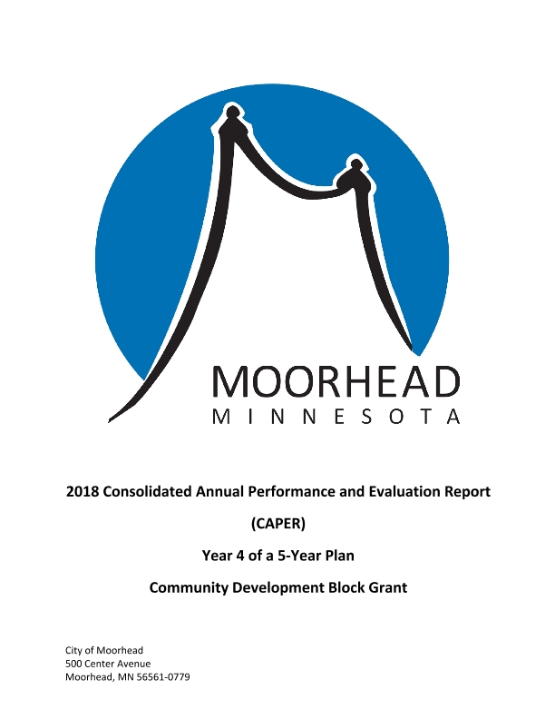

PR26
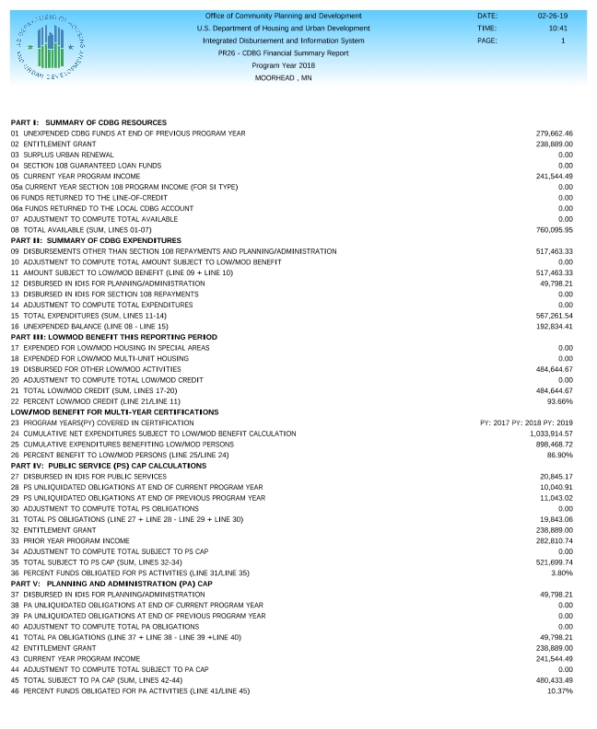
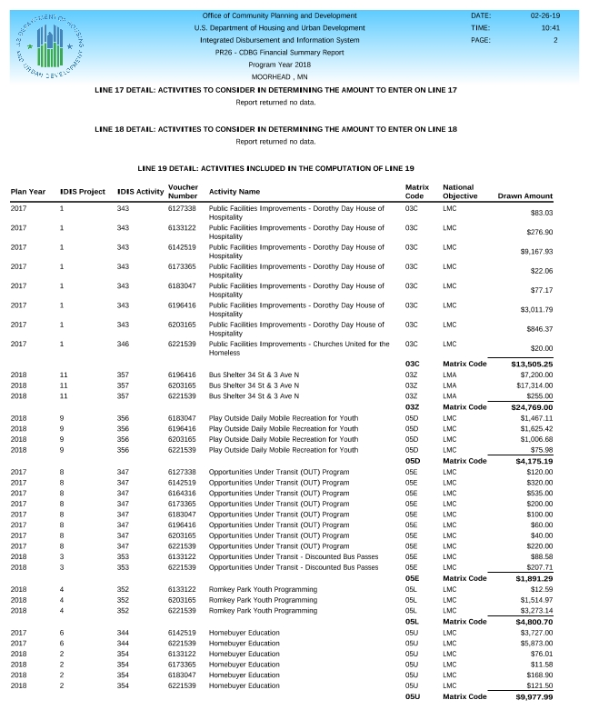
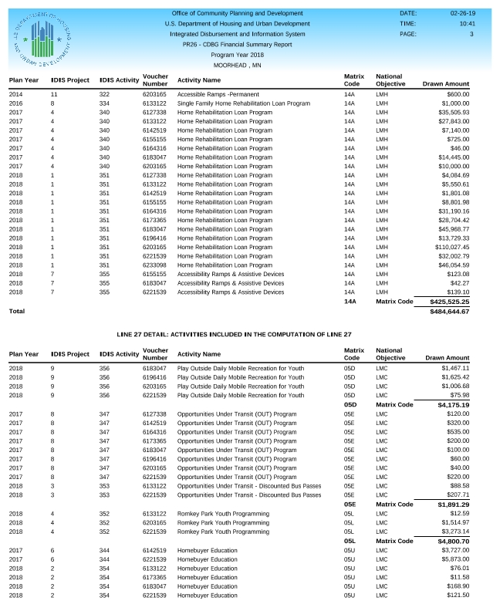
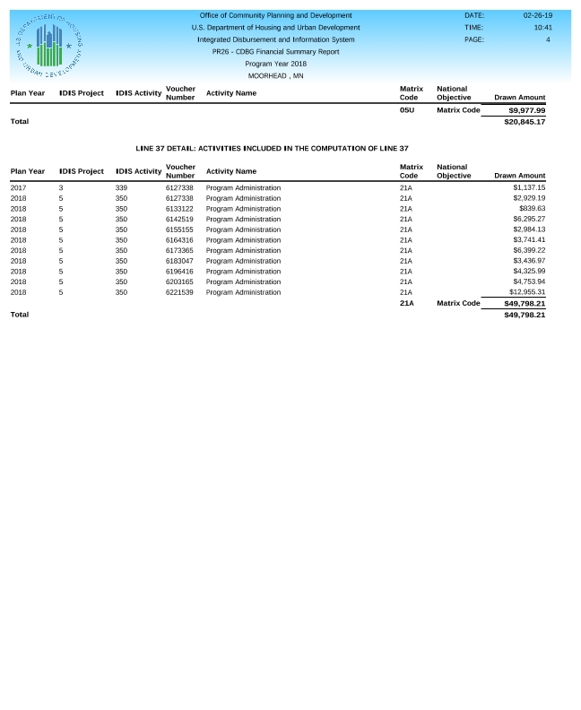

PR26 Explanations
PR-26 Explanations
Line 28: $9,990.91 for Activity 354 (Homebuyer Education) which has a subrecipient agreement period from January 2019 – December 2019. $50.00 for Activity 353 (OUT program) which carries over into 2019 program year.
Line 29: Line 28: $9,552.52 for Activity 344 (Homebuyer Education) which had a subrecipient agreement period from October 2017 – October 2018. $1,490.50 for Activity 347 (OUT program) which carries over into 2018 program year.

Public comment/meeting advertisement
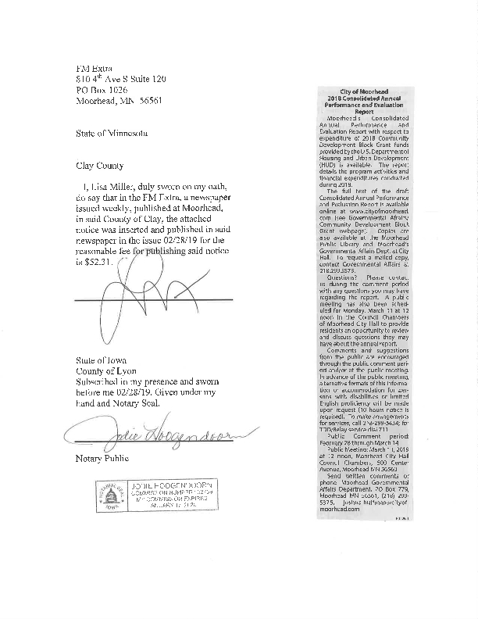

Public comment summary
2018 CAPER – Public Comment Period was February 28, 2019 through March 14, 2019.

No comments were received.

