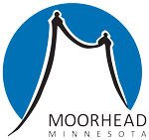

Executive Summary

ES-05 Executive Summary - 24 CFR 91.200(c), 91.220(b)
1. Introduction
Pursuant to the Housing and Community Development Act of 1974, the City of Moorhead is designated as an entitlement community and therefore receives an annual allocation of Community Development Block Grant (CDBG) funds from the US Department of Housing and Urban Development (HUD). CDBG funds are used to develop viable urban communities by providing decent housing, suitable living environments, and economic opportunities, primarily to low and moderate income persons.
In preparation of Moorhead's 2020-2024 Consolidated Plan, both qualitative and quantitative data was used to determine priority needs and principal investment areas for CDBG funds. This process was completed through consultations with local services providers/agencies, a Moorhead Community Survey, and statistical data. This Executive Summary is a result of those planning efforts.
2. Summary of the objectives and outcomes identified in the Plan Needs Assessment Overview
According to 2017 US Census Data, Moorhead has a population of 41,801 people and is included in the Fargo-Moorhead Metropolitan Statistical Area (MSA), which has an overall population of 232,660 people [2017 American Community Survey, US Census Bureau]. The City has prepared this plan in collaboration with local service providers, area agencies, and citizens who share a common goal to address Moorhead's community development needs in a way that utilizes resources efficiently and thoughtfully. The following overview summarizes those needs, which include housing needs, public housing, homeless needs, non-homeless special needs, and non-housing community development needs; objectives and outcomes are outlined in the charts provided.

A. Housing Needs
The most common housing need reported in Moorhead is a shortage of affordable housing stock. The existing housing stock does not fully meet the needs of the community, specifically low income households. Data shows over 48% of Moorhead’s households have income at or below 80% of the area median income. Affordable housing and income are directly connected. HUD explains, “Families who pay more than 30% of their income for housing are considered cost burdened and may have difficulty affording necessities such as food, clothing, transportation, and medical care.” Over 40% of Moorhead households are experiencing housing cost burden greater than 30% of their income [2011-2015 Comprehensive Housing and Affordability Strategy (CHAS) dataset (see charts in Consolidated Plan)].
Based on the data and consultations, the populations or household types more affected than others by housing problems are low income households including:
- Single person and single parent households
- People fleeing domestic violence
- People with a criminal history, poor rental history, no credit or poor credit
- Larger families
- People with mental health and/or chemical dependency issues
- Native Americans who represent 19.5% of the local adult homeless population (1.2% of the general population - 2017 ACS data)
- Black or African Americans who represent 19% of the local adult homeless population (3.5% of the general population - 2017 ACS data)
- People with a disability
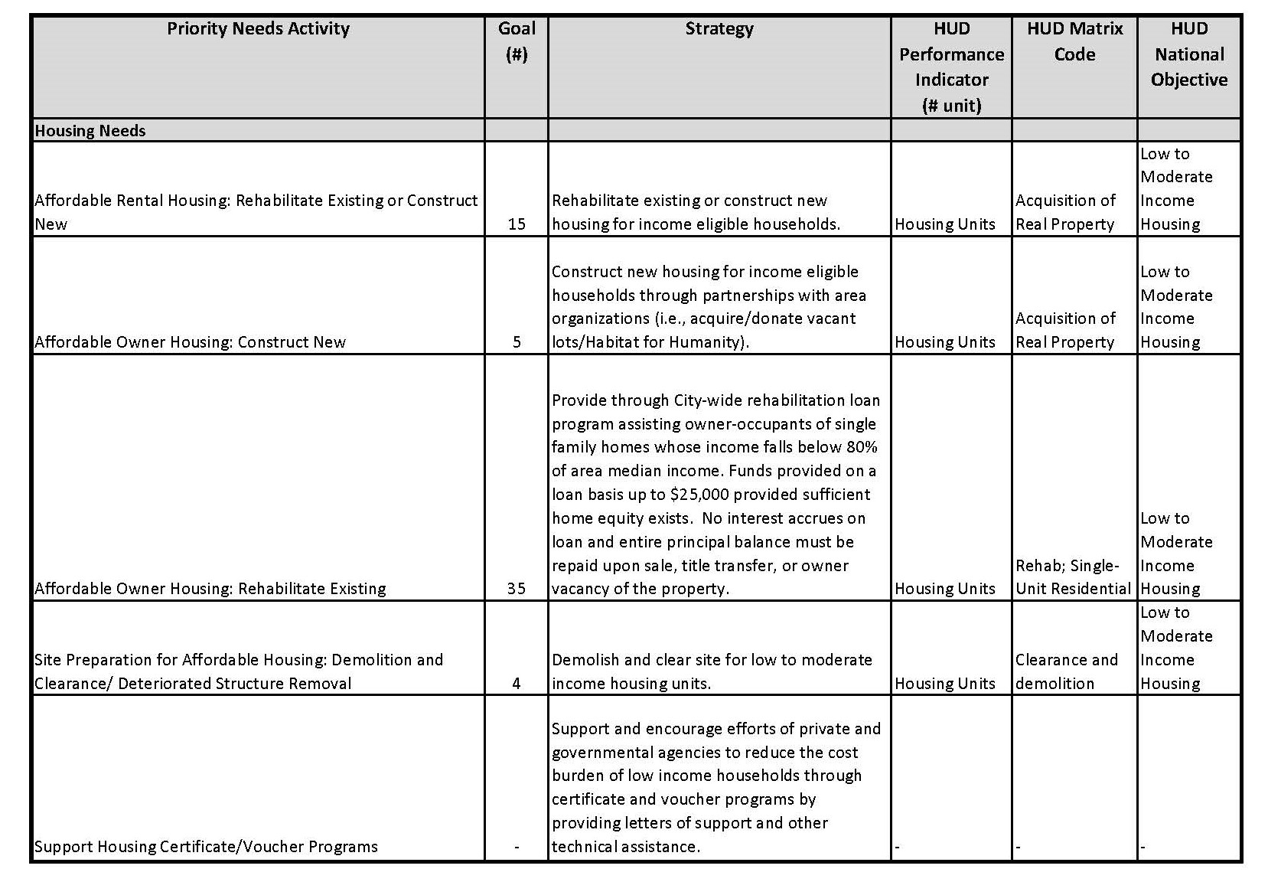
Objectives/Outcomes (2020-2024) Priority Housing Needs Chart
B. Public Housing Needs

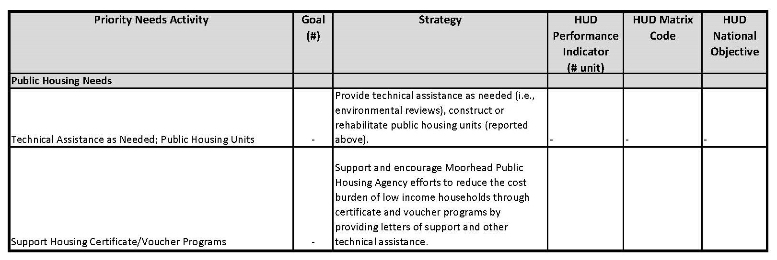
Objectives/Outcomes (2020-2024) Priority Public Housing Needs Chart
C. Homeless Needs

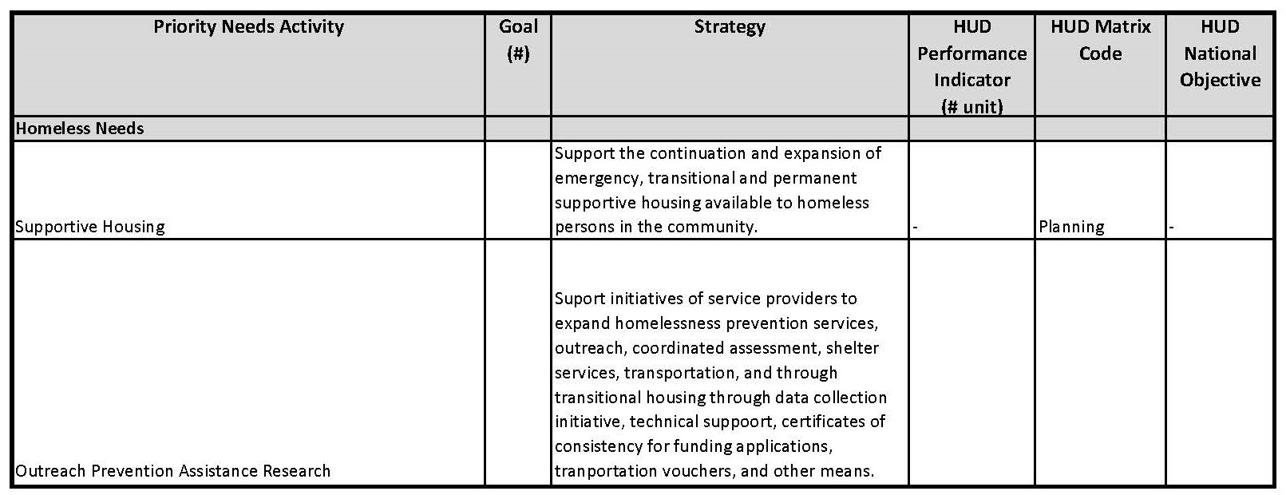
Objectives/Outcomes (2020-2024) Priority Homeless Needs Chart
D. Non-Homeless Special Needs

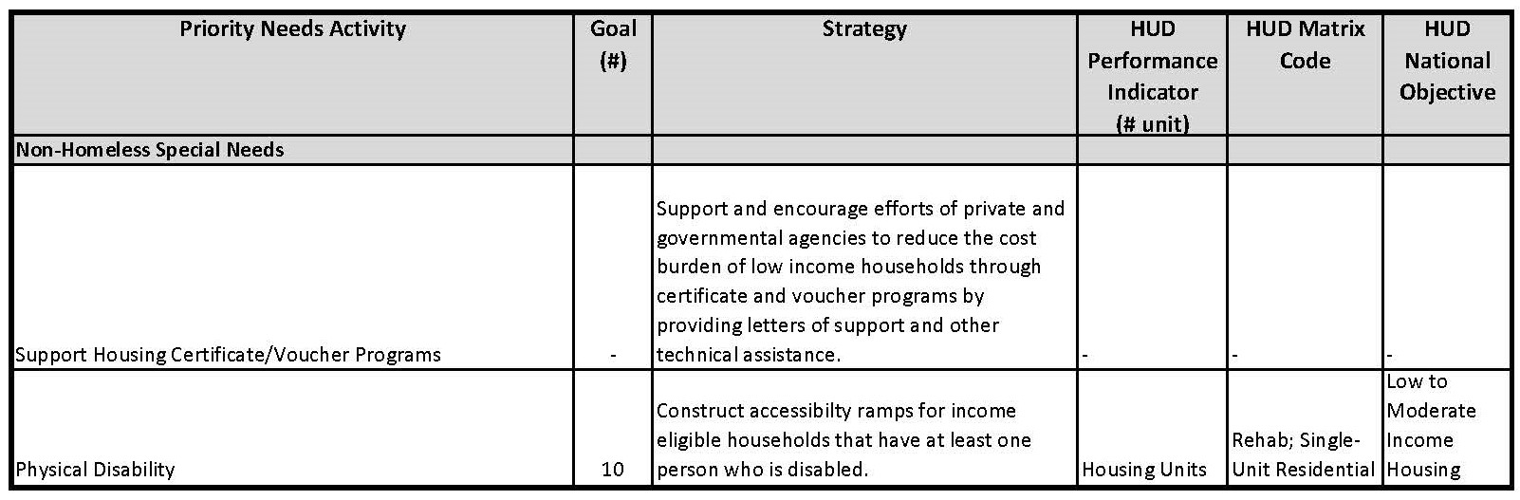
Objectives/Outcomes (2020-2024) Priority Non-Homeless Special Needs Chart
E. Non-Housing Community Development Needs

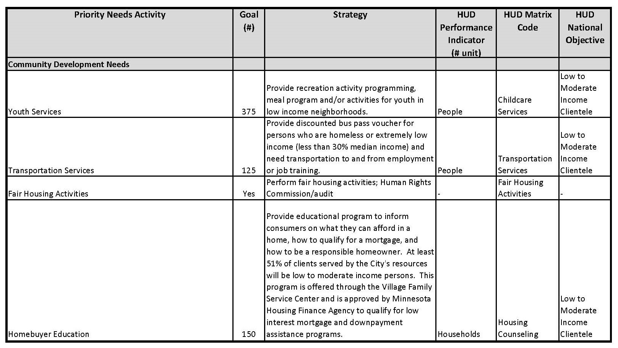
Objectives/Outcomes (2020-2024) Priority Non-Housing Community Development Needs Chart
3. Evaluation of past performance
In the City's 2015-2019 Consolidated Plan, three priority housing needs were established: 1) production or rehabilitation of new/existing rental units, 2) production of new owner units, and 3) rehabilitation of existing owner units. The City met 20% (3 out of 15 units constructed) of the first goal, 40% (2 out of 5 constructed) of the second goal, and 98% (49 rehabbed out of 50) of the third goal at 2018 year end. A reduction in state funding made it difficult to achieve the desired amount of new construction of rental housing units during the 2015-2019 period. The City of Moorhead also provided Habitat for Humanity one additional vacant lot upon which an affordable housing unit will be built in 2020. Rehabilitation on single family homes will have exceeded its goal before the end of the 2015-2019 plan period because the program relies on both entitlement and program income revenue; thus it is partially self-sustaining.
The City met 100% of its blight removal goal. During the 2015-2019 Consolidated Plan period, four blighted buildings were demolished.
Priority community development needs included youth services, transportation services, and homebuyer education. At the end of 2018, youth services reached 119% of its goal. Transportation services achieved 251% of its goal. Tenant/landlord counseling reached 16% of its goal and homebuyer education reached 32% of its goal. The service provider for tenant/landlord counseling and homebuyer education stopped offering this service two years into the 2015-2019 plan. A new provider, Lakes & Prairies Community Action began offering homebuyer education nine months after the previous provider canceled it. The number of participants dropped significantly, following this change. The City is closely monitoring this activity and working with the current provider to increase participation through additional communication and promotion channels. Fair housing activities were implemented each year. Capital improvements were conducted on two homeless shelters and a bus shelter was installed in close proximity to a permanent supportive housing development.
Performance and evaluation reports are also completed annually as required by HUD; the Consolidated Annual Performance and Evaluation Report (CAPER) is submitted to HUD after the end of each program year. The CAPER includes information and data on activities, accomplishments, and expenditures.
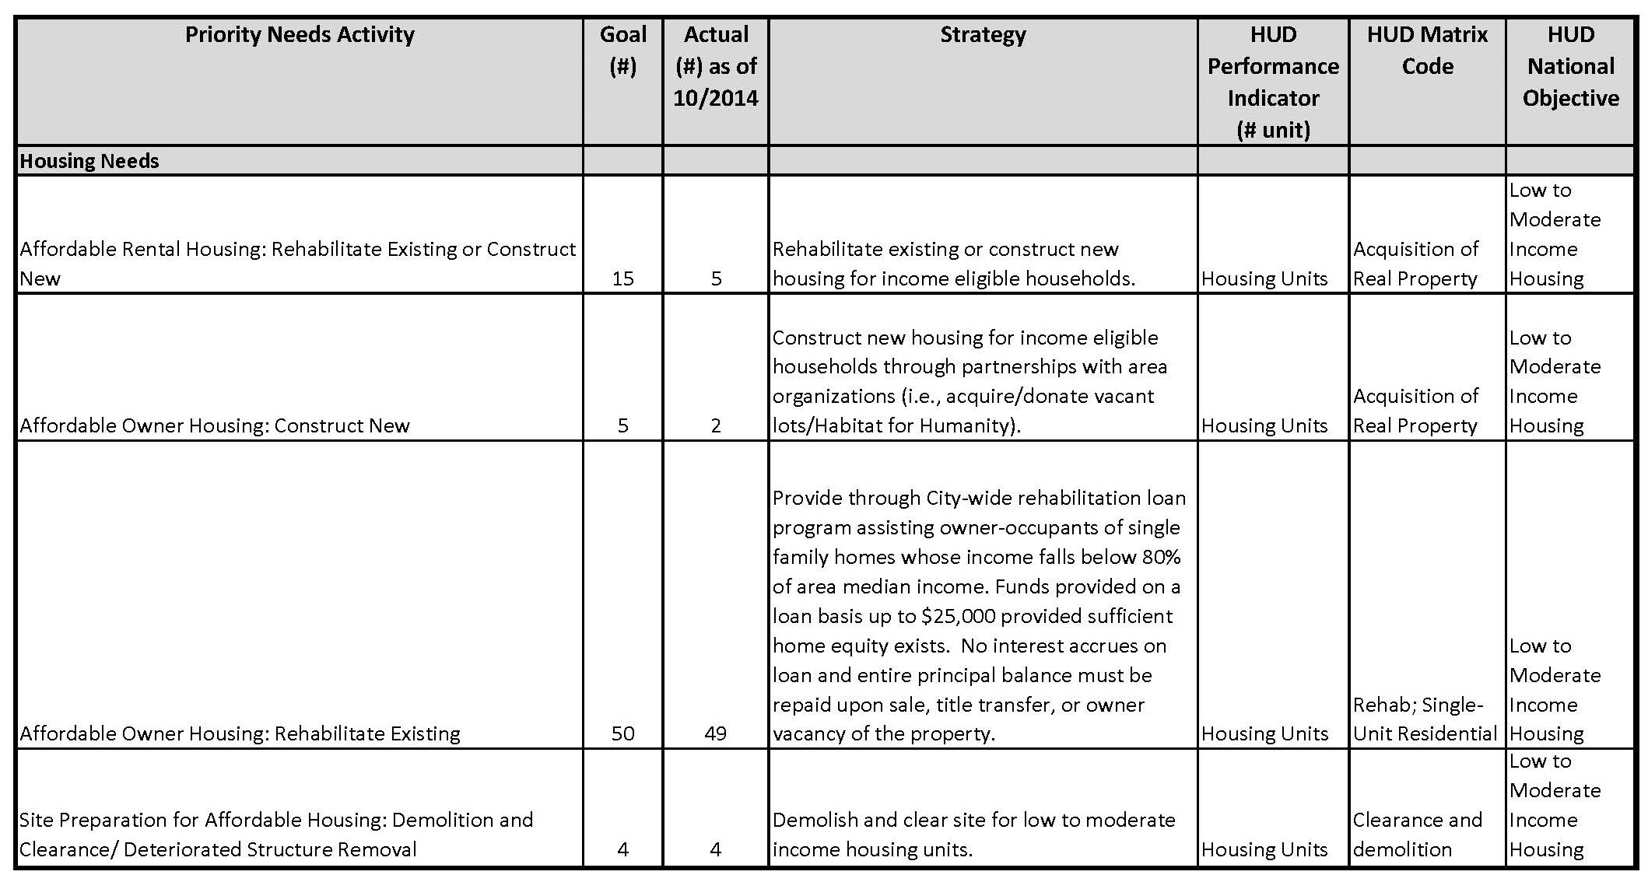
Evaluation of Past Performance Housing Needs Chart
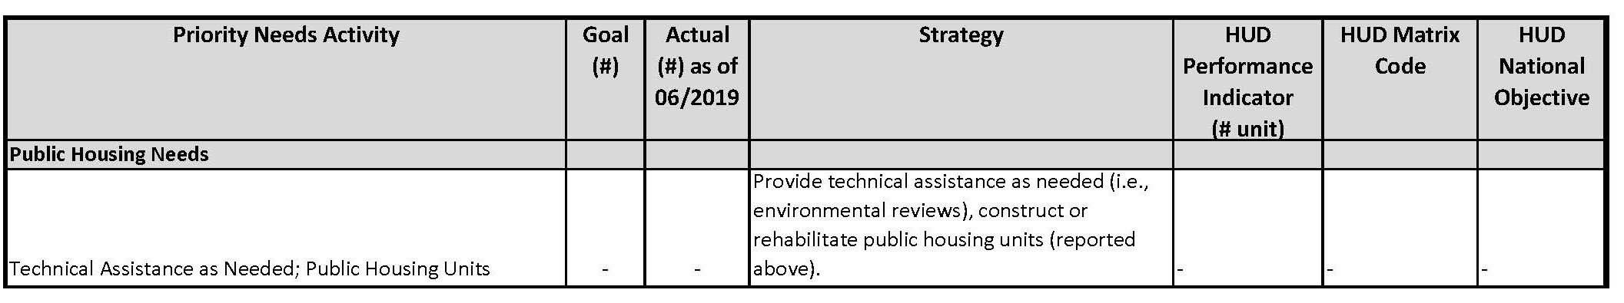
Evaluation of Past Performance Public Housing Needs Chart
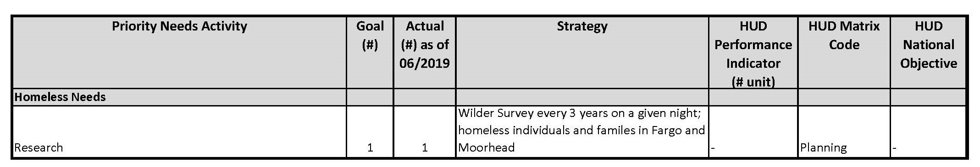
Evaluation of Past Performance Homeless Needs Chart
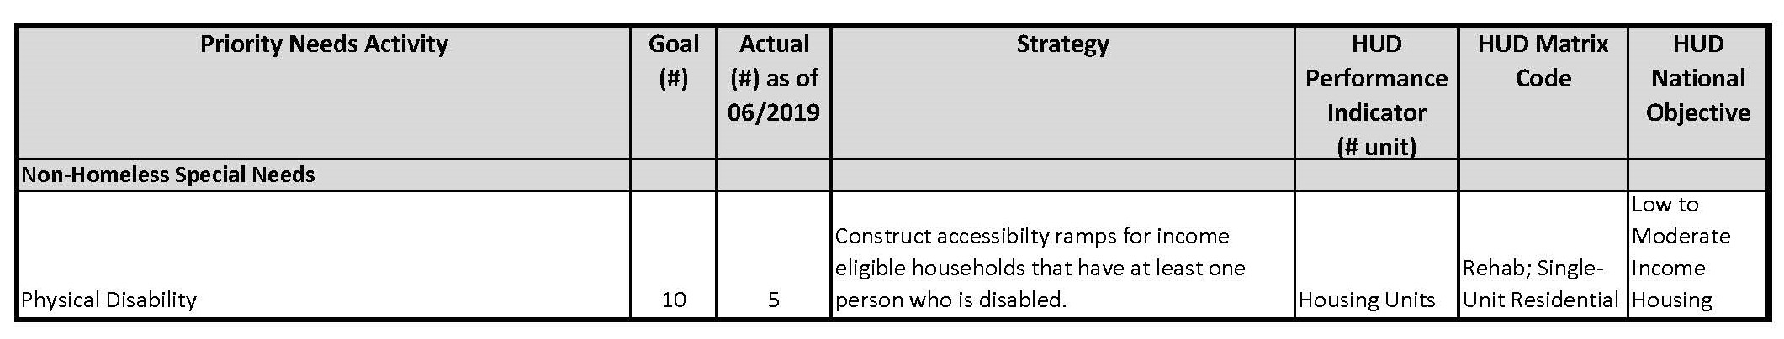
Evaluation of Past Performance Non-Homeless Needs Chart
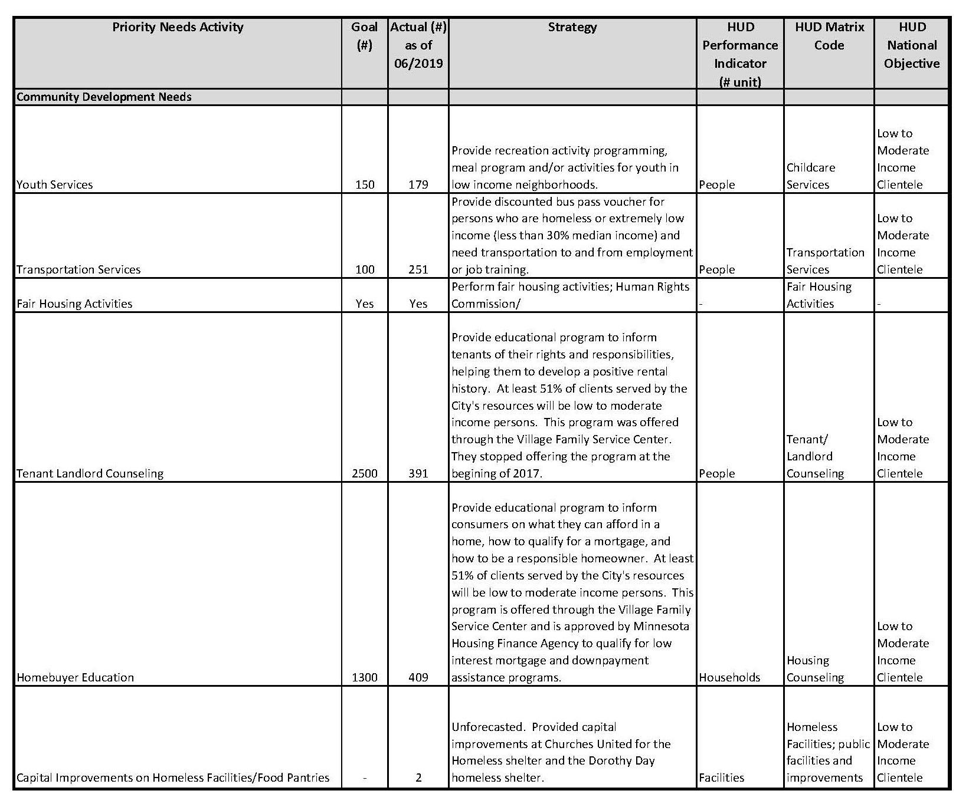
Evaluation of Past Performance Community Development Needs Chart
4. Summary of citizen participation process and consultation process
Citizens were engaged in the planning process by means of the Moorhead Community Survey, prepared and administered by the City. The purpose of the survey was to have citizens identify the most important housing and non-housing community development needs in Moorhead and gain insight into fair housing. The survey results were compared alongside notes taken during conversations with local service providers/agencies (consultations) and statistical data provided by agencies or the US Census Bureau. The Moorhead Community Survey was ultimately used to illustrate correlations among citizens, service providers, agencies, and available data.
The survey was available from June 14 - July 17, 2019 in paper and online formats; paper surveys were circulated by 24 local service providers/agencies and online surveys were available through the City of Moorhead website. The community was notified in-person, by word-of-mouth, and through e-mail and social media. Though the survey was open to both residents and non-residents, 81% of the respondents were Moorhead residents. A total of 335 surveys were completed.
The City of Moorhead consulted with several local service providers/agencies in preparation of the Consolidated Plan. A total of 15 local service providers and agencies were consulted during the formation of the plan; of the 15 consultations, 14 were consulted in-person and 1 via email. Service providers/agencies were asked to complete a SWOT (Strengths, Weaknesses, Opportunities, Threats) analysis.
5. Summary of public comments
Insert Public Comments
6. Summary of comments or views not accepted and the reasons for not accepting them
Insert Public Comments
7. Summary
The Executive Summary includes a brief introduction along with a summary of the objectives and outcomes identified in the needs assessment. Areas of need that were summarized related to housing, homelessness, non-homeless special needs, and non-housing community development needs. Brief sections on the evaluation of past performance and the citizen participation/consultation process were also included.

The Process

PR-05 Lead & Responsible Agencies 24 CFR 91.200(b)
1. Describe agency/entity responsible for preparing the Consolidated Plan and those responsible for administration of each grant program and funding source
The following are the agencies/entities responsible for preparing the Consolidated Plan and those responsible for administration of each grant program and funding source.
Agency Role | Name | Department/Agency

CDBG Administrator | MOORHEAD | City of Moorhead
Table 1 – Responsible Agencies

Narrative
The City of Moorhead is the Lead & Responsible Agency for the administration of the Community Development Block Grant (CDBG). The program is managed by the Planning & Neighborhood Services Department and the main contact is the Community Development Program Administrator.

Consolidated Plan Public Contact Information
Joshua Huffman
Community Development Program Administrator
500 Center Ave/PO Box 779
Moorhead, MN 56561
218.299.5375
joshua.huffman@cityofmoorhead.com

PR-10 Consultation – 91.100, 91.110, 91.200(b), 91.300(b), 91.215(I) and 91.315(I)
1. Introduction
The City of Moorhead consulted with several local service providers/agencies in preparation of the Consolidated Plan. A total of 15 local service providers and agencies were consulted during the formation of the plan; of the 15 consultations, 14 were consulted in-person and 1 via email. Service providers/agencies were asked to complete a SWOT (Strengths, Weaknesses, Opportunities, Threats) analysis.
Provide a concise summary of the jurisdiction’s activities to enhance coordination between public and assisted housing providers and private and governmental health, mental health and service agencies (91.215(I)).
In addition to required consultations with health and housing agencies in preparation of the Consolidated Plan, Moorhead City staff also has regular interaction with the following agencies: Moorhead Public Housing Agency (MPHA), Clay County Housing & Redevelopment Authority (CCHRA), Lakes and Prairies Community Action Partnership which manages a Family Homeless Prevention & Housing Assistance Program (FHPAP) and homebuyer education, Lake Agassiz Habitat for Humanity, Successful Outcomes for Tenants and Landlords (SOFTL), Fargo Moorhead Coalition to End Homelessness, West Central Minnesota Continuum of Care (CoC), and Creative Care for Reaching Independence (CCRI) (which help the special needs population to live and work independently), Dorothy Day and Churches United homeless shelters, MATBUS, and Legal Services of Northwest Minnesota (eviction mitigation).
All of the 24 local agencies that participated in the circulation of the Moorhead Community Survey are easily accessible and understand that the relationship with the City is reciprocal. Outreach during the citizen participation process energized relationships, providing opportunity for enhanced coordination between health and housing agencies and the City of Moorhead. The interconnectedness among local agencies is also strong; they rely on each other for services and regularly collaborate to meet the needs of their clients. A coordinated assessment system further connects providers and clients to services and information.
Describe coordination with the Continuum of Care and efforts to address the needs of homeless persons (particularly chronically homeless individuals and families, families with children, veterans, and unaccompanied youth) and persons at risk of homelessness
The City met with the West Central Minnesota Continuum of Care (CoC) lead contact to discuss assets, strengths, weaknesses, opportunities, and threats within the community. The City also worked with the CoC on sections of the Consolidated Plan to address needs related to homelessness. The City is appreciated for ongoing support of homelessness projects, specifically with recent capital improvements at the Dorothy Day homeless shelter and contributions to the Wilder Survey, both funded by CDBG. The City also recently used CDBG funding to install a bus shelter in close proximity to Bright Sky Apartments which is a 43-unit permanent supportive housing development operated by Churches United for the Homeless. The CoC noted the network of non-profit service providers as one of Moorhead's greatest strengths/assets. Some of Moorhead's weaknesses noted by the CoC and other area agencies, with particular consideration of homeless persons or persons at risk of homelessness, were related to the lack of affordable housing opportunity, lack of case management resources, and public transportation gaps.
Public Transit The Metro Area Transit (MATBUS) system has added routes, increased frequency, and extended hours on evening routes to accommodate rider needs. Ongoing marketing efforts (i.e., television, radio, billboard, newspapers, and website), are made to increase awareness of the service. MATBUS added two new Moorhead/Dilworth routes in 2014. One route increased access to southeast Moorhead where development efforts are ongoing. This new route opened up more employment opportunities, particularly for people who rely on public transit. Newer developments include Sams Club, Sanford Clinic, Menards home improvement store, and two gas stations; the route also passes by the industrial park. The other route added the Dilworth Community Center, the school, Clay County HRA, Dilworth post office, an alcohol and drug residential treatment center, Section 8 housing, and many other affordable housing units. Two evening routes in Moorhead stop within a block of Churches United and Dorothy Day Homeless shelters, the Moorhead Public Library, Concordia College, Minnesota State University Moorhead (MSUM), Minnesota State Community and Technical College (MSCTC), nursing homes, industrial park, senior center, Walmart, Target, two grocery stores, public housing, and other affordable housing units. The last circulation of the evening on these two routes starts at 10:45 P.M. from the Ground Transportation Center (GTC). This expanded service is used as a homeless prevention tool by helping households access and maintain employment, healthcare, and ultimately their housing. .
Public Utilities Moorhead Public Service (MPS) rates are comparable to other regional providers because they do not add various adjustments to their bills called rate riders. See Appendix B for area rates. MPS does not add fuel adjustments, environmental costs, or conservation fees. There are energy assistance programs in the community through West Central Communities Action, Inc., Clay County Social Services, and Salvation Army to help with utility costs.
Police Transports Due to jurisdictional restrictions, the Moorhead Police Department cannot transport a person across state lines who is being held on a peace officers 72-hour detox hold, which is a state statute that give police the authority under law to detain against a persons will for their own wellbeing. This authority is not legal in another state.
Describe consultation with the Continuum(s) of Care that serves the jurisdiction's area in determining how to allocate ESG funds, develop performance standards and evaluate outcomes, and develop funding, policies and procedures for the administration of HMIS
The West Central Minnesota CoC has written standards for provision of ESG and CoC assistance. Within their standards, the CoC explains:
While each programs regulation clearly define program use, the West Central CoC has further identified how program funds can best be utilized based on the needs of homeless persons in our region. The West Central CoC will continue to refine its written standards as the region adapts and further develops our regional CARES (Coordinated Assessment, Referral and Evaluation System) network and develops improved strategies for targeting resources.
CARES is a system of assessing homeless client needs and tracking data among service providers. The community has transitioned into this system over the last 5 years. CARES is designed to reduce the amount of time a person is homeless or prevent homelessness by connecting clients to services faster. In the past, multiple needs assessments were conducted by multiple service providers, increasing client confusion and the amount of time a person waited to access services. CARES allows for a single needs assessment and a database; once the information is inputted into the system, all service providers can access the information and run reports. Needs are assessed using a Service Prioritization Decision Assistance Tool (SPDAT or VI-SPDAT). Six area agencies are currently piloting the VI-SPDAT tool, which was designed for use in outreach assessment with homeless individuals; it combines the medical risk factors of the Vulnerability Index (VI) with the social risk factors of the SPDAT [Clarity Human Services (2014). Upcoming implementation of the VI, SPDAT, & VI-SPDAT. Retrieved on September 9, 2014 from www.clarityhumanservices.com]. Once clients are assessed, the end result produces a number used to rank needs by priority.Â Instead of the traditional first come-first serve concept, those who need help the most are the first to be connected to services. This tool will improve the service delivery system and further connect agencies. The City of Moorhead and the City of Fargo provided CDBG funding for the development of CARES.
Eligibility in the ESG programs requires participant household income of 30% or below of the area median income. Service prioritization and targeting policy (CARES) is also utilized to maximize existing resources. The West Central Minnesota CoC focuses on chronic homeless, families with children, unaccompanied youth, and persons coming from the streets or emergency shelter. Chronic homeless persons and families are given priority in coordinated assessment, open shelter beds, and permanent supportive housing lists. Families with children or unaccompanied youth are given priority in rapid-rehousing and transitional housing programs. Funds may be utilized for the following target areas: prevention, emergency shelter, motel voucher, domestic violence shelter, permanent housing, and transitional housing that includes programming related to financial literacy, rental assistance, case management, advocacy, and housing education. ESG programs are evaluated annually and program outcomes are evaluated every two years as part of the renewal request reviews. Quarterly program reviews are conducted.
2. Describe Agencies, groups, organizations and others who participated in the process and describe the jurisdictions consultations with housing, social service agencies and other entities

Table 2 – Agencies, groups, organizations who participated
1 | Agency/Group/Organization | Moorhead Public Housing Agency
 | Agency/Group/Organization Type | Housing  PHA  Services - Housing
 | What section of the Plan was addressed by Consultation? | Housing Need Assessment  Public Housing Needs  Market Analysis  Anti-poverty Strategy
 | How was the Agency/Group/Organization consulted and what are the anticipated outcomes of the consultation or areas for improved coordination? | Consulted in person, over the phone, and through email multiple times during the planning period. Outcomes of the consultation are continued support for housing projects and technical assistance as needed.
2 | Agency/Group/Organization | Clay County Housing and Redevelopment Authority
 | Agency/Group/Organization Type | Housing  Services - Housing
 | What section of the Plan was addressed by Consultation? | Housing Need Assessment  Market Analysis  Anti-poverty Strategy
 | How was the Agency/Group/Organization consulted and what are the anticipated outcomes of the consultation or areas for improved coordination? | Consulted in person, over the phone, and through email multiple times during the planning period. Outcomes of the consultation are continued support for housing projects, particularly permanent supportive housing projects for the homeless.
3 | Agency/Group/Organization | LAKES AND PRAIRIES COMMUNITY ACTION PARTNERSHIPS
 | Agency/Group/Organization Type | Housing  Services - Housing  Services-Children  Services-Victims of Domestic Violence  Services-homeless  Services-Education
 | What section of the Plan was addressed by Consultation? | Housing Need Assessment  Homelessness Strategy  Homeless Needs - Chronically homeless  Homeless Needs - Families with children  Homelessness Needs - Veterans  Homelessness Needs - Unaccompanied youth  Market Analysis  Anti-poverty Strategy
 | How was the Agency/Group/Organization consulted and what are the anticipated outcomes of the consultation or areas for improved coordination? | Consulted in person, over the phone, and through email multiple times during the planning period. Outcomes of the consultation are maintaining relationships to better understand the needs and assets of the Moorhead community, partnering on solutions when needed.
4 | Agency/Group/Organization | Churches United for the Homeless
 | Agency/Group/Organization Type | Housing  Services - Housing  Services-homeless
 | What section of the Plan was addressed by Consultation? | Housing Need Assessment  Homelessness Strategy  Homeless Needs - Chronically homeless  Anti-poverty Strategy
 | How was the Agency/Group/Organization consulted and what are the anticipated outcomes of the consultation or areas for improved coordination? | Churches United operates two homeless shelters and one food bank. Consulted in person during the planning period. Outcomes of the consultation are maintaining relationships to better understand homelessness in Moorhead, partnering on solutions when needed.
5 | Agency/Group/Organization | Clay County Social Services
 | Agency/Group/Organization Type | Services - Housing  Services-Children  Services-Elderly Persons  Services-Persons with Disabilities  Services-Victims of Domestic Violence  Services-homeless  Services-Health  Services - Victims  Health Agency  Other government - County  Regional organization
 | What section of the Plan was addressed by Consultation? | Housing Need Assessment  Homelessness Strategy  Homeless Needs - Chronically homeless  Homeless Needs - Families with children  Homelessness Needs - Veterans  Market Analysis  Anti-poverty Strategy
 | How was the Agency/Group/Organization consulted and what are the anticipated outcomes of the consultation or areas for improved coordination? | Consulted in person during the planning period. Outcomes of the consultation are maintaining relationships to better understand the needs of people living in Moorhead, partnering on solutions when needed.
6 | Agency/Group/Organization | Rural AIDS Action Network
 | Agency/Group/Organization Type | Services-Persons with HIV/AIDS
 | What section of the Plan was addressed by Consultation? | Homeless Needs - Chronically homeless  Non-Homeless Special Needs
 | How was the Agency/Group/Organization consulted and what are the anticipated outcomes of the consultation or areas for improved coordination? | Consulted in person during the planning period. Outcomes of the consultation are maintaining relationships to better understand the needs of people living in Moorhead infected and affected by HIV/AIDS, partnering on solutions when needed.
7 | Agency/Group/Organization | Legal Services of Northwest Minnesota
 | Agency/Group/Organization Type | Services - Housing  Service-Fair Housing  Regional organization
 | What section of the Plan was addressed by Consultation? | Fair housing activites
 | How was the Agency/Group/Organization consulted and what are the anticipated outcomes of the consultation or areas for improved coordination? | Consulted in person during the planning period. Outcomes of the consultation are maintaining relationships to better understand the needs of people living in Moorhead and to further fair housing, partnering on solutions when needed.
8 | Agency/Group/Organization | FARGO-MOORHEAD METROPOLITAN COUNCIL OF GOVERNMENTS
 | Agency/Group/Organization Type | Regional organization  Planning organization  Civic Leaders
 | What section of the Plan was addressed by Consultation? | Housing Need Assessment  Market Analysis  General discussion, transportation
 | How was the Agency/Group/Organization consulted and what are the anticipated outcomes of the consultation or areas for improved coordination? | Consulted in person during the planning period. Outcomes of the consultation are maintaining relationships to better understand the needs of people living in Moorhead, partnering on solutions when needed.
9 | Agency/Group/Organization | FM Coalition to End Homelessness
 | Agency/Group/Organization Type | Services-homeless
 | What section of the Plan was addressed by Consultation? | Housing Need Assessment  Public Housing Needs  Homelessness Strategy  Homeless Needs - Chronically homeless  Homeless Needs - Families with children  Homelessness Needs - Veterans  Homelessness Needs - Unaccompanied youth  Market Analysis  Anti-poverty Strategy
 | How was the Agency/Group/Organization consulted and what are the anticipated outcomes of the consultation or areas for improved coordination? | Consulted in person during the planning period. Outcomes of the consultation are maintaining relationships to better understand homelessness in Moorhead, partnering on solutions when needed.
10 | Agency/Group/Organization | West Central Minnesota Continuum of Care
 | Agency/Group/Organization Type | Services-homeless  Regional organization
 | What section of the Plan was addressed by Consultation? | Homelessness Strategy  Homeless Needs - Chronically homeless  Homeless Needs - Families with children  Homelessness Needs - Veterans  Homelessness Needs - Unaccompanied youth
 | How was the Agency/Group/Organization consulted and what are the anticipated outcomes of the consultation or areas for improved coordination? | Consulted in person during the planning period. Outcomes of the consultation are maintaining relationships to better understand homelessness in Moorhead, partnering on solutions when needed.
11 | Agency/Group/Organization | Lake Agassiz Habitat for Humanity
 | Agency/Group/Organization Type | Housing
 | What section of the Plan was addressed by Consultation? | Housing Need Assessment  Market Analysis
 | How was the Agency/Group/Organization consulted and what are the anticipated outcomes of the consultation or areas for improved coordination? | Consulted in person during the planning period. Outcomes of the consultation are maintaining relationships to better understand the needs of people living in Moorhead, partnering on solutions when needed.
12 | Agency/Group/Organization | Moorhead Human Rights Commission
 | Agency/Group/Organization Type | Other government - Local
 | What section of the Plan was addressed by Consultation? | Housing Need Assessment  Fair Housing
 | How was the Agency/Group/Organization consulted and what are the anticipated outcomes of the consultation or areas for improved coordination? | Consulted in person during the planning period. Outcomes of the consultation are maintaining relationships to better understand the needs of people living in Moorhead, partnering on solutions when needed.
13 | Agency/Group/Organization | YWCA
 | Agency/Group/Organization Type | Housing  Services - Housing  Services-Children  Services-Victims of Domestic Violence  Services-Education  Services-Employment
 | What section of the Plan was addressed by Consultation? | Housing Need Assessment  Homelessness Strategy  Homeless Needs - Families with children  Non-Homeless Special Needs
 | How was the Agency/Group/Organization consulted and what are the anticipated outcomes of the consultation or areas for improved coordination? | Consulted in person during the planning period. Outcomes of the consultation are maintaining relationships to better understand the needs of people living in Moorhead, partnering on solutions when needed.
14 | Agency/Group/Organization | Minnesota Assistance Council for Veterans
 | Agency/Group/Organization Type | Services - Housing  Veteran services
 | What section of the Plan was addressed by Consultation? | Housing Need Assessment  Homelessness Needs - Veterans
 | How was the Agency/Group/Organization consulted and what are the anticipated outcomes of the consultation or areas for improved coordination? | Consulted in person during the planning period. Outcomes of the consultation are maintaining relationships to better understand the needs of people living in Moorhead, partnering on solutions when needed.
15 | Agency/Group/Organization | FM Matbus
 | Agency/Group/Organization Type | Other government - Local  Transit
 | What section of the Plan was addressed by Consultation? | Homelessness Strategy  Non-Homeless Special Needs  Market Analysis  Transportation
 | How was the Agency/Group/Organization consulted and what are the anticipated outcomes of the consultation or areas for improved coordination? | Consulted in person during the planning period. Outcomes of the consultation are maintaining relationships to better understand the needs of people living in Moorhead, partnering on solutions when needed.

Identify any Agency Types not consulted and provide rationale for not consulting
NA - All agencies contacted for consultation participated in the process.

Other local/regional/state/federal planning efforts considered when preparing the Plan
Name of Plan | Lead Organization | How do the goals of your Strategic Plan overlap with the goals of each plan?
Continuum of Care | West Central Minnesota Continuum of Care | "consistently facilitate the movement of individuals/families toward permanent housing and successful independent living." Moorhead plans to continue support of coordinated assessment, transportation opportunities (OUT), and fostering relationships/partnerships with service providers responding to homelessness daily. "providing the housing and /or services needed to help individuals move into transitional and permanent housing". Moorhead plans to build or rehabilitate 15 rental housing units and does so through partnerships with area agencies (e.g., MPHA, CCHRA, CCRI). Moorhead also plans to rehabilitate or construct 40 affordable housing units and construct, including 5 Habitat for Humanity homes (or similar organization). "Promote access to and effective use of mainstream programs". Moorhead plans to continue support of coordinated assessment development, which will meet this goal.
2016-2019 Strategic Plan | Minnesota Housing Finance Agency | "We support successful homeowners through comprehensive homebuyer and homeowner support, including outreach, education, and counseling". Moorhead's strategy overlaps with its homebuyer education through the Lakes & Prairies Community Action Partnership. Education is approved by MHFA, allowing applicants to obtain loan products from MHFA, which are briefly discussed by City staff at each class. "Repairing existing housing is less expensive than building new housing, and we will continue to work to preserve the existing housing stock by providing flexible financing tools that meet different types of home improvement and preservation. Moorhead's strategy overlaps with its Single Family Rehabilitation program, which maintains and improves existing affordable homes. Through energy efficiency improvements, it also makes homes more affordable by reducing costs spent on utilities. "Run efficient, effective, flexible, and timely funding processes that provide the right resources to the right projects at the right time". Moorhead plans to build or rehabilitate 15 rental housing units and does so through partnerships with area agencies (e.g., MPHA, CCHRA, CCRI). "Strategic Priority: Prevent and End Homelessness. Ensure that each individual and family experiencing or at risk of homelessness receives the right assistance to meet their needs for the right period of time in the right setting". Moorhead plans to continue support of coordinated assessment, transportation opportunities (OUT), and fostering relationships/partnerships with service providers responding to homelessness daily. "Support community and economic development". Moorhead may pursue public and private storefront rehabilitation in the downtown area from funding sources other than CDBG, which will help to "make a community a desirable place to live again with job opportunities and places to shop and participate in community".
Table 3 – Other local / regional / federal planning efforts
Describe cooperation and coordination with other public entities, including the State and any adjacent units of general local government, in the implementation of the Consolidated Plan (91.215(l))
The Minnesota Housing Finance Agency (MHFA) provides statewide resources for low and moderate income Minnesotans seeking homeownership/rental assistance and homelessness/foreclosure prevention. Using local resources in combination with state resources has the most impact to address larger scale needs and is used as leverage when opportunity arises.
In 2019, the City of Moorhead met with the director of the Fargo Moorhead Coalition to End Homelessness to discuss their organization of coordinated assessment within the community. Both the City of Fargo and the City of Moorhead provided grant support in 2014 to the Coordinated Assessment, Referral and Evaluation System (CARES). CARES has been fully implemented by community agencies that serve homeless populations due to the collaborative efforts of the CoC and the FM Coalition.
The City of Moorhead also met with the Executive Director of the Fargo Moorhead Metropolitan Council of Governments (MetroCOG) to consult on current and future transportation needs in the community. This consultation helped to inform priorities that the City is implementing with this plan in regards to transportation.
Narrative (optional):
This section summarizes the consultation process with an introduction, a summary of the City's activities to enhance coordination between public and assisted housing providers and private governmental health, mental health, and service agencies, a summary of the coordination with the Continuum of Care and efforts to address the needs of homeless persons and persons at risk of homelessness, a list of organizations consulted, a summary of how the goals of the strategic plan overlap with plans of the Minnesota Housing Finance Agency and the West Central Minnesota Continuum of Care, and a description of cooperation and coordination with other public entities.

PR-15 Citizen Participation – 91.105, 91.115, 91.200(c) and 91.300(c)
1. Summary of citizen participation process/Efforts made to broaden citizen participation
Summarize citizen participation process and how it impacted goal-setting

Citizens were engaged in the planning process by means of the Moorhead Community Survey. The purpose of the survey was to have citizens identify the most important housing and non-housing community development needs in Moorhead and gain insight into fair housing. The survey results were compared alongside notes taken during conversations with local agencies (consultations) and statistical data provided by agencies or the US Census Bureau. The Moorhead Community Survey was ultimately used to illustrate correlations among citizens, agencies, and available data.
The survey was available from June 14 - July 17, 2019 in paper and online formats; paper surveys were circulated by 24 local agencies and online surveys were available on the City of Moorhead website. The community was notified in-person, by word-of-mouth, and through e-mail and social media. Though the survey was open to both residents and non-residents, 81% of the respondents were Moorhead residents. A total of 335 surveys were completed.

Citizen Participation Outreach
Sort Order | Mode of Outreach | Target of Outreach | Summary of  response/attendance | Summary of  comments received | Summary of comments not accepted and reasons | URL (If applicable)
1 | Newspaper Ad | Non-targeted/broad community | Two comments were received via the City's website. | Comment One - solar panel installation for public housing, Comment Two - a suggestion to fund newly developing community land trust | The comment regarding solar panel installation was forwarded on to Moorhead Public Housing Agency for their consideration for inclusion into their planning.
2 | Public Meeting | Non-targeted/broad community | wo public meetings were held at different times and days of the week in order to maximize attendance. Nine people attended the two meetings and provided their input. The first meeting was also attended by local media. | -United Ways Bold Goal of ending homelessness for families and youth aligns well with the priorities of the West Central Continuum of Care, which is supported by the City as well-Affordable housing is in short supply and needed-Upcoming MN Medicaid Expansion might provide some new opportunities-The United Way rep shared that the Moorhead Community Survey results are in line with the concerns they hear about, namely, affordable housing, affordable childcare, and transportation-There is an uptick in families facing homelessness-There is a need for low-income housing for families-Consider making tax breaks for new apartment developments contingent on some units being held as affordable units-Tiny homes were discussed: Tiny home may be the second frontier, Zoning may be an obstacle, Presentation Partners is looking into the possibility, The City of Fargo is analyzing existing land-use code to consider tiny homes, Embrace rather than resist, For some it's choice not necessity, Don't relegate them to mobile home status, Work into existing neighborhoods not just parking lots-Drop in center needed-Homebuyer and tenant education is important-Concern over the number of available home for rent near MSUM & Concordia, landlords might want to consider providing incentives/reduced rent to get tenants-Continue to support land acquisition for affordable housing-Continue to support permanent supportive housing projects | The majority of comments received are addressed in the 5-Year Plan with annual activities working toward outcomes supported by the comments. A few comments suggested activities that are not permissible with CDBG funding (concern over an excess of available rental units, drop in center, tiny home zoning). These comments were referred to other City departments that can potentially address the comments.
3 | Internet Outreach | Non-targeted/broad community | Moorhead Community Survey online, 243 responses. | Most important housing and non-housing needs prioritized, fair housing measure, and some demographic. No comments. | None. | No longer available.
4 | Moorhead Community Survey | Non-targeted/broad community | Moorhead Community Survey paper copies, 92 responses. Paper survey was made available in 24 community locations. | Most important housing and non-housing needs prioritized, fair housing measure, and some demographic. No comments. | None.
5 | Public Hearing | Non-targeted/broad community | The public hearing was conducted during a City Council meeting. There was a handful of people in attendance, though non comments received. | No comments received. | None.
Table 4 – Citizen Participation Outreach

Needs Assessment

NA-05 Overview
Needs Assessment Overview
Needs were identified within five categories: housing, public housing, homeless, non-homeless special needs, and non-housing community development. The most common housing need reported was a shortage of affordable housing stock. The use of housing vouchers is limited due to decreased voucher funding, high rental rates, and inability of voucher holders to find housing where the voucher is accepted. Housing vouchers reduce the monthly rent paid by tenants and allow for very low income households to obtain private sector housing. More accessible housing for households that have a member with a disability is also needed. Based on the Moorhead Community Survey, the highest ranked non-housing community development needs reported were affordable health services, street lighting/streetscape, and homeless shelter. Other high ranking activities in this category included community centers, parks & recreation facilities, storefronts, demolition of unsafe buildings, affordable childcare services, substance abuse services, and transportation services. Each needs category is further described in this section.

NA-10 Housing Needs Assessment - 24 CFR 91.205 (a,b,c)
Summary of Housing Needs
The most common housing need reported in Moorhead was a shortage of affordable housing stock. The existing housing stock does not fully meet the needs of the community, specifically low income households. Data shows over 48% of Moorhead’s households have income at or below 80% of the area median income ($53,360 –See Chart). Affordable housing and income are directly connected. HUD explains, “Families who pay more than 30% of their income for housing are considered cost burdened and may have difficulty affording necessities such as food, clothing, transportation, and medical care.” Over 40% of Moorhead households are experiencing housing cost burden greater than 30% of their income [2011-2015 Comprehensive Housing and Affordability Strategy (CHAS) dataset(see charts)].
Based on the data and consultations, the populations or household types more affected than others by housing problems are low income households including:
- Single person and single parent households
- People fleeing domestic violence
- People with a criminal history, poor rental history, no credit or poor credit
- Larger families
- People with mental health and/or chemical dependency issues
- Native Americans who represent 19.5% of the local adult homeless population (1.2% of the general population -2017 ACS data)
- Black or African Americans who represent 19% of the local adult homeless population (3.5% of the general population -2017 ACS data)
- People with a disability
The 2011-2015 Comprehensive Housing and Affordability Strategy (CHAS) dataset counted 15,130 households in Moorhead and 7,290 (48%) of those households had income at or below 80% HUD’s Area Median Family Income (HAMFI) ($53,130) [2011-2015 ACS (see charts in Consolidated Plan)].
- 2,560 (17%) households had income between 0-30% of HAMFI
- 2,085 (14%) households had income between 30-50% of HAMFI
- 2,645 (17%) households had income between 50-80% of HAMFI
- 1,630 (11%) households had income between 80-100% of HAMFI
- 6,205 (41%) households had income over 100% of HAMFI
HUD identifies the following housing problems: 1) Substandard Housing –Lacking complete plumbing or kitchen facilities, 2) Severely Overcrowded with more than 1.51 people per room, 3) Overcrowded with 1.01-1.5 people per room, 4) Housing cost burden greater than 50% of income, 5) Housing cost burden greater than 30% of the income, and 6) Zero or negative income. Just over 1% of Moorhead’s renter and homeowner households lacked complete plumbing or kitchen facilities and less than 1% of households were overcrowded. Approximately 2,635 renter households and 1,465 homeowner households were experiencing cost burden greater than 50% of their income. Approximately 1,130 renter households and 925 homeowner households were experiencing cost burden greater than 30% of their income; 230 renter households and 4 homeowner households had zero or negative income. A total of 15% of Moorhead households are experiencing one or more of the severe housing problems and have an income at 80% or less than the area median income. US Census data shows over 31% of Moorhead’s households are single or 1-person households and have a median income of $25,494, which is less than half of Moorhead’s median household income.
Demographics | Base Year: 2009 | Most Recent Year: 2015 | % Change
Population | 38,065 | 40,935 | 8%
Households | 13,681 | 15,130 | 11%
Median Income | $43,402.00 | $53,360.00 | 23%
Table 5 - Housing Needs Assessment Demographics

Data Source: | 2005-2009 ACS (Base Year), 2011-2015 ACS (Most Recent Year)

Number of Households Table
 | 0-30% HAMFI | >30-50% HAMFI | >50-80% HAMFI | >80-100% HAMFI | >100% HAMFI
Total Households | 2,560 | 2,085 | 2,645 | 1,630 | 6,205
Small Family Households | 470 | 400 | 1,050 | 835 | 3,545
Large Family Households | 135 | 105 | 105 | 120 | 545
Household contains at least one person 62-74 years of age | 300 | 310 | 320 | 199 | 1,165
Household contains at least one person age 75 or older | 345 | 565 | 385 | 130 | 275
Households with one or more children 6 years old or younger | 275 | 280 | 480 | 380 | 860

Table 6 - Total Households Table
Data Source: | 2011-2015 CHAS

Housing Needs Summary Tables
1. Housing Problems (Households with one of the listed needs)
 | Renter |  |  |  |  | Owner
 | 0-30% AMI | >30-50% AMI | >50-80% AMI | >80-100% AMI | Total | 0-30% AMI | >30-50% AMI | >50-80% AMI | >80-100% AMI | Total
NUMBER OF HOUSEHOLDS
Substandard Housing - Lacking complete plumbing or kitchen facilities | 100 | 25 | 30 | 0 | 155 | 0 | 4 | 10 | 0 | 14
Severely Overcrowded - With >1.51 people per room (and complete kitchen and plumbing) | 30 | 0 | 0 | 0 | 30 | 0 | 0 | 0 | 0 | 0
Overcrowded - With 1.01-1.5 people per room (and none of the above problems) | 45 | 0 | 0 | 0 | 45 | 0 | 10 | 35 | 0 | 45
Housing cost burden greater than 50% of income (and none of the above problems) | 1,105 | 315 | 75 | 10 | 1,505 | 225 | 270 | 45 | 0 | 540
Housing cost burden greater than 30% of income (and none of the above problems) | 390 | 415 | 305 | 20 | 1,130 | 105 | 165 | 435 | 220 | 925
Zero/negative Income (and none of the above problems) | 230 | 0 | 0 | 0 | 230 | 4 | 0 | 0 | 0 | 4
Table 7 – Housing Problems Table
Data Source: | 2011-2015 CHAS

2. Housing Problems 2 (Households with one or more Severe Housing Problems: Lacks kitchen or complete plumbing, severe overcrowding, severe cost burden)
 | Renter |  |  |  |  | Owner
 | 0-30% AMI | >30-50% AMI | >50-80% AMI | >80-100% AMI | Total | 0-30% AMI | >30-50% AMI | >50-80% AMI | >80-100% AMI | Total
NUMBER OF HOUSEHOLDS
Having 1 or more of four housing problems | 1,280 | 335 | 105 | 10 | 1,730 | 225 | 285 | 90 | 0 | 600
Having none of four housing problems | 635 | 855 | 1,035 | 275 | 2,800 | 190 | 615 | 1,420 | 1,345 | 3,570
Household has negative income, but none of the other housing problems | 230 | 0 | 0 | 0 | 230 | 4 | 0 | 0 | 0 | 4
Table 8 – Housing Problems 2
Data Source: | 2011-2015 CHAS

3. Cost Burden > 30%
 | Renter |  |  |  | Owner
 | 0-30% AMI | >30-50% AMI | >50-80% AMI | Total | 0-30% AMI | >30-50% AMI | >50-80% AMI | Total
NUMBER OF HOUSEHOLDS
Small Related | 375 | 160 | 74 | 609 | 55 | 90 | 185 | 330
Large Related | 70 | 0 | 0 | 70 | 19 | 45 | 30 | 94
Elderly | 310 | 255 | 45 | 610 | 185 | 135 | 120 | 440
Other | 910 | 315 | 270 | 1,495 | 65 | 175 | 145 | 385
Total need by income | 1,665 | 730 | 389 | 2,784 | 324 | 445 | 480 | 1,249
Table 9 – Cost Burden > 30%
Data Source: | 2011-2015 CHAS

4. Cost Burden > 50%
 | Renter |  |  |  | Owner
 | 0-30% AMI | >30-50% AMI | >50-80% AMI | Total | 0-30% AMI | >30-50% AMI | >50-80% AMI | Total
NUMBER OF HOUSEHOLDS
Small Related | 275 | 45 | 4 | 324 | 55 | 70 | 30 | 155
Large Related | 55 | 0 | 0 | 55 | 4 | 0 | 0 | 4
Elderly | 230 | 65 | 10 | 305 | 125 | 85 | 15 | 225
Other | 655 | 205 | 70 | 930 | 35 | 115 | 0 | 150
Total need by income | 1,215 | 315 | 84 | 1,614 | 219 | 270 | 45 | 534
Table 10 – Cost Burden > 50%
Data Source: | 2011-2015 CHAS

5. Crowding (More than one person per room)
 | Renter |  |  |  |  | Owner
 | 0-30% AMI | >30-50% AMI | >50-80% AMI | >80-100% AMI | Total | 0-30% AMI | >30-50% AMI | >50-80% AMI | >80-100% AMI | Total
NUMBER OF HOUSEHOLDS
Single family households | 75 | 0 | 0 | 0 | 75 | 0 | 10 | 35 | 0 | 45
Multiple, unrelated family households | 0 | 0 | 0 | 0 | 0 | 0 | 0 | 0 | 0 | 0
Other, non-family households | 10 | 0 | 0 | 0 | 10 | 0 | 0 | 0 | 0 | 0
Total need by income | 85 | 0 | 0 | 0 | 85 | 0 | 10 | 35 | 0 | 45
Table 11 – Crowding Information – 1/2
Data Source: | 2011-2015 CHAS

 | Renter |  |  |  | Owner
 | 0-30% AMI | >30-50% AMI | >50-80% AMI | Total | 0-30% AMI | >30-50% AMI | >50-80% AMI | Total
Households with Children Present | 0 | 0 | 0 | 0 | 0 | 0 | 0 | 0
Table 12 – Crowding Information – 2/2

Data Source Comments:

Describe the number and type of single person households in need of housing assistance.
There are 15,725 occupied housing units in Moorhead and 4,855 (31.1%) are single or 1-person households. Over 21% of Moorhead’s homes are occupied by a single owner. The Clay County HRA housing voucher waitlist has 304 households on it. A majority of those are single person households. Almost half of Moorhead’s rentals are occupied by single or one person households. An August 2019 rental housing search resulted in 39 efficiencies and 1-bedroom units available for rent in Moorhead (these unit types are most sought out by single person households); the average cost for rent was $582 per month for efficiencies and nearly $665 per month for 1-bedroom units. In many cases, these rental rates exceed 30% of a tenant’s income.
More than 9% of all of Moorhead’s housing units are occupied by single seniors 65 or older. Most single person households have a very low household income; the median single person household income is $25,494. That is less than half of the median household income in Moorhead ($53,360).
Data Details
There are 4,855 single person households in Moorhead, totaling approximately 31% of all occupied housing units in Moorhead (15,725). Single person households comprise 21% of all owner occupied housing units and 47.2% of all rental occupied housing units (Tables DP02, S2501). The racial composition of these households is: 4,384 White, 167 Black or African American, 140 American Indian or Alaska Native, 68 Asian, 37 are some other race, and 59 are two or more races; 207 households (all races combined) are Hispanic or Latino (Tables B11001A-G,I).
Seniors 65 and older who are living alone comprise 9.5% of all housing units in Moorhead, 7.9% of all owner-occupied housing units (779), and 12.1% of all renter-occupied housing units (719) (Table S2501).
In 2017, the median household income for single person households in Moorhead was $25,494, which is less than 50% of the Area Median Income (Table B19019). Using HUD’s 2019 FY Income Limits and the Fargo-Moorhead MSA Area Median Income ($84,100), most of Moorhead’s single person households are included in the Very Low Income category. The accepted standard for housing affordability is 30% of total household income. For these single person households earning $25,494, the maximum monthly housing budget equates to $637.35 (i.e., rent and utilities). According to 2017 Census data, most 0-bedroom rentals in Moorhead are $300-499 per month and most 1-bedroom rentals are $500-749 (Table B25068). In an apartment search on August 16, 2019 there were 38 listings available for 0-1 bedroom units in Moorhead, ranging from $340 to $1150 per month; 1 bedroom units averaged $665 per month and efficiencies averaged $582.
There is a gap in affordable housing availability for single or one person household renters in Moorhead. There are 17,082 housing units in Moorhead and only 2,206 are 0-1 bedrooms, a unit type that most low income single person households are seeking; there are 4,855 single person households in Moorhead (Table DP04). Single person household homeowners and homebuyers find themselves in a similar but worse situation. A majority of owner-occupied housing units with a mortgage have monthly housing costs that range from $1,000-1,999, which greatly exceeds the 30% rule on income and housing costs for this demographic.
Tables of the American Community Survey 2013-2017 are referenced throughout section.
Estimate the number and type of families in need of housing assistance who are disabled or victims of domestic violence, dating violence, sexual assault and stalking.
According to the State of Homelessness report, 220 (38%) homeless women that began receiving services in 2018 cited fleeing domestic violence as the reason for their current homeless situation.
The West Central Minnesota Continuum of Care’s (CoC) reports that in July of 2019 there were 200 adults and children on the priority housing list that were fleeing domestic violence and awaiting a housing program opening.
With regard to disabilities, the State of Homelessness report states that almost half (46%) of the people experiencing homelessness who responded as a part of the Everyone Counts Survey (243 homeless individuals surveyed on 10-25-18) reported having one form of disability that limited the kind or amount of work they could do. The most frequent chronic health conditions mentioned in the survey responses were high blood pressure (32%) and severe chronic pain (24%). Additionally, one-third of respondents (34%) reported evidence of traumatic brain injury.
The YWCA, a shelter for women and children fleeing domestic violence, had 1,375 women and their children staying at the shelter in 2018. Men who are fleeing domestic violence are referred to Churches United for the Homeless. The Moorhead Police Department reported the following calls for 2018, explaining that not all domestic disturbance calls come in as domestic:
- Domestic -761
- Abuse -306
- Assault -268
- Disturbance -2,185
- Threats -239
- Violation of Court Orders -151
- 911 Hangups -120
- Suicide calls – 526
What are the most common housing problems?
Lakes and Prairies Community Action Partnership reports underlying problems influencing people’s ability to maintain housing are repeated episodes of crisis, particularly those related to mental health issues, chemical dependency, domestic violence, and so forth. The tables in this section show that the most common housing problem in Moorhead is a cost burden exceeding 50% of income for extremely low income renters, which includes 1,105 Moorhead households having an income 0-30% of the median income.
The West Central Minnesota CoC explains that the largest and most common housing issue for people is finding housing. Most clients are unable to find affordable housing or pass background checks due to their poor rental history or criminal backgrounds. In addition, few Single Room Occupant (SRO) buildings or efficiency units are available. Large families also have difficulty finding units with larger bedrooms or several bedrooms. This aligns with the data provided in the Public Housing section of this plan. The West Central Minnesota CoC suggests that residential facilities with office support staff, such as permanent supportive housing models, are essential for stabilizing those experiencing long-term homelessness.
Lakes and Prairies Community Action Partnership explains that their clients do not have adequate income to cover rising rents. Many clients are unable to get Section 8 vouchers because of a long wait list. As part of the Everyone Counts Survey of homeless individuals on October 25, 2108, 117 individuals responded they were currently on a waitlist for Section 8, with an average of 11 months on the list.
People experiencing a sudden loss of income with no financial ability to stay current on their rent and utility bills is also a problem noted by Lakes and Prairies Community Action Partnership. Although high utility costs were reported as a common problem for some residents, Moorhead Public Service (MPS) rates are comparable to other regional providers because they do not add various adjustments to their bills called “rate riders”. MPS does not add fuel adjustments, environmental costs, conservation fees, etc. There are energy assistance programs in the community through West Central Communities Action, Inc., Clay County Social Services, and Salvation Army HeatShare to help with utility costs.
Are any populations/household types more affected than others by these problems?
Based on the data and consultations, the populations or household types more affected than others by these problems are single person and single parent households, people with a criminal history or poor rental history, people with no credit or poor credit, larger families, low income households, people with mental health and/or chemical dependency issues, those fleeing domestic violence, Native Americans who represent a disproportionate amount of the local adult homeless population, Black or African Americans, and in some cases, those with a disability. The Clay County HRA specifically reports that those with mental health issues and people of color are more affected by housing problems than others.
As part of the Everyone Counts Survey, respondents were asked about adverse childhood experiences and traumatic events. Among the childhood experiences asked about on the survey, those experienced the most were living with a substance user (54%), witnessing abuse of other family member (44%), being physically abused (36%) and living with a parent that struggled with mental health issues (32%). Additionally, as children, almost 50% of respondents lived in a foster home or group home and 30% were held for more than a week in a juvenile detention center/facility.
Describe the characteristics and needs of Low-income individuals and families with children (especially extremely low-income) who are currently housed but are at imminent risk of either residing in shelters or becoming unsheltered 91.205(c)/91.305(c)). Also discuss the needs of formerly homeless families and individuals who are receiving rapid re-housing assistance and are nearing the termination of that assistance
Data provided by Lakes and Prairies Community Action Partnership for 2018 shows that their supportive housing programs assisted 228 people in obtaining and maintaining safe, affordable housing, and 148 people were prevented from entering homelessness. Data is not provided specifically for extremely low-income or the needs of formerly homeless families receiving rapid re-housing assistance. Based on other data and consultations, affordable housing availability is the greatest need for a majority of people accessing homeless prevention services. Support services that keep formerly homeless families and individuals connected to essential services such as drug and alcohol counseling, mental health treatment and support, financial and budgeting education, adult education, job mentoring, affordable childcare, child tutoring, transportation, and similar support services are vital to keep families housed and out of homelessness.
If a jurisdiction provides estimates of the at-risk population(s), it should also include a description of the operational definition of the at-risk group and the methodology used to generate the estimates:
Lakes and Prairies Community Action Partnership provided at-risk counts of the people they serve. The charts provided depicted HUD as a source for their definitions. HUD’s criteria for defining at risk of homelessness are as follows:
Category 1: Individuals and Families
An individual or family who:
(i) Has an annual income below 30% of median family income for the area; AND
(ii) Does not have sufficient resources or support networks immediately available to prevent them from moving to an emergency shelter or another place defined in Category 1 of the “homeless” definition; AND
(iii) Meets one of the following conditions:
(A) Has moved because of economic reasons 2 or more times during the 60 days immediately preceding the application for assistance; OR
(B) Is living in the home of another because of economic hardship; OR
(C) Has been notified that their right to occupy their current housing or living situation will be terminated within 21 days after the date of application for assistance; OR
(D) Lives in a hotel or motel and the cost is not paid for by charitable organizations or by Federal, State, or local government programs for low-income individuals; OR
(E) Lives in an SRO or efficiency apartment unit in which there reside more than 2 persons or lives in a larger housing unit in which there reside more than one and a half persons per room; OR
(F) Is exiting a publicly funded institution or system of care; OR
(G) Otherwise lives in housing that has characteristics associated with instability and an increased risk of homelessness
Category 2: Unaccompanied Children and Youth
A child or youth who does not qualify as homeless under the homeless definition, but qualifies as homeless under another Federal statute
Category 3: Families with Children and Youth
An unaccompanied youth who does not qualify as homeless under the homeless definition, but qualifies as homeless under section 725(2) of the McKinney-Vento Homeless Assistance Act, and the parent(s) or guardian(s) or that child or youth if living with him or her.
Specify particular housing characteristics that have been linked with instability and an increased risk of homelessness
The single most common housing characteristic that is linked with instability and an increased risk of homelessness is the lack of affordable housing units that meet the space requirements of single person households, single parent households, or large families. The Clay County HRA reports that there are not enough 1 and 4+ bedroom units. They also explain that housing stock seems to be either in poor condition or brand new, two problematic housing characteristics for low-income individuals and families. Other barriers for housing people include screening or background checks. Those who have felonies, poor credit or no credit, or a poor rental history have difficulty securing housing.
HUD's noted housing problems also contribute to instability and increased risk of homelessness: Lacks kitchen or complete plumbing, severe overcrowding, or severe cost burden.
Discussion
The City of Moorhead intends on responding to these needs through a variety of eligible activities:
- Affordable Rental Housing: Rehabilitation or New Construction
- Affordable Owner Housing: Rehabilitation, New Construction, or Acquisition
- Site Preparation for Affordable Housing
- Support Housing Certificate /Voucher Programs
New construction will occur through partnerships with area organizations, such as Habitat for Humanity. The City cannot actually construct new homes with CDBG funds, but it can prepare sites or acquire property where partners can build new affordable housing. Affordable owner housing will be maintained and improved through a citywide single-family rehabilitation loan program, offered to households whose income is at 80% or less than the area median income. The City will also actively pursue other means of increasing affordable owner housing and affordable rental housing within the city. Rental housing rehabilitation may occur in a similar manner. The City is currently conducting a feasibility analysis of acquiring a development that was built utilizing a Low Income Housing Tax Credit Program for the purpose of converting the townhomes into affordable housing units. Ongoing support and encouragement of private and governmental agency efforts to reduce the cost burden of low-income households through certificate and voucher programs will occur through letters of support and other technical assistance.

NA-15 Disproportionately Greater Need: Housing Problems – 91.205 (b)(2)
Assess the need of any racial or ethnic group that has disproportionately greater need in comparison to the needs of that category of need as a whole.
Introduction
Disproportionately greater need by racial or ethnic group is not evident in the data provided for Moorhead's housing needs. Although there is some data reported for Black/African American, Asian, American Indian, Alaska Native, Pacific Islander, and Hispanic ethnicity, the difference is less than 10% and is not considered disproportionate by HUD’s definition (groups that have a need disproportionate to the jurisdiction as a whole –a difference more than 10%). As income increases, housing problems decrease.
The four housing problems are: 1) Lacks complete kitchen facilities, 2) Lacks complete plumbing facilities, 3) More than one person per room, and 4) Cost Burden greater than 30%. The City’s Rental Registration and Inspection program requires complete plumbing and kitchen facilities and has an occupancy ordinance to prevent overcrowding. Rental units must pass annual inspections in order for rental property owners to annually renew their rental registration. Unregistered rental properties may not be occupied.
0%-30% of Area Median Income
Housing Problems | Has one or more of four housing problems | Has none of the four housing problems | Household has no/negative income, but none of the other housing problems
Jurisdiction as a whole | 2,000 | 325 | 234
White | 1,635 | 250 | 129
Black / African American | 100 | 15 | 100
Asian | 90 | 30 | 0
American Indian, Alaska Native | 65 | 10 | 0
Pacific Islander | 0 | 0 | 0
Hispanic | 59 | 0 | 4
Table 13 - Disproportionally Greater Need 0 - 30% AMI
Data Source: | 2011-2015 CHAS

*The four housing problems are:
1. Lacks complete kitchen facilities, 2. Lacks complete plumbing facilities, 3. More than one person per room, 4.Cost Burden greater than 30%

30%-50% of Area Median Income
Housing Problems | Has one or more of four housing problems | Has none of the four housing problems | Household has no/negative income, but none of the other housing problems
Jurisdiction as a whole | 1,200 | 885 | 0
White | 1,040 | 800 | 0
Black / African American | 4 | 4 | 0
Asian | 0 | 0 | 0
American Indian, Alaska Native | 10 | 0 | 0
Pacific Islander | 4 | 0 | 0
Hispanic | 125 | 30 | 0
Table 14 - Disproportionally Greater Need 30 - 50% AMI
Data Source: | 2011-2015 CHAS

*The four housing problems are:
1. Lacks complete kitchen facilities, 2. Lacks complete plumbing facilities, 3. More than one person per room, 4.Cost Burden greater than 30%

50%-80% of Area Median Income
Housing Problems | Has one or more of four housing problems | Has none of the four housing problems | Household has no/negative income, but none of the other housing problems
Jurisdiction as a whole | 930 | 1,715 | 0
White | 785 | 1,500 | 0
Black / African American | 10 | 20 | 0
Asian | 0 | 10 | 0
American Indian, Alaska Native | 30 | 55 | 0
Pacific Islander | 0 | 0 | 0
Hispanic | 90 | 105 | 0
Table 15 - Disproportionally Greater Need 50 - 80% AMI
Data Source: | 2011-2015 CHAS

*The four housing problems are:
1. Lacks complete kitchen facilities, 2. Lacks complete plumbing facilities, 3. More than one person per room, 4.Cost Burden greater than 30%
80%-100% of Area Median Income
Housing Problems | Has one or more of four housing problems | Has none of the four housing problems | Household has no/negative income, but none of the other housing problems
Jurisdiction as a whole | 250 | 1,380 | 0
White | 250 | 1,345 | 0
Black / African American | 0 | 10 | 0
Asian | 0 | 0 | 0
American Indian, Alaska Native | 0 | 0 | 0
Pacific Islander | 0 | 0 | 0
Hispanic | 0 | 25 | 0
Table 16 - Disproportionally Greater Need 80 - 100% AMI
Data Source: | 2011-2015 CHAS

*The four housing problems are:
1. Lacks complete kitchen facilities, 2. Lacks complete plumbing facilities, 3. More than one person per room, 4.Cost Burden greater than 30%
Discussion
According to the data provided, the number of households in Moorhead with one or more of the four housing problems specified decreases as income increases. A total of 2,000 households have income 30% or less of the area median income and have one or more of the four housing problems; 1,200 households have income in the 30-50% range and have one or more of the four housing problems; 930 households have income in the 50-80% range; 250 households have income in the 80% or higher range.
Racial Composition of Households Experiencing One or More of the Four Housing Problems
The racial composition of households having income at 30% or less of the Area Median Income is 1,635 White, 100 Black/African American, 90 Asian, and 65 American Indian or Alaska Native; 59 of all races combined are Hispanic or Latino. For those having income between 30-50% of the Area Median Income, racial composition is 1,040 White, 4 Black or African American, 40 American Indian or Alaska Native, and 4 Pacific Islander; 125of all races combined are Hispanic or Latino. For those having income between 50-80% of the Area Median Income, racial composition is 785 White, 10 Black/African American, 30 American Indian or Alaskan Native; 45 of these households are Hispanic or Latino. For those having income at or above 80% of the Area Median Income, racial composition is 250 White.

NA-20 Disproportionately Greater Need: Severe Housing Problems – 91.205 (b)(2)
Assess the need of any racial or ethnic group that has disproportionately greater need in comparison to the needs of that category of need as a whole.
Introduction
Disproportionately greater need by racial or ethnic group is not evident in the data provided for Moorhead's severe housing needs. Although there is some data reported for Black/African American, Asian, American Indian, Alaska Native, Pacific Islander, and Hispanic ethnicity, the difference is less than 10% and is not considered disproportionate by HUD’s definition (groups that have a need disproportionate to the jurisdiction as a whole –a difference more than 10%). As income increases, housing problems decrease.
0%-30% of Area Median Income
Severe Housing Problems* | Has one or more of four housing problems | Has none of the four housing problems | Household has no/negative income, but none of the other housing problems
Jurisdiction as a whole | 1,505 | 825 | 234
White | 1,190 | 700 | 129
Black / African American | 75 | 40 | 100
Asian | 90 | 30 | 0
American Indian, Alaska Native | 50 | 25 | 0
Pacific Islander | 0 | 0 | 0
Hispanic | 54 | 4 | 4
Table 17 – Severe Housing Problems 0 - 30% AMI
Data Source: | 2011-2015 CHAS

*The four severe housing problems are:
1. Lacks complete kitchen facilities, 2. Lacks complete plumbing facilities, 3. More than 1.5 persons per room, 4.Cost Burden over 50%

30%-50% of Area Median Income
Severe Housing Problems* | Has one or more of four housing problems | Has none of the four housing problems | Household has no/negative income, but none of the other housing problems
Jurisdiction as a whole | 620 | 1,470 | 0
White | 540 | 1,305 | 0
Black / African American | 0 | 10 | 0
Asian | 0 | 0 | 0
American Indian, Alaska Native | 0 | 10 | 0
Pacific Islander | 4 | 0 | 0
Hispanic | 60 | 95 | 0
Table 18 – Severe Housing Problems 30 - 50% AMI
Data Source: | 2011-2015 CHAS

*The four severe housing problems are:
1. Lacks complete kitchen facilities, 2. Lacks complete plumbing facilities, 3. More than 1.5 persons per room, 4.Cost Burden over 50%

50%-80% of Area Median Income
Severe Housing Problems* | Has one or more of four housing problems | Has none of the four housing problems | Household has no/negative income, but none of the other housing problems
Jurisdiction as a whole | 195 | 2,455 | 0
White | 125 | 2,160 | 0
Black / African American | 0 | 30 | 0
Asian | 0 | 10 | 0
American Indian, Alaska Native | 30 | 55 | 0
Pacific Islander | 0 | 0 | 0
Hispanic | 35 | 155 | 0
Table 19 – Severe Housing Problems 50 - 80% AMI
Data Source: | 2011-2015 CHAS

*The four severe housing problems are:
1. Lacks complete kitchen facilities, 2. Lacks complete plumbing facilities, 3. More than 1.5 persons per room, 4.Cost Burden over 50%

80%-100% of Area Median Income
Severe Housing Problems* | Has one or more of four housing problems | Has none of the four housing problems | Household has no/negative income, but none of the other housing problems
Jurisdiction as a whole | 10 | 1,620 | 0
White | 10 | 1,585 | 0
Black / African American | 0 | 10 | 0
Asian | 0 | 0 | 0
American Indian, Alaska Native | 0 | 0 | 0
Pacific Islander | 0 | 0 | 0
Hispanic | 0 | 25 | 0
Table 20 – Severe Housing Problems 80 - 100% AMI
Data Source: | 2011-2015 CHAS

*The four severe housing problems are:
1. Lacks complete kitchen facilities, 2. Lacks complete plumbing facilities, 3. More than 1.5 persons per room, 4.Cost Burden over 50%

Discussion
According to the data provided, the number of households in Moorhead reporting one or more of the four housing problems listed decreases as income increases. Cost burden greater than 50% decreases as income increases. A total of 1,505 households have one or more of the four severe housing problems and have income 30% or less of the Area Median Income, there are 620 homes in the 30-50% income range, 195 in the 50-80% range, and 10 in the 80% or higher range.
Racial Composition of Households Experiencing One or More of the Four Severe Housing Problems
The racial composition of households having income at or 30% less of the Area Median Income is 1,190 White, 75 Black/African American, 90 Asian, and 50 American Indian or Alaska Native; 54 of all races combined are Hispanic or Latino. For the households having income between 30-50% of the Area Median Income, racial composition is 540 White and 4 Pacific Islander; 60 of all races combined are Hispanic or Latino. For the households having income between 50-80% of the Area Median Income, racial composition is 125 White and 30 is American Indian or Alaska Native; 35 of all races combined are Hispanic or Latino. For the households having income at or above 80% of the Area Median Income, racial composition is 10 White.

NA-25 Disproportionately Greater Need: Housing Cost Burdens – 91.205 (b)(2)
Assess the need of any racial or ethnic group that has disproportionately greater need in comparison to the needs of that category of need as a whole.
Introduction:
Disproportionately greater need by racial or ethnic group is not evident in the data provided for Moorhead's housing cost burden. Although there is some data reported for all races and the Hispanic ethnicity, the difference is less than 10% and is not considered disproportionate by HUD’s definition (groups that have a need disproportionate to the jurisdiction as a whole –a difference more than 10%).
Housing Cost Burden
Housing Cost Burden | <=30% | 30-50% | >50% | No / negative income (not computed)
Jurisdiction as a whole | 10,440 | 2,305 | 2,165 | 235
White | 9,730 | 2,055 | 1,740 | 129
Black / African American | 70 | 50 | 75 | 100
Asian | 80 | 0 | 90 | 0
American Indian, Alaska Native | 80 | 30 | 80 | 0
Pacific Islander | 0 | 0 | 4 | 0
Hispanic | 255 | 135 | 115 | 4
Table 21 – Greater Need: Housing Cost Burdens AMI
Data Source: | 2011-2015 CHAS

Discussion:
According to the data provided, 10,440 households in Moorhead are experiencing housing cost burden and have income 30% or less of the Area Median Income, 2,305 households in the 30-50% range, and 2,165 in the 50% or higher range.
Racial Composition of Households Experiencing Housing Cost Burden
The racial composition of households experiencing housing cost burden and having income at 30% or less of the Area Median Income is 9,730 White, 70 Black/African American, 80 Asian, and 80 American Indian or Alaska Native; 255 of all races combined are Hispanic or Latino. For the households experiencing housing cost burden and having income between 30-50% of the Area Median Income, racial composition is 2,055 White, 50 Black/African American, and 30 American Indian or Alaska Native; 135 of all races combined are Hispanic or Latino. For the households experiencing housing cost burden and having income at or above 50% of the Area Median Income, racial composition is 1,740 white, 75 Black/African American, 90 Asian, 80 American Indian or Alaska Native, and 4 Pacific Islander; 115 of these households are Hispanic or Latino.

NA-30 Disproportionately Greater Need: Discussion – 91.205(b)(2)
Are there any Income categories in which a racial or ethnic group has disproportionately greater need than the needs of that income category as a whole?
Though there are households with significant housing needs, the data does not demonstrate racial or ethnic groups with disproportionately greater needs than (more than 10% of the whole) in any income category.
If they have needs not identified above, what are those needs?
The data does not demonstrate racial or ethnic groups with disproportionately greater needs (more than 10% of the whole) in any income category.
Are any of those racial or ethnic groups located in specific areas or neighborhoods in your community?
The data does not demonstrate racial or ethnic groups with disproportionately greater needs (more than 10% of the whole) in any income category.

NA-35 Public Housing – 91.205(b)
Introduction
Moorhead Public Housing Agency (MPHA) reports a total of 181 public housing units in Moorhead. Three of MPHA’s units operate as transitional housing with services through Lakeland Mental Health. A total of 208 adults and 79 children are housed in MPHA units. Public housing units are homes and apartments owned by the MPHA and available to low income households. Currently, there are 267 households are on the waiting list for these units; 57% are waiting for a 1-bedroom unit. The MPHA transferred 95 housing vouchers through the Section 8 program to Clay County HRA on July 2017. Section 8 housing choice vouchers subsidize monthly rent paid by tenants to allow for very low income households to obtain private sector housing. A total of 91 of those vouchers were in use at the time of transfer. In addition to these 91 vouchers, MPHA was also transferred 24 portable vouchers from other public housing agencies. Through Minnesota Housing’s Bridges Rental Assistance program, the MPHA continues to operate voucher programs for people with serious mental illness who are on a Section 8/Housing Choice Voucher wait list. They currently have 70 vouchers in operation which are providing affordable housing for a total of 100 people, 26 of which are children.
Clay County Housing and Redevelopment Authority reported 304 households on their housing voucher waiting list. Most of their vouchers are based in Moorhead where there are 522 Housing Choice Vouchers (only 460 are funded). Of the 460 funded Housing Choice Vouchers, 15 are VASH (veterans) and 28 are Mainstream vouchers (disabled age 18-60). The Fargo Housing and Redevelopment Authority had 125 vouchers used in Moorhead at the beginning of 2019.
Totals in Use
Program Type
 | Certificate | Mod-Rehab | Public Housing | Vouchers
 |  |  |  | Total | Project -based | Tenant -based | Special Purpose Voucher
 |  |  |  |  |  |  | Veterans Affairs Supportive Housing | Family Unification Program | Disabled  *
# of units vouchers in use | 0 | 0 | 146 | 88 | 5 | 83 | 0 | 0 | 0

Table 22 - Public Housing by Program Type
*includes Non-Elderly Disabled, Mainstream One-Year, Mainstream Five-year, and Nursing Home Transition

Data Source: | PIC (PIH Information Center)

Characteristics of Residents

Program Type
 | Certificate | Mod-Rehab | Public Housing | Vouchers
 |  |  |  | Total | Project -based | Tenant -based | Special Purpose Voucher
 |  |  |  |  |  |  | Veterans Affairs Supportive Housing | Family Unification Program
Average Annual Income | 0 | 0 | 12,912 | 11,736 | 14,812 | 11,551 | 0 | 0
Average length of stay | 0 | 0 | 6 | 4 | 0 | 4 | 0 | 0
Average Household size | 0 | 0 | 1 | 2 | 5 | 1 | 0 | 0
# Homeless at admission | 0 | 0 | 2 | 0 | 0 | 0 | 0 | 0
# of Elderly Program Participants (>62) | 0 | 0 | 59 | 8 | 0 | 8 | 0 | 0
# of Disabled Families | 0 | 0 | 54 | 52 | 1 | 51 | 0 | 0
# of Families requesting accessibility features | 0 | 0 | 146 | 88 | 5 | 83 | 0 | 0
# of HIV/AIDS program participants | 0 | 0 | 0 | 0 | 0 | 0 | 0 | 0
# of DV victims | 0 | 0 | 0 | 0 | 0 | 0 | 0 | 0
Table 24 – Characteristics of Public Housing Residents by Program Type

Data Source: | PIC (PIH Information Center)

Race of Residents
Program Type
Race | Certificate | Mod-Rehab | Public Housing | Vouchers
 |  |  |  | Total | Project -based | Tenant -based | Special Purpose Voucher
 |  |  |  |  |  |  | Veterans Affairs Supportive Housing | Family Unification Program | Disabled  *
White | 0 | 0 | 124 | 77 | 4 | 73 | 0 | 0 | 0
Black/African American | 0 | 0 | 7 | 8 | 1 | 7 | 0 | 0 | 0
Asian | 0 | 0 | 8 | 1 | 0 | 1 | 0 | 0 | 0
American Indian/Alaska Native | 0 | 0 | 6 | 2 | 0 | 2 | 0 | 0 | 0
Pacific Islander | 0 | 0 | 1 | 0 | 0 | 0 | 0 | 0 | 0
Other | 0 | 0 | 0 | 0 | 0 | 0 | 0 | 0 | 0

*includes Non-Elderly Disabled, Mainstream One-Year, Mainstream Five-year, and Nursing Home Transition
Table 25 – Race of Public Housing Residents by Program Type
Data Source: | PIC (PIH Information Center)

Ethnicity of Residents
Program Type
Ethnicity | Certificate | Mod-Rehab | Public Housing | Vouchers
 |  |  |  | Total | Project -based | Tenant -based | Special Purpose Voucher
 |  |  |  |  |  |  | Veterans Affairs Supportive Housing | Family Unification Program | Disabled  *
Hispanic | 0 | 0 | 7 | 5 | 1 | 4 | 0 | 0 | 0
Not Hispanic | 0 | 0 | 139 | 83 | 4 | 79 | 0 | 0 | 0

*includes Non-Elderly Disabled, Mainstream One-Year, Mainstream Five-year, and Nursing Home Transition
Table 26 – Ethnicity of Public Housing Residents by Program Type
Data Source: | PIC (PIH Information Center)

Section 504 Needs Assessment: Describe the needs of public housing tenants and applicants on the waiting list for accessible units:
The Moorhead PHA reports 6 applicants on the Public Housing waiting list in need of accessible units. Beyond the need for accessible units, their specific individual needs are not known to the Moorhead PHA.
Most immediate needs of residents of Public Housing and Housing Choice voucher holders
Public Housing–There are 267 people on the public housing waiting list.
- 153 households are waiting for a 1- bedroom unit
- 55 households are waiting for a 2-bedroom unit
- 50 households are waiting for a 3-bedroom unit
- 9 households are waiting for a 4-bedroom unit
Clay County HRA reports 304 households on their Housing Choice voucher waiting list. Most of their vouchers are based in Moorhead. They have 380 tenant-based vouchers and 80 project based vouchers. Most applicants on the waiting list are waiting for a 1-bedroom unit.
Immediate Need –There are 181 public housing units and 4 vacancies at the present time. Vacancies are attributed to unit preparation after one tenant leaves and before another moves in (unit turnaround) and to background checks; the prospective tenant(s) must complete the background process prior to occupying the unit. MPHA reports a very strong occupancy rate at 98-99%, which speaks to their efficiency in turning units as quickly as possible. The Clay County Housing and Redevelopment Authority reports a total of 522 Housing Choice vouchers in Moorhead and the Fargo Housing and Redevelopment Authority reported 125 Housing Choice vouchers in use in Moorhead. Not all vouchers are used because it is difficult for voucher holders to secure units at affordable rental rates and there is not currently funding available for all the vouchers. With a majority of applicants waiting for a 1-bedroom housing unit, the most immediate need reported is an increase in the availability and affordability of 1-bedroom or Single Room Occupant (SRO) units.
How do these needs compare to the housing needs of the population at large
For non-public housing voucher and HCV holders, the needs are comparable for other low-income households in Moorhead. For moderate to higher income households, the needs are less comparable because they can afford to rent an apartment at a higher rate than low-income households. Increased income also provides more options for location (e.g., safe or quiet neighborhood, next to transportation, school, or work), unit type, and features.
Discussion
The City of Moorhead intends on responding to these needs through the following activities:
- Technical Assistance; Public Housing Units
- Support Housing Certificate/Voucher Programs
Technical assistance and support will be provided as needed (i.e., environmental reviews, support construction and rehabilitation of public housing units, letters of support).

NA-40 Homeless Needs Assessment – 91.205(c)
Introduction:
The FM Coalition to End Homelessness released a report titled State of Homelessness in Fargo-Moorhead Metro on June 20, 2019. The report details a significant number homeless adults and their children in Fargo, ND and Moorhead, MN, indicating that homelessness is still a major issue in the Fargo Moorhead community. According to the report, on a given night, there are 1,075 individuals estimated to be experiencing homelessness in the FM Metro. On any given night, 312 individuals in Moorhead are experiencing homelessness in a sheltered location (either in emergency shelter or in a transitional housing program). The report also details data collected from the Homeless Management Information System (HMIS). According to the HMIS data, a total of 3,283 individuals received homeless services in the Fargo-Moorhead metro area in 2018. Of those who received services, 62% were working age adults between the ages of 18 and 54, 24% were children under the age of 18, and 14% were older adults that were age 55 and above. The State of Homelessness report also identifies a significant racial disparity exists among the homeless population compared to the general population of the Fargo-Moorhead Metro. Only half of the individuals that received homeless services in 2018 identified their race as White. As of 2017, US Census American Community Survey (ACS) estimates show 89% of the total population identify as White alone. 19% of the homeless population identify as Black or African-American and 19.5% as American Indian. We can see significant racial disparities as these populations are over represented compared to the general population. U.S. Census estimates show only 4% of the general population identify as Black or African American alone and 1% as American Indian and Alaskan Native alone. 10% of individuals experiencing homelessness identify their ethnicity as Hispanic/Latino which is an over representation as well compared to the general population which is estimated at only 3%. Data in the State of Homelessness report show that approximately 30% of all individuals who are experiencing homelessness are considered chronically homeless or experiencing homelessness for 12 months or more from the day there were surveyed or experienced at least 4 episodes of homelessness within three years from the day they were surveyed.
There are various reasons why people leave their housing and are unable to secure different housing. Individuals experiencing homelessness in our community face many barriers to sustainability, specifically when it comes to gaining and maintaining livable-wage employment and safe, stable housing. According to the State of Homelessness report, surveying local people experiencing homelessness revealed poor credit and rental history, employment, and livable wages, transportation, and affordable housing are the common reasons for experiencing homelessness. Eviction or not having leases renewed, not able to afford rent or house payments, and loss of job or hours cut are top reasons for current experiences of homelessness. Common barriers for those unemployed are physical and mental health, transportation, childcare, and criminal background.
Homeless Needs Assessment
Population | Estimate the # of persons experiencing homelessness on a given night |  | Estimate the # experiencing homelessness each year | Estimate the # becoming homeless each year | Estimate the # exiting homelessness each year | Estimate the # of days persons experience homelessness
 | Sheltered | Unsheltered
Persons in Households with Adult(s) and Child(ren) | 1 | 215 | 938 | 824 | 375 | 112
Persons in Households with Only Children | 0 | 35 | 0 | 0 | 0 | 0
Persons in Households with Only Adults | 0 | 0 | 0 | 0 | 0 | 0
Chronically Homeless Individuals | 0 | 16 | 0 | 0 | 0 | 0
Chronically Homeless Families | 0 | 0 | 0 | 0 | 0 | 0
Veterans | 9 | 9 | 0 | 0 | 0 | 0
Unaccompanied Child | 0 | 0 | 0 | 0 | 0 | 0
Persons with HIV | 0 | 0 | 0 | 0 | 0 | 0
Table 27 - Homeless Needs Assessment

Data Source Comments: | State of homelessness in Fargo-Moorhead Metro ReportWest Central CoC PIT/Competition Report

Indicate if the homeless population is: | Partially Rural Homeless

Rural Homeless Needs Assessment
Population | Estimate the # of persons experiencing homelessness on a given night |  | Estimate the # experiencing homelessness each year | Estimate the # becoming homeless each year | Estimate the # exiting homelessness each year | Estimate the # of days persons experience homelessness
 | Sheltered | Unsheltered
Persons in Households with Adult(s) and Child(ren) | 0 | 0 | 0 | 0 | 0 | 0
Persons in Households with Only Children | 0 | 0 | 0 | 0 | 0 | 0
Persons in Households with Only Adults | 0 | 0 | 0 | 0 | 0 | 0
Chronically Homeless Individuals | 0 | 0 | 0 | 0 | 0 | 0
Chronically Homeless Families | 0 | 0 | 0 | 0 | 0 | 0
Veterans | 0 | 0 | 0 | 0 | 0 | 0
Unaccompanied Youth | 0 | 0 | 0 | 0 | 0 | 0
Persons with HIV | 0 | 0 | 0 | 0 | 0 | 0
Table 28 - Homeless Needs Assessment

Data Source Comments: | State of homelessness in Fargo-Moorhead Metro ReportWest Central CoC PIT/Competition Report

For persons in rural areas who are homeless or at risk of homelessness, describe the nature and extent of unsheltered and sheltered homelessness with the jurisdiction:
The West Central Minnesota CoC reports that rural numbers are difficult to obtain for two reasons:
- The coordinated assessment system does not separate rural vs. urban counts.
- Rural homelessness is often more hidden and the service usage is less and spread out throughout the year so a PIT count does not represent the extent of rural homelessness.
The West Central Minnesota CoC also reports the stigma attached to rural homelessness when everyone knows you, in addition to an increased likelihood that people are living in substandard housing (due to fewer regulations or inspections on rental units or shut-off utilities). There is also a transportation issue with individuals accessing needed services.
If data is not available for the categories "number of persons becoming and exiting homelessness each year," and "number of days that persons experience homelessness," describe these categories for each homeless population type (including chronically homeless individuals and families, families with children, veterans and their families, and unaccompanied youth):
The West Central Minnesota CoC’s PIT counts the number of people experiencing homelessness from year to year and the total varies. According to the West Central Minnesota CoC, there were 16 Chronic Homeless persons sheltered and none unsheltered during their January 2019 PIT count for Clay County.
Data on veterans and their families, persons with HIV, and unaccompanied youth entering, exiting, and duration of homelessness was not available.

Nature and Extent of Homelessness: (Optional)
Race: | Sheltered: | Unsheltered (optional)
White | 108 | 0
Black or African American | 41 | 0
Asian | 0 | 0
American Indian or Alaska Native | 42 | 0
Pacific Islander | 2 | 0
Ethnicity: | Sheltered: | Unsheltered (optional)
Hispanic | 22 | 0
Not Hispanic | 193 | 0

Data Source Comments: | State of Homelessness Fargo-Moorhead Metro Report

Estimate the number and type of families in need of housing assistance for families with children and the families of veterans.
Lakes and Prairies Community Action Partnership (CAPLP), a local organization with a Family Homeless Prevention & Assistance Program (FHPAP), states that 1,351 applications were screened at CAPLP in 2018. In late 2017, homeless prevention partners began working closely together to develop a community homelessness strategy to help faith-based and non-profit agencies direct efforts in a coordinated way. Of those applications, 430 applicants were assisted by CAPLP, The Salvation Army, or Presentation Partners in Housing to prevent or end homelessness. In a single report period 7/1/18 to 6/30/19, 224 individuals and 85 households entered the program; 63 households exited the program. Households received assistance for: rent payment (70), rent deposit (32), and utility service payment (17). The amount of assistance per service ranged from $339-$1,352 depending on assistance type. The housing status of the people served were “imminently losing their housing” (69), “literally homeless” (65), and “at-risk of losing their housing” (90). The average monthly income of families at the time of entry into the program is $948. The most common age range for head of households was 31-40. The most common age range for all participants was 1-5, followed by 6-12. There were 224 participants in this reporting period:
- 68 adult females and 45 adult males, 1 gender non-conforming
- 42 female children and 68 male children
- 53 families and 32 singles
- 13 couples with children and 5 couples with no children
- 28 female single parents and 4 male single parents
- 14 single females without children and 17 single males without children
- 4 in an “Other” category
- 55 female headed households, 29 male headed households, 1 gender non-conforming head of household in the program
- 11 households headed by individuals between the age of 18 and 24
- CAPLP provided supportive services to 228 people to obtain safe, affordable housing in 2018 in a variety of other homeless housing programs.
- According to the State of Homelessness in Fargo-Moorhead Metro, 541 people are currently experiencing homelessness or are enrolled in a housing program in Clay County. This includes shelters beds (94), Transitional Housing (62), Rapid Re-housing (24), Permanent Supportive Housing (361).
- In July of 2019, 467 households were experiencing homelessness and identified living in Clay County.
The West Central Minnesota CoC’s Annual Homeless Point in Time (PIT) Count counted 9 sheltered veterans and no unsheltered veterans. Data on the families of veterans in need of housing assistance was unavailable.
Describe the Nature and Extent of Homelessness by Racial and Ethnic Group.
In 2018, according to the State of Homelessness Report in Fargo Moorhead Metro area 50% of the homeless adults were Caucasian, 19.5% were American Indian, 19% were African American, 8.5% were of a mixed racial background, 1% were Native Hawaiian or Other Pacific Islander, and 0% were Asian. A total of 10% identified themselves as being of Hispanic origin.
Describe the Nature and Extent of Unsheltered and Sheltered Homelessness.
According to the State of Homelessness Report, on any given night in the Fargo Moorhead Metro area, there are an estimated 468 individuals staying in shelters and 52 unsheltered individuals that are staying in a place that is not a regular or permanent place to stay, such as outdoors, in a car or vacant building, or in a place of business.
Estimating those that are doubled up is difficult as those individuals are often the most unseen. According to the State of Homelessness Report, as of May 2019, 581 students were identified as homeless in the metro school districts. At this same point, there were 37 school-aged children staying at the two emergency shelters that serve families. The remaining 544 students identified as homeless were most likely doubled up with family or friends. The majority of those experiencing homelessness are age 25-54, 62% identify as male, and only half of individuals that received homeless services identified their race as white, showing a disparity, which exists among the homeless population, compared to the general population in the FM Metro.
According to the State of Homelessness Report, in 2018, 29% of individuals utilizing homeless services were considered chronically homeless. Similar to the overall homeless population, a majority of chronically homeless individuals are working age adults. 68% of those considered chronically homeless were between the ages of 18 and 54. Aging adults are classified as chronically homeless at a higher rate compared to the general homeless population, with 21% of the chronically homeless population age 55 or older.
Discussion:
There are multiple reasons why people reported having left their housing, such as job loss or reduction in work hours, rent was too high, eviction, chemical dependency problems, incarcerated, went to treatment, problems with roommates, a breakup with a spouse or partner, and to flee an abusive relationship.
There are also multiple reasons why people cannot be rehoused after leaving their last housing. Both men and women reported lack of job or income, credit problems, criminal background, unaffordable housing, and cost of application. Local agencies report that application costs are difficult for clients to pay ($25-50) because they add up. If they are denied housing, there is no refund on the application and Lakes and Prairies Community Action Partnership reported that they cannot fund application costs, only deposit and other rental assistance.
The City of Moorhead intends on responding to these needs through the following activities:
- Supportive Housing
- Outreach/Prevention/Assistance/Research
Supportive housing will be promoted through supporting the efforts of agencies in the continuation and expansion of emergency, transitional, and permanent supportive housing available to homeless persons in the community. Service providers will be supported and encouraged to expand homelessness prevention services, outreach, coordinated assessment, shelter services, transportation, and transitional housing through survey research, technical support, certificates of consistency for funding applications, transportation vouchers, and other means.

NA-45 Non-Homeless Special Needs Assessment - 91.205 (b,d)
Introduction:
Non-homeless subpopulations that may need housing or other supportive services include the elderly, frail elderly, persons with disabilities (mental, physical, developmental), persons with HIV/AIDS and their families, persons with alcohol or other drug addiction, victims of domestic violence, and public housing residents.

Describe the characteristics of special needs populations in your community:
Non-homeless people with special housing or other supportive service needs include the elderly, frail elderly, persons with disabilities (mental, physical, developmental), persons with HIV/AIDS and their families, persons with alcohol or other drug addiction, victims of domestic violence, and public housing residents.
Over 11% of Moorhead’s population is 65 years or older and more than 33% has a disability [American Community Survey (2013-2017). US Census Bureau.]. Just over 10% of Moorhead’s population has a disability. Needs are based on type of disability or disabilities of individuals. The most common disability reported to the US Census for Moorhead is a cognitive difficulty, the second is an ambulatory difficulty, and the third is an independent living difficulty.
Specific characteristics of the local HIV/AIDS population are not available, but the Minnesota Department of Health reports 286 new cases of HIV reported in 2018. While diagnoses levels are similar to 2017, this is below the 5-year average of 296 cases per year from 2014-2018. The leading risk factor continues to be male to male sex and more than half of the newly reported cases were amount communities of color. [Minnesota Department of Health,www.health.state.mn.us,2018]
In the June 2019 State of Homelessness in Fargo-Moorhead Metro report issued by the FM Coalition to End Homelessness, 57% homeless people surveyed had a serious mental illness, 49% reporting having a chronic health condition, and 26% had a substance abuse disorder. 23% of those being served, for the first time in 2018, had a history of domestic violence; of those, 220 households were fleeing domestic violence. The YWCA, a Fargo, ND shelter for women and children fleeing domestic violence provided safe shelter to 1,375 women and children in 2018, largely from Cass County North Dakota and Clay County Minnesota. The Moorhead Police Department reported the following calls for 2018, explaining that not all domestic disturbance calls are identified as such during the initial call:
- Domestic -761
- Abuse -306
- Assault -268
- Disturbance -2,185
- Threats -239
- Violation of Court Orders -151
- 911 Hang-ups -120
- Suicide calls - 526
What are the housing and supportive service needs of these populations and how are these needs determined?
Clay County Social Services coordinates and manages special service needs for persons with physical and mental disabilities, frail elderly, and persons with mental illness, including those returning from mental and physical health institutions. Several contracted agencies provide care attendants and support services for all of the special needs subpopulations; some of these agencies were consulted during the consultation process. Agencies determine the needs of their clients, usually through a needs assessment model tool that they were trained to use. By combining agency data counts and State of Homelessness report, areas of housing and supportive service need throughout the community are discernible.
Clay County Social Services coordinates and manages special service needs for persons with physical and mental disabilities, frail elderly, and persons with mental illness, including those returning from mental and physical health institutions. Several contracted agencies provide care attendants and support services. There are 118 licensed adult foster care sites in Moorhead for people with developmental disabilities, adults with mental illness, adults with chemical dependency, and elderly persons in Moorhead, and one residential facility for adults with mental illness. There are 52 Home and Community Based Services offering a community residential setting. There are 10 assisted living facilities in Moorhead that provide housing with customized living services for elderly and disabled who are at risk of nursing facility placement. Several other apartment complexes in Moorhead also provide assisted living services. There are two residential treatment facilities that provide housing for adults with chemical dependency issues and one residential facility for adults with mental illness. Other in-home services funded by Clay County include case management for several people with serious mental illness.
Discuss the size and characteristics of the population with HIV/AIDS and their families within the Eligible Metropolitan Statistical Area:
Moorhead is not an Eligible Metropolitan Statistical Area, though Moorhead does have residents that are infected and/or affected by HIV/AIDS. In 2018, approximately 23% of Greater Minnesota was reporting new cases of HIV; the remainder resided in the Minneapolis/St. Paul area. In 2019, the Rural Aids Action Network reported 32 people living with HIV/AIDS. According to the Center for Disease Control (CDC), in 2016, 38,700 people in the United States were diagnosed with HIV (most recent data available on HIV/AIDS at the time of the consolidated plan). The overall rate at which people are infected with HIV each year in Minnesota is 5.4 per 100,000. At the end of 2018 there were 8,981 people living with HIV in Minnesota, primarily in the Twin Cities region.
Discussion:
The City of Moorhead intends on responding to these needs through the following eligible activities:
- Physical Disability Services –Accessible ramps
- Services/Outreach/Assessment
Permanent or temporary accessibility ramps will be constructed or installed for income eligible households that have at least one person who is disabled. Other special needs populations will receive services, outreach, or assessment that is supported by the City of Moorhead through technical support, certificates of consistency for funding application, and other means.

NA-50 Non-Housing Community Development Needs – 91.215 (f)
Describe the jurisdiction’s need for Public Facilities:
The highest ranked Public Facilities needs in the Moorhead Community Survey were a homeless shelter, community centers, and parks and recreation facilities.
How were these needs determined?
In the Moorhead Community Survey, there were 30 non-housing community development needs listed. Respondents were asked to rank the 4 most important needs. The Public Facilities listed were Homeless Shelter (ranked 7 out of all 30), Community Centers (ranked 8), Park and Recreation Facilities (ranked 9), Youth Centers (ranked 13), Childcare Centers (ranked 20), Senior Centers (ranked 22), and Centers for Disabled Persons (ranked 28). Consultations with local service providers/agencies did not indicate the need for another homeless shelter, but for permanent supportive housing and more affordable housing to provide housing to those experiencing homelessness rather than sheltering and re-sheltering.

Describe the jurisdiction’s need for Public Improvements:
The highest ranked Public Improvements were Code Enforcement, Street Lighting/Streetscape, and Demolition of Unsafe Buildings.
How were these needs determined?
In the Moorhead Community Survey, there were 30 non-housing community development needs listed. Respondents were asked to rank the 4 most important needs. The Public Improvements listed were Code Enforcement (ranked 10 out of all 30), Street Lighting/Streetscape (ranked 11), Demolition of Unsafe Buildings (ranked 15), Storefronts (ranked 18), Sidewalks (ranked 19), Accessibility (ADA) (ranked 26), Drainage (ranked 29), and Water/Sewer (ranked 30). Consultations with local services providers and agencies indicated the need for downtown business development and improvements to spur employment opportunity and curb appeal. Ideas included storefront and sidewalk accessibility improvements.

Describe the jurisdiction’s need for Public Services:
The highest ranked Public Services were Affordable Health Services, Affordable Childcare Services, and Substance Abuse Services.
How were these needs determined?
In the Moorhead Community Survey, there were 30 non-housing community development needs listed. Respondents were asked to rank the 4 most important needs. Public Services listed were Affordable Health Services (ranked 1 out of all 30), Affordable Childcare Services (ranked 2), Substance Abuse Services (ranked 3), Transportation Services (ranked 4), Jobs (Creation/Retention) (ranked 5), Homeless Services (non-housing) (ranked 6), Anti-Crime Programs (ranked 12), Neglected/Abused Child Services (ranked 14), Services for Disabled Persons (ranked 16), Employment Training (ranked 17), Youth Activities (ranked 21), Domestic Violence Services (ranked 22), Senior Activities (ranked 24), Emergency Home Repair (ranked 25), and Business Mentoring (ranked 27). Consultations with local service providers/agencies indicated a need for more transportation options and non-shelter homeless services; no reports were made for affordable childcare and jobs by service providers. A majority of the consultations focused on affordable housing needs. The homebuyer education program is a public services that increase opportunity for affordable housing (i.e., access to income-based state financing options for homeownership).

Housing Market Analysis

MA-05 Overview
Housing Market Analysis Overview:
There are 16,355 housing units in Moorhead. A total of 635 rental units are affordable to households earning 0-30% of the area median income; 2,640 are affordable to households earning 30-50% of the area median income and 4,495 for those earning 80-100%. There are smaller numbers of affordable housing units for purchase than for rent. Based on current data and on what service providers and the public housing agencies are noticing, current housing availability and affordability do not fully meet the needs of the population. In the Moorhead Community Survey, the primary housing need in Moorhead was affordable housing for purchase and the second was affordable rental housing. The availability of affordable housing is likely to decrease as home and property values increase and the demand for housing in Moorhead has influenced the rental market. Agencies are reporting that landlords being very selective when assessing potential renters. This increases the difficultly for a number of renters to be accepted as tenants, particularly if they have poor or no credit, criminal history, or poor rental history.

MA-10 Number of Housing Units – 91.210(a)&(b)(2)
Introduction
There are 16,355 housing units in Moorhead. More than half (57%) are 1-unit, detached structures. Multi-family units (5 or more units) comprise 27% of the housing units in Moorhead. 80% of the owner-occupied housing units have 3 or more bedrooms; only 26% of renter-occupied housing units have three bedrooms. Over 40% of renter-occupied housing units have two bedrooms and over 30% have one or no bedroom, a highly sought after unit size for many people in Moorhead.
All residential properties by number of units
Property Type | Number | %
1-unit detached structure | 9,280 | 57%
1-unit, attached structure | 1,340 | 8%
2-4 units | 870 | 5%
5-19 units | 2,190 | 13%
20 or more units | 2,335 | 14%
Mobile Home, boat, RV, van, etc | 340 | 2%
Total | 16,355 | 100%
Table 31 – Residential Properties by Unit Number
Data Source: | 2011-2015 ACS

Unit Size by Tenure
 | Owners |  | Renters
 | Number | % | Number | %
No bedroom | 4 | 0% | 210 | 4%
1 bedroom | 155 | 2% | 1,610 | 29%
2 bedrooms | 1,765 | 18% | 2,240 | 41%
3 or more bedrooms | 7,675 | 80% | 1,465 | 26%
Total | 9,599 | 100% | 5,525 | 100%
Table 32 – Unit Size by Tenure
Data Source: | 2011-2015 ACS

Describe the number and targeting (income level/type of family served) of units assisted with federal, state, and local programs.
The income level targeted for a majority of programs is 30% of the area median income. Some of the programs are at 60% of the area median income. The City of Moorhead’s Single Family Rehabilitation program targets 80% or less of the area median income. The City of Moorhead provides roughly 10 single family rehabilitation loans yearly and assists in the construction of new affordable housing for 1-2 homes yearly through providing land acquisition assistance to organizations like Habitat for Humanity. The City also assists the Moorhead Public Housing Agency and the Clay County Housing and Redevelopment Authority with occasional rehabilitation assistance for their public housing units.
Provide an assessment of units expected to be lost from the affordable housing inventory for any reason, such as expiration of Section 8 contracts.
No vouchers are expected to be lost from the affordable housing inventory.
At this time, we do not anticipate losing an affordable housing inventory in the near future. The community has increased affordable housing over the past 5 years. Churches United has constructed a 42-unit permanent supportive housing apartment building, Habitat for Humanity will build two units in Moorhead in 2020.
Does the availability of housing units meet the needs of the population?
Based on what service providers and the public housing agencies are noticing, current housing availability and affordability do not fully meet the needs of the population. In the Moorhead Community Survey, the primary housing need in Moorhead was affordable housing for purchase and the second was affordable rental housing. Additionally, the Housing Affordability charts in section MA-15 show only 4% of both renter and owner housing units affordable to households making 0-30% of the area median income; 22% of housing units are affordable to households making 30-50% of the area median income; 47% for the 50-80% range.
Describe the need for specific types of housing:
Consultations with agencies and the data on public housing and voucher waiting lists show a need for studio/efficiencies and 1 bedroom units for individuals.
Discussion
The City of Moorhead intends on responding to these needs through a variety of eligible activities:
- Affordable Rental Housing: Rehabilitation or New Construction
- Affordable Owner Housing: Rehabilitation or New Construction
- Site Preparation for Affordable Housing
- Support Housing Certificate /Voucher Programs
New construction will occur through partnerships with area organizations, such as Habitat for Humanity. The City cannot actually construct new homes with CDBG funds, but it can prepare sites or acquire property where partners can build new affordable housing. Affordable owner housing will be maintained and improved through a city-wide single family rehabilitation loan program, offered to households whose income is at 80% or less than the area median income. Rental housing rehabilitation may occur in a similar manner. Ongoing support and encouragement of private and governmental agency efforts to reduce the cost burden of low income households through certificate and voucher programs will occur through letters of support and other technical assistance.

MA-15 Housing Market Analysis: Cost of Housing - 91.210(a)
Introduction
The median home value in Moorhead in 2015 was $159,100, a 17% increase from 2009.
Cost of Housing
 | Base Year: 2009 | Most Recent Year: 2015 | % Change
Median Home Value | 136,500 | 159,100 | 17%
Median Contract Rent | 533 | 606 | 14%
Table 33 – Cost of Housing

Data Source: | 2005-2009 ACS (Base Year), 2011-2015 ACS (Most Recent Year)

Rent Paid | Number | %
Less than $500 | 1,785 | 32.3%
$500-999 | 2,965 | 53.6%
$1,000-1,499 | 600 | 10.9%
$1,500-1,999 | 75 | 1.4%
$2,000 or more | 108 | 2.0%
Total | 5,533 | 100.1%
Table 34 - Rent Paid
Data Source: | 2011-2015 ACS

Housing Affordability
% Units affordable to Households earning | Renter | Owner
30% HAMFI | 635 | No Data
50% HAMFI | 2,640 | 755
80% HAMFI | 4,495 | 2,685
100% HAMFI | No Data | 4,089
Total | 7,770 | 7,529
Table 35 – Housing Affordability
Data Source: | 2011-2015 CHAS

Monthly Rent
Monthly Rent ($) | Efficiency (no bedroom) | 1 Bedroom | 2 Bedroom | 3 Bedroom | 4 Bedroom
Fair Market Rent | 0 | 0 | 0 | 0 | 0
High HOME Rent | 0 | 0 | 0 | 0 | 0
Low HOME Rent | 0 | 0 | 0 | 0 | 0
Table 36 – Monthly Rent

Data Source Comments:

Is there sufficient housing for households at all income levels?
According to the charts provided, there are 16,355 housing units in Moorhead. A total of 635 rental units are affordable to households earning 0-30% of the area median income; 2,640 are affordable to households earning 30-50% of the area median income and 4,495 for those earning 80-100%.
The Housing Affordability chart in this section shows smaller numbers of affordable housing units for purchase than for rent. No data exists for the number of units affordable for households earning 0-30% of the area median income, 755 units are affordable for households earning 30-50% of the area median income, 2,685 earning 50-80%; and 4,089 earning 80-100%.
How is affordability of housing likely to change considering changes to home values and/or rents?
The availability of affordable housing is likely to decrease as home and property values increase. The demand for housing in Moorhead has influenced the rental market as well. Agencies are reporting landlords are being selective when assessing potential tenants. This increases the difficultly for a number of renters to be accepted as tenants, particularly if they have poor or no credit, criminal history, or poor rental history.
How do HOME rents / Fair Market Rent compare to Area Median Rent? How might this impact your strategy to produce or preserve affordable housing?
The FY 2019 Fair Market Rents are $561 for an efficiency, $691 for a 1 bedroom, $859 for a 2 bedroom, $1,242 for a 3 bedroom, and $1,509 for a 4 bedroom. Considering the greatest demand being for studio/efficiencies or 1 bedroom units for individuals, the fair market rents for these types of units are above 30% of the income of a 1 and 2-person household earning income at 0-30% of the area median income ($84,100). According to the 2013-2017 American Community survey, median area contract rent is $707, higher than the fair market rents for studio/efficiencies and 1 bedrooms, also higher than 30% of the income of someone earning 0-30% of the median area income. With affordable rental housing being the most important housing need reported in Moorhead by area agencies and citizens and supported by available data, preservation of affordable rental housing may be an important element of the City’s housing strategy.
Discussion
The cost of housing in Moorhead has increased significantly over the past 15-20 years. Between 2000 and 2015, the median home value increased by 17% and rental rates increased by 14% (See Cost of Housing Chart –Table 30). Fewer housing units are available to households earning less than 50% of the area median family income; affordable housing was one of the top concerns of citizens and organizations consulted in the citizen participation process. The Single Family Home Rehabilitation program preserves affordable housing for its homeowners. Preservation of affordable rental housing may also be an important element of the City’s housing strategy. The Homebuyer Education Program also helps to make housing affordable. Homebuyers Education helps new homeowners obtain housing through local and state programs. The City intends to be involved in and supportive of discussions surrounding affordable housing within Moorhead.

MA-20 Housing Market Analysis: Condition of Housing – 91.210(a)
Introduction
A majority of housing units in Moorhead have one or no selected housing conditions (Table 34). Those conditions include: 1) Lacks complete kitchen facilities, 2) Lacks complete plumbing facilities, 3) Has more than one person per room, and 4) the cost burden is greater than 30%. Housing conditions are further defined in the next section.
Definitions
Standard housing conditions are defined for the purposes of the Consolidated Plan as those units meeting the Housing Choice Voucher (HCV) program’s Housing Quality Standards (HQS), free of life safety hazards. HQS include: sanitary facilities, food preparation and refuse disposal, space and security, thermal environment, illumination and electricity, structure and materials, interior air quality, water supply, lead-based paint, access, site and neighborhood, sanitary condition, and smoke detectors. Moorhead defines substandard units suitable for rehabilitation as those units for which the cost to correct the conditions does not exceed the estimated after-improvement value.
Condition of Units
Condition of Units | Owner-Occupied |  | Renter-Occupied
 | Number | % | Number | %
With one selected Condition | 1,655 | 17% | 2,710 | 49%
With two selected Conditions | 15 | 0% | 170 | 3%
With three selected Conditions | 0 | 0% | 10 | 0%
With four selected Conditions | 0 | 0% | 0 | 0%
No selected Conditions | 7,930 | 83% | 2,640 | 48%
Total | 9,600 | 100% | 5,530 | 100%
Table 37 - Condition of Units
Data Source: | 2011-2015 ACS

Year Unit Built
Year Unit Built | Owner-Occupied |  | Renter-Occupied
 | Number | % | Number | %
2000 or later | 2,155 | 22% | 1,125 | 20%
1980-1999 | 1,775 | 18% | 1,310 | 24%
1950-1979 | 4,295 | 45% | 2,590 | 47%
Before 1950 | 1,375 | 14% | 510 | 9%
Total | 9,600 | 99% | 5,535 | 100%
Table 38 – Year Unit Built
Data Source: | 2011-2015 CHAS

Risk of Lead-Based Paint Hazard
Risk of Lead-Based Paint Hazard | Owner-Occupied |  | Renter-Occupied
 | Number | % | Number | %
Total Number of Units Built Before 1980 | 5,670 | 59% | 3,100 | 56%

Housing Units build before 1980 with children present | 1,335 | 14% | 1,025 | 19%
Table 39 – Risk of Lead-Based Paint
Data Source: | 2011-2015 ACS (Total Units) 2011-2015 CHAS (Units with Children present)

Vacant Units
 | Suitable for Rehabilitation | Not Suitable for Rehabilitation | Total
Vacant Units | 0 | 0 | 0
Abandoned Vacant Units | 0 | 0 | 0
REO Properties | 0 | 0 | 0
Abandoned REO Properties | 0 | 0 | 0
Table 40 - Vacant Units
Data Source: | 2005-2009 CHAS

Need for Owner and Rental Rehabilitation
Both owner-occupied and renter-occupied housing was rated for 4 conditions of housing in Table 34. Those conditions include: 1) Lacks complete kitchen facilities, 2) Lacks complete plumbing facilities, 3) Has more than one person per room, and 4) the cost burden is greater than 30%. A total of 17% of the owner-occupied housing had one of these conditions and 83% had none of these conditions. A total of 52% of the renter-occupied housing had one or more conditions. A total of 17% of the owner-occupied housing had one or more conditions. Citizens ranked home rehabilitation as the third most important housing need in the Moorhead Community Survey. A need is demonstrated for both owner-occupied and renter-occupied housing rehabilitation.
Estimated Number of Housing Units Occupied by Low or Moderate Income Families with LBP Hazards
According to Table 35 –Risk of Lead Based Paint, a total of 59% of owner-occupied housing was built before 1980 which could contain lead-based paint hazards; 56% of renter-occupied housing was built before 1980. Specific data on which of these housing units are occupied by low or moderate income families and which have deteriorated pain was not available.
Discussion
The City will respond to housing market needs in Moorhead with the following eligible activities:
- Rehabilitating or constructing new owner-occupied housing
- Rehabilitating or constructing new rental housing
- Homebuyer education
- Supporting initiatives of local service providers to establish affordable housing in Moorhead

MA-25 Public and Assisted Housing – 91.210(b)
Introduction
The Moorhead Public Housing Agency (MPHA) manages 181 public housing units in Moorhead. Units range from single family scattered site housing to multi-family high density housing. Annual repair and maintenance projects are regular; the City of Moorhead provides Environmental Reviews for the MPHA on HUD-assisted projects. This section will provide further detail on projects planned in the next 5 years.

Totals Number of Units
Program Type
 | Certificate | Mod-Rehab | Public Housing | Vouchers
 |  |  |  | Total | Project -based | Tenant -based | Special Purpose Voucher
 |  |  |  |  |  |  | Veterans Affairs Supportive Housing | Family Unification Program | Disabled  *
# of units vouchers available |  |  | 178 | 95 |  |  | 0 | 0 | 0
# of accessible units

*includes Non-Elderly Disabled, Mainstream One-Year, Mainstream Five-year, and Nursing Home Transition
Table 41 – Total Number of Units by Program Type
Data Source: | PIC (PIH Information Center)

Describe the supply of public housing developments:
Describe the number and physical condition of public housing units in the jurisdiction, including those that are participating in an approved Public Housing Agency Plan:
Developments are:
• River View Heights high rise – 104 units – 103 – 1 BR; 1 – 2 BR (7 are accessible 1 BR units); Work needed includes modernization of 2 elevators (this project is scheduled for the fall of 2019), boiler repairs, kitchen upgrades, replacement of air handler units, window replacement, and carpet replacement in common areas.
• Sharp View elderly housing - 47 units – 45 – 1 BR; 2 – 2 BR (5 are accessible 1 BR units); work needed includes modernization of one elevator (this project is scheduled for the fall of 2019), replacement of door locks, roof replacement, and carpet replacement in common areas.
• Heatherwood Circle duplexes - 12 units - All 3 BR in size (all split foyer/none accessible).
• Scattered Site Housing - 18 units – 3 BR and 4 BR (one is accessible); these are single family homes scattered throughout Moorhead; Work needed includes new furnaces and ACs in one homes, roof and shingle repair, concrete repair, and some window replacement.

Public Housing Condition
Public Housing Development | Average Inspection Score
MPHA | 81
Table 42 - Public Housing Condition

Describe the restoration and revitalization needs of public housing units in the jurisdiction:
Previously described in this section.
Describe the public housing agency's strategy for improving the living environment of low- and moderate-income families residing in public housing:
The MPHA will continue to maintain and improve properties as planned, following their mission to provide quality, affordable housing to low income households and, as a strong partner, promote positive outcomes for residents and the community it serves.

Discussion:
This section summarized the conditions of public housing in Moorhead. All the conditions noted are scheduled to be addressed in this next 5 years.

MA-30 Homeless Facilities and Services – 91.210(c)
Introduction
There are two homeless shelters in Moorhead, Churches United for the Homeless which houses families, individuals, and veterans and Dorothy Day House of Hospitality which houses men. There are two permanent supportive housing facilities, Gateway Gardens & Bright Sky Apartments, which houses individuals and couples. This section further describes support services for people experiencing homelessness or at risk of homelessness.

Facilities and Housing Targeted to Homeless Households
 | Emergency Shelter Beds |  | Transitional Housing Beds | Permanent Supportive Housing Beds
 | Year Round Beds (Current & New) | Voucher / Seasonal / Overflow Beds | Current & New | Current & New | Under Development
Households with Adult(s) and Child(ren) | 89 | 0 | 62 | 361 | 0
Households with Only Adults | 0 | 0 | 0 | 0 | 0
Chronically Homeless Households | 0 | 0 | 0 | 0 | 0
Veterans | 4 | 0 | 0 | 0 | 0
Unaccompanied Youth | 0 | 0 | 0 | 0 | 0
Table 43 - Facilities and Housing Targeted to Homeless Households

Data Source Comments: | State of Homelessness Fargo Moorhead Metro Report - Moorhead specific data of available beds.

Describe mainstream services, such as health, mental health, and employment services to the extent those services are use to complement services targeted to homeless persons
There are several mainstream services that are used to compliment services targeted to homeless persons. The Fargo-Moorhead community is greatly interconnected and a majority of the agencies collaborate or refer clients to each other.
The West Central Minnesota CoC supports and promotes access to mainstream services as an essential means of ending homelessness. Through their Coordinated Assessment Diversion Process, individuals are screened for diversion to mainstream resources, prevention services, or entry into the homeless system. This will is done using a homeless hotline through 211. This partnerships provides up-to-date information via an online – 24 hr. resource module. Additionally, supportive housing agencies conduct a vulnerability assessment for all clients prior to entry into their program and every 3-6 months while in their program (persons who have been stable in permanent supportive housing and long term homeless programs may actually complete the assessment only 1 x annually depending on the program). This assessment identifies key areas where linkage to mainstream and other supportive services are needed. The West Central Minnesota CoC’s Coordinated Assessment system links individuals in supportive housing to mainstream and other supportive services.
Medical
There are many options for medical services in addition to the main hospitals Sanford, Essentia, and the VA Medical Hospital, those include Clay County Public Health, Family Healthcare and Homeless Health Services, Healthcare for Homeless Veterans, Community Health Services, Inc., and the Rape and Abuse Crisis Center.
Mental Health
There are several mental health options, including CCRI, Fargo VA Medical Center, Lakeland Mental Health, Prairie St. John’s, Solutions, Southeast Human Service Center, Community Outreach Center, Myrt Armstrong Center, the Village Family Service Center, and Clay County Social Services.
Chemical Dependency
Some chemical dependency options include Clay County Chemical Dependency Services, Clay County Detox, Lost and Found Ministry/Recovery Worship, Red River Recovery, Stepping Stones, Sisters Path, ShareHouse, Southeast Human Service Center, Anchorage, Drake Counseling, Adolescent Program at West Central Regional Juvenile Detention Center, and Fargo VA Medical Center.
Employment Services
Employment services include CareerForce, Rural MN CEP, Moorhead Public Schools Homeless Liaison, Motivation, Education, and Training (MET), Veterans Employment Representative, Youthbuild, and Job Service ND.

List and describe services and facilities that meet the needs of homeless persons, particularly chronically homeless individuals and families, families with children, veterans and their families, and unaccompanied youth. If the services and facilities are listed on screen SP-40 Institutional Delivery Structure or screen MA-35 Special Needs Facilities and Services, describe how these facilities and services specifically address the needs of these populations.
The West Central Minnesota CoC prioritizes service to persons based on their vulnerability index pre-screen. Those who are most vulnerable are prioritized for any open unit in emergency shelter (ES), transitional housing (TH), rapid-re housing (RRH), or permanent supportive housing (PSH). The West Central Minnesota CoC also has a region-wide policy to prioritize Chronic Homeless in all PSH beds. Minnesota Assistance Council for Veterans (MACV) serves our entire service areas with rental assistance and supportive services. This is a statewide program so they do not designate the number of units for each region.
In addition to the previously mentioned services, there are shelters, food pantries, meals, drop-in centers, and legal advocacy services for homeless persons in the Fargo Moorhead area. Duplicate or similar programs in Fargo, ND are available, but not all are listed.
Shelters
Moorhead shelters include Churches United for the Homeless for men, women, children, and veterans and Dorothy Day House for men. Fargo shelters include Gladys Ray Shelter for men and women, New Life Center for men, YWCA for women and children, Sister’s Path for women and children, and Fraser transitional living for men and women. Individuals and families experiencing homelessness utilize services available throughout the metropolitan area regardless of prior residency.
Food
Food-related services include the Dorothy Day Food Pantry in Moorhead, Churches United food pantry, FM Emergency Food Pantry in Fargo, Salvation Army for meals, and all the shelters provide full or light meals.
Drop In Centers
Daytime drop in centers include Stepping Stones Resource Center, Gladys Ray Veteran Drop in Center, Native American Center, Salvation Army, Myrt Armstrong Center, YWCA, and the Social Connextion.
Housing
Housing referral services and rental supports are offered through the Clay-Wilkin Homeless Prevention Assistance Program, Churches United transitional housing, Clay County Housing Authority, Moorhead Public Housing Agency, Fargo Housing and Redevelopment Authority, and Lakes and Prairies Community Action Partnership Family Homeless Prevention and Housing Assistance Program.
Legal Services
Legal Services of Northwest Minnesota and Migrant Legal Services provide legal advocacy and case management to low income special needs populations.

MA-35 Special Needs Facilities and Services – 91.210(d)
Introduction
There are several organizations in Moorhead that provide services to its special needs population. The special needs population typical includes the elderly, frail elderly, persons with disabilities (mental, physical, and developmental), persons with alcohol or other drug additions, persons with HIV/AIDS and their families, and public housing residents. The largest services providers for the special needs population in Moorhead is Clay County Social Services and the Moorhead Public Housing Agency. Other facilities and the types of services offered are summarized in this section.

Including the elderly, frail elderly, persons with disabilities (mental, physical, developmental), persons with alcohol or other drug addictions, persons with HIV/AIDS and their families, public housing residents and any other categories the jurisdiction may specify, and describe their supportive housing needs
Many of the needs of Moorhead’s special needs population is the same as the low income household population. Based on conversations with area agencies and the available data, the greatest need is a larger supply of affordable housing. Providing supportive housing without regard to criminal history, poor rental history, or no/poor credit would also be helpful for several people in the special needs population.
Clay County Social Services and Moorhead Public Housing Agency are local agencies that continue to report a significant proportion of their clients who require housing assistance together with supportive services, particularly mental health case management to deal with serious and persistent mental illness, alcohol and other drug addictions. It is recognized that housing for persons with mental illness and disabilities is most successful when combined with support services, and local housing providers, particularly Clay County Housing and Redevelopment Authority, continues to pursue development of permanent supportive housing units to better serve the needs of Moorhead’s special needs population.
Describe programs for ensuring that persons returning from mental and physical health institutions receive appropriate supportive housing
There are a number of transitional housing units in the Fargo-Moorhead community that offer or connect their residents to support programs, particularly those returning from mental health institutions. Oftentimes, caseworkers help clients find housing if they are homeless and then provide regular home visits to make sure they are doing well. Depending on the needs of a person leaving a physical health institution or hospital, previously mentioned options could be utilized or local nursing homes, in home healthcare, or some other transitional living arrangement.
All of the following permanent supportive housing units require that residents have a disability (mental, physical, and developmental). Clay County HRA has a 24-unit permanent supportive housing building called Gateway Gardens and vouchers for private market units currently under lease in Moorhead for permanent supportive housing. Clay County HRA also is a project manager for a MN Department of Human Services grant that provides case management for those exiting institutions. In 2018, Churches United completed construction of 42 units of permanent supportive housing on a 10 acre parcel of land zoned for multi-use in Moorhead, MN for individuals and families who are determined eligible based on the Coordinated Assessment SPDAT tool. The units accommodate 17 singles in efficiencies and one-bedroom apartments, and 24 families in two, three, and four bedroom apartments. Common areas include an indoor active play area, an adult exercise room, and a community/family room with a kitchen for classes, community meals, and activities. Support services include two full-time case managers (one from Churches United, and another from collaborating service providers such as Lakes and Prairies), a part-time nurse, and a youth worker.
Creative Care for Reaching Independence (CCRI) is constructing a housing unit in Moorhead with CDBG participation in the fall of 2019. CCRI will maintain ownership of the property and will utilize it to serve persons with disabilities in a traditional neighborhood setting.
Clay County Social Services coordinates and manages special service needs for persons with physical and mental disabilities, frail elderly, and persons with mental illness, including those returning from mental and physical health institutions. Several contracted agencies provide care attendants and support services. There are 118 licensed adult foster care sites in Moorhead for people with developmental disabilities, adults with mental illness, adults with chemical dependency, and elderly persons in Moorhead, and one residential facility for adults with mental illness. There are 10 assisted living facilities in Moorhead that provide housing with customized living services for elderly and disabled who are at risk of nursing facility placement. Several other apartment complexes in Moorhead also provide assisted living services. There are two residential treatment facilities that provide housing for adults with chemical dependency issues and one residential facility for adults with mental illness. Other in-home services funded by Clay County include case management for several people with serious mental illness.
There are no housing units in Moorhead specifically designated to serve persons with HIV/AIDS and their families. However, agencies in the community may serve persons with AIDS within existing program offerings.
Specify the activities that the jurisdiction plans to undertake during the next year to address the housing and supportive services needs identified in accordance with 91.215(e) with respect to persons who are not homeless but have other special needs. Link to one-year goals. 91.315(e)
This section is for states only, not entitlement grantees.
For entitlement/consortia grantees: Specify the activities that the jurisdiction plans to undertake during the next year to address the housing and supportive services needs identified in accordance with 91.215(e) with respect to persons who are not homeless but have other special needs. Link to one-year goals. (91.220(2))
Refer to goals in strategic plan and action plan sections.

MA-40 Barriers to Affordable Housing – 91.210(e)
Negative Effects of Public Policies on Affordable Housing and Residential Investment
Barriers to affordable housing were determined through citizen participation, the Moorhead Community Survey, and consults with area agencies. Common barriers in Moorhead include:
- High rental rates
- Available units to match household size (Clay County HRA and Moorhead Public Housing Agency report 1-bedroom and 4-bedroom units are sought)
- Poor/no credit history
- Poor rental history
- Criminal background
- Tenant/landlord disputes and evictions

MA-45 Non-Housing Community Development Assets – 91.215 (f)
Introduction
Job creation and retention was one of the highest ranked (5th out of 30) by Moorhead residents in non-housing community development needs. This section summarizes major employment sectors within Moorhead and the workforce and infrastructure needs of the business community. Also addressed is the relationship between employers and workforce training educators.
Economic Development Market Analysis
Business Activity
Business by Sector | Number of Workers | Number of Jobs | Share of Workers  % | Share of Jobs  % | Jobs less workers  %
Agriculture, Mining, Oil & Gas Extraction | 153 | 46 | 1 | 0 | -1
Arts, Entertainment, Accommodations | 2,104 | 1,640 | 13 | 15 | 2
Construction | 1,038 | 463 | 7 | 4 | -3
Education and Health Care Services | 3,422 | 4,046 | 22 | 37 | 15
Finance, Insurance, and Real Estate | 1,198 | 337 | 8 | 3 | -5
Information | 406 | 100 | 3 | 1 | -2
Manufacturing | 1,394 | 955 | 9 | 9 | 0
Other Services | 668 | 504 | 4 | 5 | 1
Professional, Scientific, Management Services | 1,360 | 661 | 9 | 6 | -3
Public Administration | 0 | 0 | 0 | 0 | 0
Retail Trade | 2,233 | 1,463 | 14 | 13 | -1
Transportation and Warehousing | 612 | 192 | 4 | 2 | -2
Wholesale Trade | 1,176 | 654 | 7 | 6 | -1
Total | 15,764 | 11,061 | -- | -- | --
Table 45 - Business Activity
Data Source: | 2011-2015 ACS (Workers), 2015 Longitudinal Employer-Household Dynamics (Jobs)

Labor Force
Total Population in the Civilian Labor Force | 23,865
Civilian Employed Population 16 years and over | 22,670
Unemployment Rate | 5.01
Unemployment Rate for Ages 16-24 | 13.85
Unemployment Rate for Ages 25-65 | 3.60
Table 46 - Labor Force
Data Source: | 2011-2015 ACS

Occupations by Sector | Number of People
Management, business and financial | 4,860
Farming, fisheries and forestry occupations | 980
Service | 3,055
Sales and office | 5,490
Construction, extraction, maintenance and repair | 1,780
Production, transportation and material moving | 1,075
Table 47 – Occupations by Sector
Data Source: | 2011-2015 ACS

Travel Time
Travel Time | Number | Percentage
< 30 Minutes | 19,320 | 91%
30-59 Minutes | 1,435 | 7%
60 or More Minutes | 515 | 2%
Total | 21,270 | 100%
Table 48 - Travel Time
Data Source: | 2011-2015 ACS

Education:
Educational Attainment by Employment Status (Population 16 and Older)
Educational Attainment | In Labor Force
 | Civilian Employed | Unemployed | Not in Labor Force
Less than high school graduate | 425 | 125 | 275
High school graduate (includes equivalency) | 3,010 | 155 | 915
Some college or Associate's degree | 5,495 | 285 | 860
Bachelor's degree or higher | 6,440 | 110 | 610
Table 49 - Educational Attainment by Employment Status
Data Source: | 2011-2015 ACS

Educational Attainment by Age
 | Age
 | 18–24 yrs | 25–34 yrs | 35–44 yrs | 45–65 yrs | 65+ yrs
Less than 9th grade | 43 | 60 | 35 | 90 | 300
9th to 12th grade, no diploma | 320 | 270 | 145 | 220 | 265
High school graduate, GED, or alternative | 1,915 | 1,125 | 775 | 2,195 | 1,685
Some college, no degree | 5,790 | 1,170 | 950 | 1,765 | 1,090
Associate's degree | 275 | 1,215 | 430 | 1,120 | 185
Bachelor's degree | 675 | 1,925 | 1,250 | 2,090 | 710
Graduate or professional degree | 0 | 410 | 585 | 920 | 430
Table 50 - Educational Attainment by Age
Data Source: | 2011-2015 ACS

Educational Attainment – Median Earnings in the Past 12 Months
Educational Attainment | Median Earnings in the Past 12 Months
Less than high school graduate | 27,321
High school graduate (includes equivalency) | 30,417
Some college or Associate's degree | 31,874
Bachelor's degree | 43,329
Graduate or professional degree | 55,924
Table 51 – Median Earnings in the Past 12 Months
Data Source: | 2011-2015 ACS

Based on the Business Activity table above, what are the major employment sectors within your jurisdiction?
The major employment sectors in Moorhead with the most workers are listed in order: 1) Education and Health Care Services, 2) Retail Trade, 3) Arts, Entertainment, and Accommodations, 4) Manufacturing, and 5) Professional, Scientific, and Management Services. Education and Health Care Services have 36% of the share of jobs and 21% of the workers in the jurisdiction. There are four colleges and two major healthcare providers in Moorhead; Minnesota State University Moorhead, Concordia College, Rasmussen, Minnesota State Community and Technical College, Sanford Health, and Essentia Health.

Describe the workforce and infrastructure needs of the business community:
Population
There are 23,865 people in Moorhead’s civilian labor force. The top five occupations with the most employees are Sales and Office (5,490 people); Management, Business, and Financial (4,860); Service (3,055); Construction, Extraction, Maintenance, and Repair (1,780); Production, Transportation, and Material Moving (1,075); Farming, Fisheries, and Forestry (980).
Travel Time to Work
A total of 1,435 workers travel 30-59 minutes to work; 515 workers travel 60 or more minutes.
Educational Attainment 16 Years of Age and Older
Approximately 52% (425 workers) of the population having less education than a high school graduate are employed in the labor force, which represents 2% of the overall population 16 years of age and older. Approximately 74% (3,010 workers) of the population with a high school diploma or equivalent are employed in the labor force, which represents 16% of the overall population 16 years of age and older. Approximately 83% (5,495 workers) of the population with some college or an Associate’s degree are employed in the labor force, which represents 29% of the overall population 16 years of age and older. Approximately 90% (6,440 workers) of the population with a Bachelor’s Degree or higher are employed in the labor force, which represents 34% of the overall population 16 years of age and older.
The highest numbers of people who have less than 9th grade education are 65 or older (300). The highest numbers of people who have between 9th to 12th grade education with no diploma are 18-24 year olds (320). The highest numbers of high school graduates, GED, or alternative is in the 45-65 age group (2,195). 18-24 year olds (5,790) have the highest numbers for some college, no degree; most are in college but have not yet graduated at this age. The highest numbers of people with an Associate’s degree are in the 25-34 year old group (1,215). The highest numbers of people with Bachelor’s degree, or graduate or professional degree are in the age group 45-64 (3,010). As education level increases, so does the median earnings in the past 12 months, the range is $27,321-$55,924.
West Central Initiative (regional economic development planning organization) reports that the business needs in the community are a well-trained and specialized workforce. Thus, the needs of the workforce are the same. Workers need to be trained in the positions that businesses need filled.
Describe any major changes that may have an economic impact, such as planned local or regional public or private sector investments or initiatives that have affected or may affect job and business growth opportunities during the planning period. Describe any needs for workforce development, business support or infrastructure these changes may create.
West Central Initiative anticipates the “65+ Age Wave” will continue as baby boomers continue to age out of the workforce. This will greatly impact the workforce and services. They identify the need for a larger workforce, particularly within the fields of health care/social assistance, manufacturing, transportation/warehousing, and educational services. Projected growth in the community over the next 5-10 years will exacerbate this need for a larger workforce. There is also a need to expand access and coverage to broadband internet service. The designation of downtown Moorhead as an ‘Opportunity Zone” will also lead to increased economic development and investment in that area.
How do the skills and education of the current workforce correspond to employment opportunities in the jurisdiction?
Area colleges, particularly community and vocational, meet with area employers to understand what kind of employees they are looking for and design their curriculums from that basis. Shaping the workforce to meet the needs of area employers promotes job placement after education. Major areas of education are business development, information technology, health and emergency services, and trade and industry.
Describe any current workforce training initiatives, including those supported by Workforce Investment Boards, community colleges and other organizations. Describe how these efforts will support the jurisdiction's Consolidated Plan.
As previously mentioned, area colleges meet with area employers to customize and develop the workforce. Minnesota State Community and Technical College has Custom Training Services and Workforce Development in the major areas of education previously listed.
Does your jurisdiction participate in a Comprehensive Economic Development Strategy (CEDS)?
Yes
If so, what economic development initiatives are you undertaking that may be coordinated with the Consolidated Plan? If not, describe other local/regional plans or initiatives that impact economic growth.
In the Moorhead Community Survey, “job creation and retention” was ranked as one of the highest non-housing need in Moorhead and is already an economic development initiative in the community. With the West Central Initiative’s CEDS plan focus on workforce training and development, this high need will be met.
Discussion
The unemployment rate is low (2.0%) for the Fargo-Moorhead MSA [Bureau of Labor Statistic: Economy at a Glance (2019). Retrieved on October 25, 2019 from www.bls.gov]. Yet, job creation and retention is an economic development initiative in the community. New initiatives mentioned in this section will be employed during this 5 year plan period (2020-2024) and are intended to help develop workforce training, job creation, and retention.

MA-50 Needs and Market Analysis Discussion
Are there areas where households with multiple housing problems are concentrated? (include a definition of "concentration")
Concentration for the purposes of this Consolidated Plan is defined as a significant amount of household-types existing in one area. According to CPD Maps, households with multiple housing problems are dispersed throughout the City.
Are there any areas in the jurisdiction where racial or ethnic minorities or low-income families are concentrated? (include a definition of "concentration")
There are no concentrations of racial or ethnic minorities higher than 7.5% in any one census tract in Moorhead. There are some concentrations of low and extremely low income households in three census tracts (204/203/202.02) encompassing the downtown area and two college campuses, Concordia College and Minnesota State University Moorhead (MSUM). A large amount of the people living in and around the college campuses are students who are primarily low to extremely low income households.
What are the characteristics of the market in these areas/neighborhoods?
Development is on the rise in these areas. MSUM and Concordia College are regularly improving and building on their campuses; projects range from student residential to classroom buildings. Rental properties are highly concentrated around the colleges and because Moorhead has a rental registration program, landlords are required to adhere to the Rental Registration Code. In doing so, properties are maintained and meet a standard of decent, safe, and sanitary living conditions. More developers are doing infill or restoration projects in the downtown area; projects include restaurants, entertainment, and residential. More business owners are opening businesses in this area including retail, restaurant, healthcare, and office. At the time of this Consolidated Plan, approximately 24 homes were listed for sale in this area; the average sales price was $179,250.
Are there any community assets in these areas/neighborhoods?
The most important assets related to human, financial, and built capital are located in these areas and include MSUM and Concordia College, and the downtown business district. Other important community assets, particularly related to social, political, natural, and cultural capitals in these areas include a police station, fire station, elementary school, court house, river parks, cultural museum, and the Moorhead Service Center which has several agencies that assist low income households and people with disabilities (e.g., City Hall, Clay County Social Services, Public Health, Lakes and Prairies, CareerForce, Veterans Service Office (VSO), RAAN (HIV/AIDS support), etc.).
Are there other strategic opportunities in any of these areas?
There may be vacant building redevelopment opportunities and/or private or public storefront rehabilitation opportunities using funding sources other than CDBG. Tax Increment Financing (TIF) may also be an option for projects with an assessed new building value of $1.5 million or more. TIF qualifying expenses include:
- Blighted or substandard buildings
- Extraordinary cost to assemble multiple parcels of land
- Site requires remediation of contaminated soils, removal of asbestos, lead based paint, dry cleaner contaminates, or other contaminants
- Project includes underground or ramped parking
- Extraordinary public improvement cost
Ongoing support and partnerships with the agencies, organizations, institutions, and businesses in these areas is an important strategy to improving the lives of those living in the area, particularly those who have low or extremely low income households. Balancing the community capitals leads to sustainable and vibrant communities and Moorhead has significant potential considering many of its assets are concentrated in a low to extremely low income area.

MA-60 Broadband Needs of Housing occupied by Low- and Moderate-Income Households - 91.210(a)(4), 91.310(a)(2)
Describe the need for broadband wiring and connections for households, including low- and moderate-income households and neighborhoods.
According to HUD’s Office of Policy Development and Research, “As information, services, and resources increasingly move online, digital inequality has come to both reflect and contribute to other persistent forms of social inequality. Disparate access to the Internet and digital devices corresponds closely with longstanding inequalities in income, education, race and ethnicity, age, immigration status, and geography. At the same time, the negative consequences of being underconnected are growing, and researchers and policymakers are increasingly concerned that underconnection is fueling other socioeconomic disparities. Indeed, Internet access, and particularly broadband Internet access, has become an important tool for taking full advantage of opportunities in education, employment, health, social services, and the production and dissemination of knowledge and digital content.”
Affordable access to broadband internet is an increasingly integral component of community development. According to the latest data from the MN Office of Broadband Development, over 95% of Clay County residents, which includes Moorhead, have access to broadband internet service.

Describe the need for increased competition by having more than one broadband Internet service provider serve the jurisdiction.
According to the FCC Broadband Map, 99% of Moorhead residents are served by 3 or more broadband providers with greater than broadband speed of 25/3 Mbps. Approximately 70% of residents have access to at least two providers of broadband speed of 100/10 Mbps, generally considered one of the highest speeds available.
Based on the latest available ACS data, about 86% of Fargo-Moorhead households have a broadband Internet subscription (2018). Residents without a computer and/or broadband subscription may obtain access at any of the public libraries.

MA-65 Hazard Mitigation - 91.210(a)(5), 91.310(a)(3)
Describe the jurisdiction’s increased natural hazard risks associated with climate change.
The City of Moorhead understands that there are increased natural hazard risks associated with climate change. Tornadoes, floods, blizzards, and other natural disasters will affect the City of Moorhead. The City is particularly focused on risks from flooding. The Red River makes up the City of Moorhead’s western border. Five of the top ten floods of record occurred within the last twenty years.
The City of Moorhead is currently working with a consultant to update its 5-year Hazard Mitigation Plan. The City of Moorhead will have several mitigation actions planned to enhance community resiliency. Since 2009, the City has spent over $100 million on flood mitigation. The City has developed over 18 miles of levees/flood walls, upgraded and added pump stations, installed additional flood gates and taken many other mitigation steps to protect all citizens, including low and moderated income households.

Describe the vulnerability to these risks of housing occupied by low- and moderate-income households based on an analysis of data, findings, and methods.
According to the Center for Disease Control’s (CDC) Social Vulnerability Mapping, the City of Moorhead contains some census tracts that have a moderate-to-high level of vulnerability for a variety of reasons such as: number of single parent households, households with a disabled member, and households below the poverty line. These households are particularly vulnerable to risks stemming from natural disasters. Natural disasters like flooding and pandemics can lead to a loss of income due to travel restrictions and business closures. These vulnerable households often have little to no savings and a disruption in their income can quickly lead to lack of ability to make rent/mortgage payments putting their housing at risk.

Strategic Plan

SP-05 Overview
Strategic Plan Overview
While unmet housing and community development needs are prevalent, CDBG resources and state assistance has declined over the years. Goals in strategic planning continue to be adjusted accordingly. Twenty-five years ago (1995), funding awards were as high as $489,000. There has been a downward trend since then and the 2019 entitlement amount was $239,674, which was a slight increase from 2018. Priority needs and goals are for affordable housing, homelessness, non-homeless special needs, and non-housing community development needs.

SP-10 Geographic Priorities – 91.215 (a)(1)
Geographic Area
Table 52 - Geographic Priority Areas

General Allocation Priorities
Describe the basis for allocating investments geographically within the jurisdiction (or within the EMSA for HOPWA)
Although there are no HUD approved target areas, recreation programming at Romkey Park targets primarily low income geography. The neighborhood where the park is located has many children who participate in after school and summer programming, which requires income verification.

SP-25 Priority Needs - 91.215(a)(2)
Priority Needs
Table 53 – Priority Needs Summary
1 | Priority Need Name | Affordable Housing
 | Priority Level | High
 | Population | Extremely Low  Low  Moderate  Families with Children  Public Housing Residents
 | Geographic Areas Affected
 | Associated Goals | AH1 Affordable Housing  AH2 Affordable Housing  AH3 Affordable Housing  AH4 Affordable Housing  AH5 Affordable Housing  HL1 Homelessness
 | Description | The City of Moorhead’s highest priority for community development resources continues to be maintaining and creating affordable housing opportunity within the community.  Obstacles to meeting underserved needs include resource limitations, both CDBG allocation and resources of partner agencies and funders, and the lengthy, complex development process for new construction in which many funding partners are participating. Funds will be used citywide but projects that adhere to “smart growth” principles will be considered most favorably in order to make best use of public infrastructure.
 | Basis for Relative Priority | Both Census data and local needs assessment information contained within the Consolidated Plan indicate a significant number of both renter and homeowner households with high cost burdens and other housing problems in lower income categories. Moorhead’s housing stock, while generally affordable, is aging, indicating a need for housing preservation activities and creation of additional new housing units. As population continues to grow, the City of Moorhead must be deliberate in its planning efforts to ensure affordable housing is part of development throughout the City.
2 | Priority Need Name | Homelessness Services and Prevention
 | Priority Level | High
 | Population | Extremely Low  Low  Chronic Homelessness  Individuals  Families with Children  Mentally Ill  Chronic Substance Abuse
 | Geographic Areas Affected
 | Associated Goals | HL1 Homelessness  HL2 Homelessness
 | Description | The City of Moorhead will support existing service providers working to prevent homelessness, provide shelter, and transition homeless persons to permanent housing. Homelessness is a significant metropolitan and regional issue affecting the City of Moorhead.
 | Basis for Relative Priority | Within the needs assessment, programs and activities to address and assist homeless persons were identified. Effectively addressing these needs will require funding far beyond the City’s CDBG resources. Existing social service agencies address the needs of homeless persons and very low income households who are at risk of homelessness independent of the City of Moorhead, although the City regularly provides certificates of consistency with the Consolidated Plan for agencies seeking federal and state funding.
3 | Priority Need Name | Non-Homeless Special Needs Services
 | Priority Level | Low
 | Population | Extremely Low  Low  Moderate  Elderly  Frail Elderly  Persons with Mental Disabilities  Persons with Physical Disabilities  Persons with Developmental Disabilities
 | Geographic Areas Affected
 | Associated Goals | SN1 Non-Homeless Special Needs Services  SN2 Non-Homeless Special Needs Services
 | Description | The City of Moorhead will support existing service providers working to address the human service and supportive housing needs of elderly, frail elderly, persons with disabilities, persons with drug/alcohol addiction, and persons with HIV/AIDS. The City of Moorhead would support the development of affordable housing for special needs populations within larger, general developments or specialized facilities.  Specific needs for special needs populations identified within the Consolidated Plan include financial assistance, reduced cost or free medical and dental care, addiction treatment, and others. These needs are being addressed within the community through Clay County Social Services directly and through contractual agreements with other organizations, and through privately funded programs. Obstacles to addressing the needs of special needs populations include resource limitations. Some special needs populations may be served within the housing preservation and development activities conducted by the City of Moorhead and other community partners. The City of Moorhead is not the primary resource for addressing the needs of special needs populations, but supports cooperative community partnerships to meet the needs of these persons. Therefore addressing special needs populations will be considered a low expenditure priority within the Consolidated Plan.
 | Basis for Relative Priority | Needs were identified through statistical data and consultations with local service providers.
4 | Priority Need Name | Non-Housing Community Development Needs
 | Priority Level | High
 | Population | Extremely Low  Low  Moderate  Large Families  Families with Children  Elderly  Public Housing Residents
 | Geographic Areas Affected
 | Associated Goals | NH-3 Slum & Blight Removal  NH2 Non-Housing Community Development Needs
 | Description | The highest ranked Public Facilities needs in the survey were a homeless shelter, community centers, and parks and recreation facilities. Consultations with local service providers/agencies did not indicate the need for another homeless shelter, but for permanent supportive housing and more affordable housing to provide housing to those experiencing homelessness rather than sheltering and re-sheltering.  The highest ranked Public Improvements were Street Lighting/Streetscape, Demolition of Unsafe Buildings, and Storefronts. Consultations with local services providers and agencies indicated the need for downtown business development and improvements to spur employment opportunity and curb appeal. Ideas included storefront and sidewalk accessibility improvements. The City of Moorhead recently revamped its Storefront Rehab Program to provide financial assistance to small business owners to encourage the revitalization of older commercial properties in the Moorhead Renaissance Zone.  The highest ranked Public Services were Affordable Health Services, Affordable Childcare Services, and Substance Abuse Services. Consultations with local service providers/agencies indicated a need for more transportation options and non-shelter homeless services; no reports were made for affordable childcare and jobs by service providers. A majority of the consultations focused on affordable housing needs. The homebuyer education program is a public services that increase opportunity for affordable housing (i.e., access to income-based state financing options for homeownership).
 | Basis for Relative Priority | Needs were identified through the use of a community survey and statistical data.

Narrative (Optional)
This section identifies four priority areas of need including affordable housing, homeless services and prevention, non-homeless special needs services, and non-housing community development needs. Priority levels are identified and actions are written with corresponding goals.

SP-30 Influence of Market Conditions – 91.215 (b)
Influence of Market Conditions
Affordable Housing Type | Market Characteristics that will influence  the use of funds available for housing type
Tenant Based Rental Assistance (TBRA) | TBRA provided by local service providers.
TBRA for Non-Homeless Special Needs | TBRA provided by local service providers.
New Unit Production | Based on current market data and on what service providers and the public housing agencies are noticing, current housing availability and affordability do not fully meet the needs of the population. In the Moorhead Community Survey, the primary housing need in Moorhead was affordable housing for purchase and the second was affordable rental housing. The availability of affordable housing is likely to decrease as home and property values increase and the demand for housing in Moorhead has influenced the rental market.
Rehabilitation | Both owner-occupied and renter-occupied housing was rated for 4 conditions of housing in Table 8. Those conditions include: 1) Lacks complete kitchen facilities, 2) Lacks complete plumbing facilities, 3) Has more than one person per room, and 4) the cost burden is greater than 30%. A total of 14% of the owner-occupied housing had one or more of these conditions and 86% had none of these conditions. A total of 38% of the renter-occupied housing had one or more conditions. Citizens ranked home rehabilitation as the third most important housing need in the Moorhead Community Survey. A need is demonstrated for both owner-occupied and renter-occupied housing rehabilitation.
Acquisition, including preservation | Land acquisition for local service providers and/or agencies to construct affordable housing (i.e., Habitat for Humanity, public housing)
Table 54 – Influence of Market Conditions

SP-35 Anticipated Resources - 91.215(a)(4), 91.220(c)(1,2)
Introduction
Community Development Block Grant funds must address one of three National Objectives; benefit low to moderate income individuals, prevention of slum and blight conditions (i.e., vacant buildings, code enforcement, and removal of unsafe structures), and to address urgent need that threatens the health, safety, and welfare of the community’s residents. This section briefly summarizes anticipated resources for 2020 along with a short explanation of how federal funds will leverage additional resources (private, state, and local). Resources have decreased throughout the years. In 2019, there was a slight increase from 2018, but overall the resources are significantly lower than they used to be 10 years ago and beyond.
Anticipated Resources
Program | Source of Funds | Uses of Funds | Expected Amount Available Year 1 |  |  |  | Expected Amount Available Remainder of ConPlan  $ | Narrative Description
 |  |  | Annual Allocation: $ | Program Income: $ | Prior Year Resources: $ | Total:  $
CDBG | public - federal | Acquisition  Admin and Planning  Economic Development  Housing  Public Improvements  Public Services | 266,803 | 225,000 | 122,375 | 614,178 | 2,056,000 | The Annual Allocation, Program Income, and Prior Year Resources (estimate of $50,000/year) were multiplied by 4 to obtain an estimate for Expected Amount Available Remainder of Con Plan for 2021-2024.
Table 55 - Anticipated Resources

Explain how federal funds will leverage those additional resources (private, state and local funds), including a description of how matching requirements will be satisfied
CDBG funds for housing activities are regularly leveraged against and combined with state and federal resources managed by Minnesota Housing Finance Agency, including Start Up, Step Up, and Fix Up and Community Fix Up loans, Rehabilitation Loan/Emergency and Accessibility Loan Programs, Minnesota Housing Community Development, downpayment and closing cost assistance loans, multi-family loans and programs, and Foreclosure Prevention through Minnesota Homeownership Center. Public service activities have many sources of matching funds (public and private), including the State of Minnesota. Contributors for metropolitan activities and organizations (i.e., Lakes & Prairies Community Action Partnership -Homebuyer Education Program, Fargo Moorhead Coalition to End Homelessness -transportation and coordinated assessment, and Freedom Resource Center –accessible ramps) include the State of North Dakota and City of Fargo, among several other private and public donors and foundations.
If appropriate, describe publically owned land or property located within the jurisdiction that may be used to address the needs identified in the plan
In the past, there have been attempts to utilize publically owned land to address affordable housing needs in the plan, but needs were not able to be fulfilled in way the meets timeliness.
Discussion
CDBG Program Administration and activities designated as “Public Services” are subject to statutory expenditure limits. The Public Services limit is 15% of the grant plus prior year program income. The Program Administration limit is 20% of the grant plus current year program income. Annual activity budgets will be within these limits. CDBG awards between 2020 and 2024 may be greater or less than what is projected. Contingency Funds of $20,625 are held in contingency for issues which may arise during the program year. Contingency funds will be used as necessary for any of the activities listed in the plan except program administration.
- Reductions to estimated program income will first reduce the contingency account established within the plan. If the reduction exceeds the contingency account, home rehabilitation activities will be reduced, or the City may conduct a plan amendment after public notification.
- Program income received that exceeds the revenue forecast will be used to conduct additional home rehabilitation loans, or the City may conduct a plan amendment after public notification.
- Funds allocated to home rehabilitation projects not underway by June 30 of the program year may be redirected to blight removal activities.
- Fluctuations greater than 25% of activity budgets will require a plan amendment with a 30-day public comment period.

SP-40 Institutional Delivery Structure – 91.215(k)
Explain the institutional structure through which the jurisdiction will carry out its consolidated plan including private industry, non-profit organizations, and public institutions.
Responsible Entity | Responsible Entity Type | Role | Geographic Area Served
MOORHEAD | Government | Planning | Jurisdiction
Table 56 - Institutional Delivery Structure
Assess of Strengths and Gaps in the Institutional Delivery System
The City of Moorhead Department of Governmental Affairs is the lead agency in implementation of the Consolidated Plan. Other departments/divisions within the City government implement CDBG activities, including Parks and Recreation and Metro Area Transit. A community partner directly funded through CDBG is Lakes & Prairies Community Action Partnership. However, numerous other community organizations, businesses and churches are directly and instrumentally involved in addressing the housing and community development needs within the City of Moorhead, including the organizations providing emergency shelter and homeless prevention services, affordable home production and lending, education and employment, health care, transportation, childcare, counseling, social services, and others.
The strength of the institutional structure overall is the wide variety of organizations and collaboration to address housing and community development issues within the City of Moorhead and the Fargo-Moorhead metropolitan community. Of particular strength is the communication between homeless services providers through an active Fargo-Moorhead Coalition for the Homeless. Churches United for the Homeless, Moorhead’s largest emergency shelter, is a partnership of 58 faith congregations that work together to address the needs of homeless persons.
The City of Moorhead works to achieve strengthened communication in other housing and community development activities through an asset building, solution-based Neighborhood Services Division, which crosses existing City departmental lines and increases outreach to private financial and business sectors, and communication with residents.
The Mayor and Moorhead City Council are responsible for appointments to the Moorhead Public Housing Agency Board of Directors and the employment of the Executive Director. MPHA services contracting, other employment decisions, and procurement are handled independently of the City of Moorhead. The City of Moorhead conducts environmental reviews for the MPHA and on limited occasions financed architectural studies and facility analyses of MPHA facilities.
The City of Moorhead will continue to communicate with MPHA, Clay County Housing and Redevelopment Authority, and other community organizations, sharing existing needs assessment data and working together with them to address emerging community needs.
Availability of services targeted to homeless persons and persons with HIV and mainstream services
Homelessness Prevention Services | Available in the Community | Targeted to Homeless | Targeted to People with HIV
Homelessness Prevention Services
Counseling/Advocacy | X | X | X
Legal Assistance | X
Mortgage Assistance | X
Rental Assistance | X
Utilities Assistance | X

Street Outreach Services
Law Enforcement
Mobile Clinics
Other Street Outreach Services

Supportive Services
Alcohol & Drug Abuse | X
Child Care | X
Education | X
Employment and Employment Training | X
Healthcare | X | X
HIV/AIDS | X |  | X
Life Skills | X
Mental Health Counseling | X
Transportation | X | X

Other
Food Pantries & Meals | X | X
Table 57 - Homeless Prevention Services Summary
Describe how the service delivery system including, but not limited to, the services listed above meet the needs of homeless persons (particularly chronically homeless individuals and families, families with children, veterans and their families, and unaccompanied youth)
The Fargo-Moorhead community is greatly interconnected and agencies regularly collaborate or refer clients to each other. Previously, multiple agencies were assessing the needs of an individual client and were aware of their clients’ needs. Over the last three-five years a shift occurred in the way needs were determined and how clients were assessed. The community transitioned into a new system, CARES, which is Coordinated Assessment and Referral and Evaluation System. With this new way of assessing needs and recording/retrieving data, only one needs assessment is done and the information goes into a system that can be accessed by all human service providers. Needs are assessed using a SPDAT or VI-SPDAT, a Service Prioritization Decision Assistance Tool. The VI-SPDAT is a triage tool designed to assist with prioritization based upon vulnerability and risks to housing instability, it combines the medical risk factors of the VI or Vulnerability Index with the social risk factors of the SPDAT. This system helps clients to get what they need faster and helps to prevent or reverse homelessness. Clients are assessed and the result is a number used to rank by priority. Those who are most in need of help are the ones to get it first. This tool has improved the service delivery system and has further connected agencies. The City of Moorhead and the City of Fargo invested CDBG funding into the development of CARES.
Describe the strengths and gaps of the service delivery system for special needs population and persons experiencing homelessness, including, but not limited to, the services listed above
The greatest strength of the service delivery system in the Fargo-Moorhead community is that agencies regularly collaborate with each other. They are an interconnected system and rely on each other to meet the needs of the clients. Duplication and overlap of services in the community is limited, usually due to the MN/ND state line and different funding sources and requirements.
In terms of gaps, service providers report that people who are homeless and/or have special needs may not receive timely assistance because waiting lists for resources are long and sometimes resources can run out before someone gets assistance. Service providers have also identified the lack of comprehensive case management (from entry into homeless services through permanent housing) as a gap. Ideally, if funding allowed, they would have case management that followed individuals through the entire process to provide the support needed to maintain permanent housing.
Provide a summary of the strategy for overcoming gaps in the institutional structure and service delivery system for carrying out a strategy to address priority needs

SP-45 Goals Summary – 91.215(a)(4)
Goals Summary Information
Sort Order | Goal Name | Start Year | End Year | Category | Geographic Area | Needs Addressed | Funding | Goal Outcome Indicator
1 | AH1 Affordable Housing | 2020 | 2024 | Affordable Housing |  | Affordable Housing |  | Rental units constructed:  3 Household Housing Unit  Rental units rehabilitated:  7 Household Housing Unit
2 | AH2 Affordable Housing | 2020 | 2024 | Affordable Housing |  | Affordable Housing |  | Homeowner Housing Rehabilitated:  35 Household Housing Unit
3 | AH3 Affordable Housing | 2020 | 2024 | Affordable Housing |  | Affordable Housing |  | Homeowner Housing Added:  5 Household Housing Unit
4 | AH4 Affordable Housing | 2020 | 2024 | Affordable Housing |  | Affordable Housing |  | Public service activities for Low/Moderate Income Housing Benefit:  150 Households Assisted  Homeowner Housing Added:  17 Household Housing Unit
5 | AH5 Affordable Housing | 2020 | 2024 | Affordable Housing |  | Affordable Housing |  | Other:  100 Other
6 | HL1 Homelessness | 2020 | 2024 | Affordable Housing  Homeless |  | Affordable Housing  Homelessness Services and Prevention |  | Other:  1 Other
7 | HL2 Homelessness | 2020 | 2024 | Homeless |  | Homelessness Services and Prevention |  | Other:  5 Other
8 | SN1 Non-Homeless Special Needs Services | 2020 | 2024 | Non-Homeless Special Needs |  | Non-Homeless Special Needs Services |  | Other:  1 Other
9 | SN2 Non-Homeless Special Needs Services | 2020 | 2024 | Non-Homeless Special Needs |  | Non-Homeless Special Needs Services |  | Homeowner Housing Rehabilitated:  10 Household Housing Unit
10 | NH2 Non-Housing Community Development Needs | 2020 | 2024 | Non-Housing Community Development |  | Non-Housing Community Development Needs |  | Public service activities other than Low/Moderate Income Housing Benefit:  300 Persons Assisted
11 | NH-3 Slum & Blight Removal | 2020 | 2024 | Non-Housing Community Development |  | Non-Housing Community Development Needs |  | Buildings Demolished:  2 Buildings
Table 58 – Goals Summary

Goal Descriptions

1 | Goal Name | AH1 Affordable Housing
 | Goal Description | Rehabilitate or construct 10 affordable rental housing units by 2024. Although the annual goal is 2 units per year to be made available to households earning 60% MFI or less, it is recognized that multifamily projects might not occur each year. CDBG resources are anticipated to be used to leverage and match at least 10 percent of these units should be made available for persons with disabilities.
2 | Goal Name | AH2 Affordable Housing
 | Goal Description | Rehabilitate or construct 35 affordable housing units for homeownership by 2024. CDBG resources will be used for rehabilitation activities; CDBG resources used for construction activities will be leveraged against funds from Minnesota Housing Finance Agency and/or Greater Minnesota Housing Fund, and energy efficiency funds from Moorhead Public Service. Annual goal is 7 units per year (3 to be made available to households earning not more than 60%MFI and 4 to be made available to households earning not more than 80% MFI).
3 | Goal Name | AH3 Affordable Housing
 | Goal Description | Construct at least 5 affordable housing units for homeownership by 2024, specifically through partnership with Habitat for Humanity or other qualified non-profit organization. CDBG resources will be used for land acquisition and/or utility installation costs (special assessments) and will leverage private individual and corporate donations. One of the five homes is to be made available to households earning less than 60% MFI and 4 to be made available to households earning not more than 80% MFI.
4 | Goal Name | AH4 Affordable Housing
 | Goal Description | Create homeownership opportunity for 150 households through assistance to homebuyers with the use of down payment assistance and/or below market interest rate mortgages for first time homebuyers. CDBG resources will be used for homebuyer education programs and counseling needed to access Minnesota Housing and Greater Minnesota Housing Funds homeownership assistance programs. Annual goal is 30 households per year (15 households below 60% MFI and 15 households between 60 - 80% MFI). Create homeownership opportunity for 17 households through using CDBG resources for acquisition costs related to purchasing Maple Court Townhomes (a low income housing tax credit development). Maple Court Townhomes would be made available to current tenants to convert to affordable homeownership units.
5 | Goal Name | AH5 Affordable Housing
 | Goal Description | Support and encourage the efforts of governmental and private agencies seeking to reduce the cost burden of low-income households through certificate and voucher programs by providing letters of support and technical assistance with background information upon request. While not within the City of Moorhead’s control, it is hoped that the number of rental subsidies available in Moorhead increases by at least 20 per year, or 100 over the five-year period.
6 | Goal Name | HL1 Homelessness
 | Goal Description | Support the continuation and expansion of emergency, transitional and permanent supportive housing available to homeless persons in the community. While the City of Moorhead’s CDBG allocation is not sufficient to provide primary support to construct housing units, it can serve as a leverage source to support applications to primary funding agencies.
7 | Goal Name | HL2 Homelessness
 | Goal Description | Support the initiatives of service providers to expand homeless prevention services including outreach, coordinated assessment, shelter services, transportation, and transitional housing through survey research, technical support, certificates of consistency for funding applications, transportation vouchers, and other means. The City will support the F-M Area Coalition to End Homelessness by serving as a funding partner for improved data collection through software updates, staff training, and/or staff data entry. The data that is collected will serve as a resource for agencies addressing issues related to homelessness.
8 | Goal Name | SN1 Non-Homeless Special Needs Services
 | Goal Description | Support initiatives of service providers to maintain and expand services, outreach, and assessment for special needs populations through technical support, certificates of consistency for funding applications, and other means.
9 | Goal Name | SN2 Non-Homeless Special Needs Services
 | Goal Description | Rehabilitate 10 affordable homes specifically through the construction of accessibility ramps for households with a disabled household member. CDBG resources will be used for construction materials, and labor will be provided through a volunteer program. Also, to provide temporary and portable accessibility ramps to 10 households that have a disabled household member.  Annual goal is 1-2 homes per year serving households earning less than 80% MFI, based on demand.
10 | Goal Name | NH2 Non-Housing Community Development Needs
 | Goal Description | Partner to address the needs of low-income youth by providing positive recreational and developmental opportunities.
11 | Goal Name | NH-3 Slum & Blight Removal
 | Goal Description | Blighted and Hazardous Property Clearance. May include any of the following clearance and remediation activities: acquisition, environmental remediation, clearance, demolition, and relocation benefits to qualified tenants or owners as required by the state or federal law. HUD National Objective: Slum & Blight Removal Spot Basis [24 CFR Part 570.208 (b)(2)]  Priorities – Hazardous structures and nonconforming use residential properties in deteriorated condition along the Main Avenue corridor and/or in residential neighborhoods under the City’s abatement authority when owner has not complied.
Estimate the number of extremely low-income, low-income, and moderate-income families to whom the jurisdiction will provide affordable housing as defined by HOME 91.315(b)(2)
Approximately 67 families will benefit from rehabilitated or newly constructed affordable housing by 2024.

SP-50 Public Housing Accessibility and Involvement – 91.215(c)
Need to Increase the Number of Accessible Units (if Required by a Section 504 Voluntary Compliance Agreement)
Currently, the MPHA has 6 individuals on their waiting list in need of an accessible unit. Modifications have been made to a number of units to make them more accessible over the past 5 years. MPHA has an admission policy in place for public housing programs where a person who needs an accessible unit gets priority for those specific units over all others. An individual waiting for an accessible unit does not spend longer on the wait list than those not in need of an accessible unit. For current residents who may acquire a disability in while residing in a non-accessible units, MPHA will make modifications to help them remain in place if possible, they also have a transfer policy to cover these situations. MPHA recently installed a chair lift in one of their units for a resident in need of accessibility.
Activities to Increase Resident Involvements
Moorhead Public Housing Agency (MPHA) was awarded the ROSS grant from HUD March 2018. ROSS stands for Resident Opportunity and Self Sufficiency. This federal grant allowed MPHA to add a staff position to assist residents with connecting to services and supports within the Fargo-Moorhead community. The majority of MPHA residents have a disability or are elderly and many are extremely low-income. Information on what services are out there and how to access them can be challenging to navigate. The ROSS Coordinator position assists residents to identify goals and connect to services to increase health and other quality of life outcomes.
River View Heights is a 14 Story High Rise with 104 units. In 2018 a community garden was created on land near the High Rise owned by MPHA. The River View Garden provides residents with access to nutritious food, opportunities to connect with others in the community, and an outdoor opportunity to garden which is proven beneficial to those struggling with mental illness. 577 pounds of fresh produce was harvested from the garden in 2018. In addition to the garden, MPHA facilitates weekly food distribution from Great Plains Food Bank at both apartment locations.
MPHA has brought in outside agencies to provide information and assistance to both apartment locations, Sharp View and River View Heights. The following are examples of informational sessions as well as services that have been brought in to support MPHA residents with increasing their health and wellness:
- Fall Prevention- Dancing Sky Area Agency on Aging
- Personal Safety- Moorhead Police Department
- Social Cultural and Wellness- Village Family Service Center
- Rain Barrel Workshop- River Keepers
- Cooking Matters- University of MN Extension Office
- Tax returns- Lakes and Prairies CAPLP
Along with facilitating educational workshops and services, MPHA also collaborates and works with a number of organizations to bring more individualized services to residents. Examples include home health care, mental health supports, case management, Hospice, Meals on Wheels, NAPS for seniors, employment services and transportation. MPHA collaborates with agencies such as Lakeland Mental Health, CCRI, Sanford home health, Summit Guidance, Valley Senior Services, Lakes and Prairies CAPLP, Hospice of the Red River Valley, Clay County Social Services, West Central Initiative, Metro Senior Rides, Essentia home health, and many more.
MPHA staff are committed to the mission of the organization which includes promoting positive outcomes for the residents and the community we serve. Staff participate and serve on a number of boards and committees that are dedicated to this to advocate for the population that resides in public housing. Examples include: Successful Outcomes for Tenants and Landlords (SOFTL), Regional Adult Mental Health Initiative Steering Committee, West Central Continuum of Care Board, Program Coordination Committee, Lakes & Prairies CAPLP Housing Advisory Board and Consumer Action Board. The Consumer Action Board is the newest group and consists of individuals who are living in public housing, supportive housing, homeless shelters, and in the community on housing supports. There are currently two residents of MPHA that serve on this board. The individuals are able to share their journeys to find and maintain housing and provide ideas on how current systems could be improved to better serve people.
MPHA is governed by 5 board members, 1 of which is specifically designated for a resident of public housing. MPHA staff also meets regularly with residents to obtain input on capital improvement projects and other issues important to residents.
Is the public housing agency designated as troubled under 24 CFR part 902?
No
Plan to remove the ‘troubled’ designation
The Moorhead PHA is not ‘troubled’.

SP-55 Barriers to affordable housing – 91.215(h)
Barriers to Affordable Housing
Barriers to affordable housing were determined through citizen participation, the Moorhead Community Survey, and consults with area agencies. Common barriers in Moorhead include:
- High rental rates
- Available units to match household size (Clay County HRA and Moorhead Public Housing Agency report 1-bedroom and 4-bedroom units are sought)
- Poor/no credit history
- Poor rental history
- Criminal background
- Tenant/landlord disputes and evictions
Strategy to Remove or Ameliorate the Barriers to Affordable Housing
While striving to maintain neighborhood livability and safety, the City of Moorhead will continue to work on reducing barriers to affordable housing. Some of the ways the City has done this in the past and continues to do are listed below:
- Financing and participating in homebuyer education
- Securing downpayment and closing cost assistance programs for local lenders through state program financing
- Land contributions to Habitat for Humanity, Access of the Red River Valley, and Creative Care for Reaching Independence
- Investment partnerships in new and renovated rental and owner-occupied housing developments
- Subdivision provisions allowing modest lot sizes (40 foot width)
- Tax increment financing for affordable housing development
Moorhead’s housing costs are modest in comparison to state and national costs; however, as in other communities, this does not mean housing is affordable to lower income households in this community. More affordable housing stock, both rental and ownership, is needed and must be encouraged through public and private partnerships. Given the age of Moorhead’s housing stock, preservation activities must continue. Housing rehabilitation ranked the third most important housing need in the Moorhead Community Survey.
Land use controls as included within the Comprehensive Plan, Zoning Ordinance, and Subdivision Ordinance, do not contain regulations that constitute barriers to affordability. Fees are set at a level to cover the cost of providing oversight in the construction and improvement of quality housing units. Moorhead does not impose growth limits, but manages growth to maximize the availability of public infrastructure.
Public infrastructure installation is a significant cost to the creation of new housing at all price levels, but Moorhead and other cities in the metropolitan area do share risk by financing infrastructure in the form of special assessments and amortize the costs over time.

SP-60 Homelessness Strategy – 91.215(d)
Reaching out to homeless persons (especially unsheltered persons) and assessing their individual needs
CARES utilizes the 211 phone hotline as a central access to shelter. This phone access will be available at numerous access points throughout the region. The VA, PATH (Lakeland Mental Health) and Youthworks all have designated homeless outreach. Additionally, many mainstream and support service programs provide on-site office hours or outreach to local shelters (VA, Lakeland Mental Health (PATH, Case Managers, DA’s, and counseling), Public Health, Sanford Health, CAP’s). CARES and the Fargo-Moorhead Coalition to End Homelessness work to increase outreach through cards, posters, resident meetings and public service announcements.
Addressing the emergency and transitional housing needs of homeless persons
Fargo and Moorhead homeless shelters utilize a single entry system through a homeless hotline (in partnership with First Link, the 211-phone hotline provider). This helps divert individuals from entry into the homeless system, as well as link them to appropriate mainstream services. Coordinated assessments link individuals to transitional housing based on their VI-SPDAT score.
Helping homeless persons (especially chronically homeless individuals and families, families with children, veterans and their families, and unaccompanied youth) make the transition to permanent housing and independent living, including shortening the period of time that individuals and families experience homelessness, facilitating access for homeless individuals and families to affordable housing units, and preventing individuals and families who were recently homeless from becoming homeless again.
The goal of CARES is to provide individuals with the right information about services to help them successfully obtain and retain housing based on a Housing First methodology. All projects must conduct an annual Housing First assessment which is reviewed by the West Central Minnesota CoC Performance Evaluation Committee. CARES utilizes the SPDAT assessments for prioritization and linkage to housing and to promote housing stabilization once housed. Linkage (not just referrals) to mainstream resources is essential to stabilization as well.
Help low-income individuals and families avoid becoming homeless, especially extremely low-income individuals and families who are likely to become homeless after being discharged from a publicly funded institution or system of care, or who are receiving assistance from public and private agencies that address housing, health, social services, employment, education or youth needs
The West Central Minnesota CoC participates in statewide prison discharge fairs. The West Central Minnesota CoC also partners with the regional mental health and family/children’s collaborative groups to help assure practices and policies are in place and being utilized, particularly to avoid discharging or releasing someone into homelessness. In instance that it does, the West Central Minnesota CoC and partner agencies meet with institution staff to resolve the individual’s situation and to strategize to help prevent future occurrences of discharging someone into homelessness. The local medical facilities partner with local shelters to provide on-site shelter nursing staff. This partnership has significantly decreased discharges from healthcare facilities into shelters and helped to advocate for admittance to other more supportive environments (e.g., foster care, respite care, nursing homes, halfway house, etc.), particularly for those who are in shelter or discharged who need more intensive medical or mental health, but are no longer in need of inpatient care.
Minnesota provides statewide family homeless prevention and assistance funds. These funds provide one time mortgage payments, one time or short-term rental assistance, and energy assistance funds for those who are at-risk of homelessness or to immediately re-house households with minimal barriers and vulnerability. Access to this program is through CARES.

SP-65 Lead based paint Hazards – 91.215(i)
Actions to address LBP hazards and increase access to housing without LBP hazards
The City of Moorhead continues to implement HUD’s Lead-Safe Housing regulations as established in 1999. All assisted tenants and owners living in pre-1979 construction housing units are notified of the dangers of lead-based paint and receive the brochure, “How to protect your family from Lead.” Lead risk assessments are conducted on all pre-1979 construction housing units receiving assistance under CDBG rehabilitation programs. Lead-safe work practices are followed for lead-based paint removal and/or stabilization on all units in which lead-based paint is detected in accordance with EPA/HUD and Minnesota Department of Health. Approximately 8-10 homes are rehabilitated each year and many have lead based paint; lead safe work practices are used during rehabilitation. Older housing units have been demolished over time, which also reduces the number of homes with lead based paint and potential hazards.
How are the actions listed above related to the extent of lead poisoning and hazards?
Taking precautions associated with lead safe work practices and understanding HUD’s Lead-Safe Housing regulations reduce the chances for lead poisoning and hazards.
How are the actions listed above integrated into housing policies and procedures?
The actions are written into the rehabilitation program guidelines, which are referenced for other activities that do not have program guidelines.

SP-70 Anti-Poverty Strategy – 91.215(j)
Jurisdiction Goals, Programs and Policies for reducing the number of Poverty-Level Families
The Moorhead community’s approach to poverty reduction is multifaceted and multi-jurisdictional. The City of Moorhead is a proponent of the Minnesota Department of Employment and Economic Development’s Job Creation Fund, which provides financial incentives to new and expanding businesses that meet certain job creation and capital investment targets. Companies deemed eligible to participate may receive up to $1 million for creating or retaining high-paying jobs and for constructing or renovating facilities or making other property improvements. In some cases, companies may receive awards of up to $2 million.
Moorhead has a Minnesota Workforce Center at the Clay County Family Service Center (CareerForce). Training and higher education opportunities are available from Minnesota State Community and Technical College, Minnesota State University Moorhead, Concordia College, and Rasmussen. Moorhead School District provides Adult Basic Education and English as a Second Language courses.
Several other community non-profits also offer similar services to their constituent groups to coordinate services available in Moorhead to reduce the number of poverty level families and increase economic success.
The City’s goals for reducing the number of poverty level families are:
- To ensure opportunities are available for job training and higher education
- To increase good paying job opportunities and affordable housing expenses within the community
- To ensure access to job opportunities through affirmative marketing and a variety of transportation alternatives.
The City of Moorhead supports these goals by requiring businesses receiving local government incentives to create jobs paying wages not less than $10.15 and expanding homeownership to underserved markets; the average wage for new employees was $12.25. The City operates and subsidizes mass transit services and participates in the Metropolitan Access to Jobs initiative in the F-M area. The City’s support of Habitat for Humanity and Access of the Red River Valley, low interest mortgage financing, and downpayment assistance and other homeownership opportunities affirmatively targeted to underserved households in order to stabilize family housing expenses and increase household asset building. These services are coordinated with the Metropolitan Council of Governments, Minnesota Housing Finance Agency, Greater Minnesota Housing Fund, and Minnesota Department of Employment and Economic Development. The City anticipates that these efforts will assist to reduce poverty for 20 households per year.
How are the Jurisdiction poverty reducing goals, programs, and policies coordinated with this affordable housing plan
All of the goals listed in the City’s 5-year Consolidated Plan help to reduce poverty. Annual activities are developed and/or promoted to meet the goals and the primary beneficiaries are low to moderate income individuals. In summary, the goals help to create and maintain affordable housing through home rehabilitation or construction, the homebuyer education program, strategies to reduce homelessness, and by providing opportunities for children to participate in park programming for free.

SP-80 Monitoring – 91.230
Describe the standards and procedures that the jurisdiction will use to monitor activities carried out in furtherance of the plan and will use to ensure long-term compliance with requirements of the programs involved, including minority business outreach and the comprehensive planning requirements
HUD staff from the Minneapolis Field Office periodically conduct onsite monitoring of the City’s CDBG program to verify that activities are administered in accordance with requirements. The City prepares and publishes an annual performance report to monitor and document its progress in meeting goals set forth in the Annual Action Plans and the 5-Year Consolidated Plan. The City also monitors each CDBG activity to ensure compliance with rules and regulations. Monitoring visits with subrecipients (external entities administering CDBG activities through an agreement with the City of Moorhead) are conducted generally in the fourth quarter of each year. The City’s subrecipient agreements are structured to typically follow the calendar year. By conducting reviews in the fourth quarter of each year, issues of concern can be identified and resolved before committing to future funding. The City’s right to monitor is identified in each subrecipient agreement and visits are scheduled at least 7 days in advance of the visit.
CDBG activities will be monitored with a primary focus on, but not limited to, program performance, financial performance, and regulatory performance. City staff will accomplish activity monitoring through the following methods:
- Annual, onsite field visits of public service activities.
- Construction and acquisition activities monitored through submission of documentation required by HUD guidance (checklist) and site visits prior to release of payment. The City’s Home Rehabilitation Program requires homeowner release forms to ensure homeowner satisfaction with work performed prior to contractor payment.
- Written, electronic, and verbal communication with staff and subrecipient administrators regarding program procedures and/or changes.
- Review of quarterly and annual reports and/or billing submissions.
- Directing internal staff administrators to follow established program procedures which are monitored by the Planning and Neighborhood Services Department staff for compliance with eligibility criteria, record keeping, and fiscal management on an annual basis.
- An internal system of checks and balances is used in Single Family Rehabilitation program activities; separating duties between the City Accountant and Office Specialist administering the program ensures accurate disbursement of funds.
HUD has specific requirements for its grantees on expending resources in a timely manner. City staff monitors revenue and expenses each month and forecasts compliance with HUD’s requirement that it has on hand not more than 1.5 times the annual grant award as measured 60 days prior to the end of each program year. During monitoring visits, staff will discuss timely expenditure progress, activity eligibility, national objective verification, and any corrective action if necessary; technical assistance will be provided as needed.
The City will utilize the Checklist for On-site Monitoring of a Subrecipient Community Development Block Grant Program. A written report will be provided to the subrecipient agency outlining compliance concerns and findings. Serious findings, such as ineligibility of clients or inappropriate expenditures may result in repayment of funds or discontinuation of funding as outlined within the subrecipient agreement.
Efforts will be made to hire women and minority businesses for contract work. Subrecipients will be informed of the Minority Business Enterprise (MBE) goals for projects requiring contracted services.

Expected Resources

AP-15 Expected Resources – 91.220(c)(1,2)
Introduction
Community Development Block Grant funds must address one of three National Objectives; benefit low to moderate income individuals, prevention of slum and blight conditions (i.e., vacant buildings, code enforcement, and removal of unsafe structures), and to address urgent need that threatens the health, safety, and welfare of the community’s residents. This section briefly summarizes anticipated resources for 2020 along with a short explanation of how federal funds will leverage additional resources (private, state, and local). Resources have decreased throughout the years. In 2019, there was a slight increase from 2018, but overall the resources are significantly lower than they used to be 10 years ago and beyond.
Anticipated Resources
Program | Source of Funds | Uses of Funds | Expected Amount Available Year 1 |  |  |  | Expected Amount Available Remainder of ConPlan  $ | Narrative Description
 |  |  | Annual Allocation: $ | Program Income: $ | Prior Year Resources: $ | Total:  $
CDBG | public - federal | Acquisition  Admin and Planning  Economic Development  Housing  Public Improvements  Public Services | 266,803 | 225,000 | 122,375 | 614,178 | 2,056,000 | The Annual Allocation, Program Income, and Prior Year Resources (estimate of $50,000/year) were multiplied by 4 to obtain an estimate for Expected Amount Available Remainder of Con Plan for 2021-2024.
Table 59 - Expected Resources – Priority Table

Explain how federal funds will leverage those additional resources (private, state and local funds), including a description of how matching requirements will be satisfied
CDBG funds for housing activities are regularly leveraged against and combined with state and federal resources managed by Minnesota Housing Finance Agency, including Start Up, Step Up, and Fix Up and Community Fix Up loans, Rehabilitation Loan/Emergency and Accessibility Loan Programs, Minnesota Housing Community Development, downpayment and closing cost assistance loans, multi-family loans and programs, and Foreclosure Prevention through Minnesota Homeownership Center. Public service activities have many sources of matching funds (public and private), including the State of Minnesota. Contributors for metropolitan activities and organizations (i.e., Lakes & Prairies Community Action Partnership -Homebuyer Education Program, Fargo Moorhead Coalition to End Homelessness -transportation and coordinated assessment, and Freedom Resource Center –accessible ramps) include the State of North Dakota and City of Fargo, among several other private and public donors and foundations.

If appropriate, describe publically owned land or property located within the jurisdiction that may be used to address the needs identified in the plan
In the past, there have been attempts to utilize publically owned land to address affordable housing needs in the plan, but needs were not able to be fulfilled in way the meets timeliness.
Discussion
CDBG Program Administration and activities designated as “Public Services” are subject to statutory expenditure limits. The Public Services limit is 15% of the grant plus prior year program income. The Program Administration limit is 20% of the grant plus current year program income. Annual activity budgets will be within these limits. CDBG awards between 2020 and 2024 may be greater or less than what is projected. Contingency Funds of $20,625 are held in contingency for issues which may arise during the program year. Contingency funds will be used as necessary for any of the activities listed in the plan except program administration.
- Reductions to estimated program income will first reduce the contingency account established within the plan. If the reduction exceeds the contingency account, home rehabilitation activities will be reduced, or the City may conduct a plan amendment after public notification.
- Program income received that exceeds the revenue forecast will be used to conduct additional home rehabilitation loans, or the City may conduct a plan amendment after public notification.
- Funds allocated to home rehabilitation projects not underway by June 30 of the program year may be redirected to blight removal activities.
- Fluctuations greater than 25% of activity budgets will require a plan amendment with a 30-day public comment period.

Annual Goals and Objectives

AP-20 Annual Goals and Objectives
Goals Summary Information
Sort Order | Goal Name | Start Year | End Year | Category | Geographic Area | Needs Addressed | Funding | Goal Outcome Indicator
1 | AH1 Affordable Housing | 2015 | 2019 | Affordable Housing |  | Affordable Housing | CDBG: $40,500 | Rental units constructed: 1 Household Housing Unit
2 | AH2 Affordable Housing | 2015 | 2019 | Affordable Housing |  | Affordable Housing | CDBG: $238,750 | Homeowner Housing Rehabilitated: 7 Household Housing Unit
3 | AH4 Affordable Housing | 2020 | 2024 | Affordable Housing |  | Affordable Housing | CDBG: $10,600 | Public service activities for Low/Moderate Income Housing Benefit: 30 Households Assisted  Homeowner Housing Added: 17 Household Housing Unit
4 | AH5 Affordable Housing | 2015 | 2019 | Affordable Housing |  | Affordable Housing | CDBG: $0 | Other: 20 Other
5 | HL1 Homelessness | 2015 | 2019 | Affordable Housing  Homeless |  | Affordable Housing  Homelessness Services and Prevention | CDBG: $0 | Other: 1 Other
6 | HL2 Homelessness | 2015 | 2019 | Homeless |  | Homelessness Services and Prevention | CDBG: $10,600 | Public service activities other than Low/Moderate Income Housing Benefit: 25 Persons Assisted  Other: 1 Other
7 | SN1 Non-Homeless Special Needs Services | 2015 | 2019 | Non-Homeless Special Needs |  | Non-Homeless Special Needs Services | CDBG: $0 | Other: 1 Other
8 | NH2 Non-Housing Community Development Needs | 2015 | 2019 | Non-Housing Community Development |  | Non-Housing Community Development Needs | CDBG: $19,600 | Public service activities other than Low/Moderate Income Housing Benefit: 155 Persons Assisted
9 | SN2 Non-Homeless Special Needs Services | 2020 | 2024 | Non-Homeless Special Needs |  | Non-Homeless Special Needs Services | CDBG: $5,400 | Homeowner Housing Rehabilitated: 2 Household Housing Unit
Table 60 – Goals Summary

Goal Descriptions

1 | Goal Name | AH1 Affordable Housing
 | Goal Description | Rehabilitate or construct 15 affordable rental housing units by 2024. Although the annual goal is 3 units per year to be made available to households earning 60% MFI or less, it is recognized that multifamily projects might not occur each year. CDBG resources are anticipated to be used to leverage and match at least 10 percent of these units should be made available for persons with disabilities.  Creative Care for Reaching Independence (CCRI) - Acquisition for building affordable rental for individuals with disabilities below 80% AMI
2 | Goal Name | AH2 Affordable Housing
 | Goal Description | Rehabilitate or construct 35 affordable housing units for homeownership by 2024. CDBG resources will be used for rehabilitation activities; CDBG resources used for construction activities will be leveraged against funds from Minnesota Housing Finance Agency and/or Greater Minnesota Housing Fund, and energy efficiency funds from Moorhead Public Service. Annual goal is 7 units per year (3 to be made available to households earning not more than 60% MFI and 4 to be made available to households earning not more than 80% MFI).  Single Family Home Rehabilitation
3 | Goal Name | AH4 Affordable Housing
 | Goal Description | Create homeownership opportunity for 150 households through use of down payment assistance and/or below market interest rate mortgages for first time homebuyers. CDBG resources will be used for homebuyer education programs needed to access Minnesota Housing and Greater Minnesota Housing Funds homeownership assistance programs; Annual goal is 30 households per year (15 households below 60% MFI and 15 households between 60 - 80% MFI). Create homeownership opportunity for 17 households through using CDBG resources for acquisition costs related to purchasing Maple Court Townhomes (a low income housing tax credit development). Maple Court Townhomes would be made available to current tenants to convert to affrodable homeownership units.  Lakes & Prairies Community Action Partnership - 30 households
4 | Goal Name | AH5 Affordable Housing
 | Goal Description | Support and encourage the efforts of governmental and private agencies seeking to reduce the cost burden of low-income households through certificate and voucher programs by providing letters of support and technical assistance with background information upon request. While not within the City of Moorhead’s control, it is hoped that the number of rental subsidies available in Moorhead increases by at least 20 per year, or 100 over the five-year period.
5 | Goal Name | HL1 Homelessness
 | Goal Description | Support the continuation and expansion of emergency, transitional and permanent supportive housing available to homeless persons in the community. While the City of Moorhead’s CDBG allocation is not sufficient to provide primary support to construct housing units, it can serve as a leverage source to support applications to primary funding agencies and support. The goal is to assist with 1 application in 2020.
6 | Goal Name | HL2 Homelessness
 | Goal Description | Support the initiatives of service providers to expand homeless prevention services including outreach, coordinated assessment, shelter services, transportation, and transitional housing through survey research, technical support, certificates of consistency for funding applications, transportation vouchers, and other means. The City will support the F-M Area Coalition to End Homelessness by serving as a funding partner for improved data collection through software updates, staff training, and/or staff data entry. The data that is collected will serve as a resource for agencies addressing issues related to homelessness.  Fargo Moorhead Coalition to End Homelessness - Improved data collection  Opportunities Under Transit - bus passes
7 | Goal Name | SN1 Non-Homeless Special Needs Services
 | Goal Description | Support initiatives of service providers to maintain and expand services, outreach, and assessment for special needs populations through technical support, certificates of consistency for funding applications, and other means.
8 | Goal Name | NH2 Non-Housing Community Development Needs
 | Goal Description | Partner to address the needs of low-income youth by providing positive recreational and developmental opportunities.  Romkey Park Program -25 children  Play Outside Daily - Boys & Girls Club - 50 children  Afro-American Development Association Youth Program - 80 children
9 | Goal Name | SN2 Non-Homeless Special Needs Services
 | Goal Description | Rehabilitate affordable homes specifically through the construction of accessibility ramps or addition of assistive devices for households with a disabled household member. CDBG resources will be used for construction materials and/or labor and assistive devices (e.g., door handles, grab bars).

Projects

AP-35 Projects – 91.220(d)
Introduction
Activities are direct responses to the needs assessment and market analysis in the 5-Year Plan and ongoing consultations and citizen participation. Priority areas include affordable housing, homelessness, non-homeless special needs, and non-housing community development. The following chart provides descriptions and expenditures of 2020 activities.
The City undertakes multiple activities to Affirmatively Further Fair Housing such as supporting the Moorhead Human Rights Commission’s education efforts, through the homebuyer education CDBG activity, and through support of organizations that provide Fair Housing services in the community. The City is also planning to undertake a Fair Housing Study in 2020.
All expected funds are accounted for in the project listing except for $20,625 which is an amount that does not exceed ten percent of total available CDBG funds and is excluded from the funds for which eligible activities are described because it has been identified for the contingency of cost overruns [24 CFR Part 91.220 (l)].

Projects
# | Project Name
1 | Home Rehabilitation Loan Program
2 | Opportunities Under Transit
3 | Romkey Park Youth Programming
4 | Play Outside Daily Mobile Recreation for Youth
5 | Accessibility Ramps & Assistive Devices
6 | Acquisition - affordable rental housing
7 | Maple Court Acquisition
8 | Homebuyer Education
9 | Data Collection Initiative - FM Coalition to End Homelessness
10 | Program Administration
11 | Afro-American Development Association Youth Program
Table 61 – Project Information

Describe the reasons for allocation priorities and any obstacles to addressing underserved needs
Allocation priorities are a result of citizen participation, consultations with local service providers, statistical data, needs assessment, market analysis, and evaluation of past performance.
The City of Moorhead’s highest priority for community development resources continues to be maintaining and creating affordable housing opportunity within the community. Both the US Census data and local needs assessment information contained within the 5-Year plan indicate a significant number of both low-income renter and homeowner households with high cost burdens and other housing problems. Moorhead’s housing stock, while generally affordable, is aging, indicating a need for housing preservation activities and creation of additional new housing units. As population continues to grow, the City of Moorhead must be deliberate in its planning efforts to ensure affordable housing is part of development throughout the City. Obstacles to meeting underserved needs include resource limitations, both the CDBG allocation and the resources of partner agencies and funders is not as high as it was in the past.

AP-38 Project Summary
Project Summary Information

1 | Project Name | Home Rehabilitation Loan Program
 | Target Area
 | Goals Supported | AH2 Affordable Housing
 | Needs Addressed | Affordable Housing
 | Funding | CDBG: $233,453
 | Description | City-wide rehabilitation loan program assisting owner-occupants of single family homes whose income falls below 80% of area median income. Funds are provided on a loan basis up to $20,000 provided sufficient home equity exists and up to an additional $5,000 if needed to repair the home to standard condition. No interest accrues on the loan and the entire principal balance must be repaid upon sale, title transfer or owner vacancy of the property. Applications from interested individuals are accepted by the City on a first come, first served basis. The program is administered by the City of Moorhead. Includes program administration.
 | Target Date | 12/31/2020
 | Estimate the number and type of families that will benefit from the proposed activities | A total of 6 low to moderate income households are estimated to benefit from the Home Rehabilitation Loan Program.
 | Location Description | City-wide
 | Planned Activities | Rehabilitation of existing housing stock for low to moderate income households.
2 | Project Name | Opportunities Under Transit
 | Target Area
 | Goals Supported | HL2 Homelessness
 | Needs Addressed | Homelessness Services and Prevention
 | Funding | CDBG: $4,200
 | Description | Discounted bus pass voucher program for persons who are homeless or extremely low income (less than 30% median income) to provide transportation to and from employment or job training. The program can be accessed for monthly bus passes up to four times per year per participant. The program will be administered by Metro Area Transit. Includes program administration.
 | Target Date | 12/31/2020
 | Estimate the number and type of families that will benefit from the proposed activities | 25 extremely low income individuals
 | Location Description | City-wide transportation
 | Planned Activities | Provide discounted bus pass voucher for persons who are homeless or extremely low income.
3 | Project Name | Romkey Park Youth Programming
 | Target Area
 | Goals Supported | NH2 Non-Housing Community Development Needs
 | Needs Addressed | Non-Housing Community Development Needs
 | Funding | CDBG: $6,200
 | Description | Recreation activity programming, meal program and/or activities for youth in low-income neighborhoods at a new or increased level conducted by Moorhead Parks & Recreation Department. Participating youth range in age from 3-17 years; the predominant age of participants is under 12 years. Includes program administration.
 | Target Date | 12/31/2020
 | Estimate the number and type of families that will benefit from the proposed activities | At least 25 youth/individuals will benefit from this program.
 | Location Description | Romkey Park  900 19 St S  Located in a lower income neighborhood, near a college campus and industrial park.
 | Planned Activities | Provide recreational programming for 25 youth/individuals in the Romkey Park Neighborhood.
4 | Project Name | Play Outside Daily Mobile Recreation for Youth
 | Target Area
 | Goals Supported | NH2 Non-Housing Community Development Needs
 | Needs Addressed | Non-Housing Community Development Needs
 | Funding | CDBG: $7,200
 | Description | Boys & Girls Club of the Red River Valley began offering portable recreation opportunities in Moorhead's Queens (3201 20 St S), Belsly (3500 12 St S), and Stonemill (1210 45 Ave S) Parks in 2014 by means of their P.O.D. Play Outside Daily truck, which is staffed by recreation leaders and filled with play equipment. The truck travels to metro area parks that do not have regular youth programming. The P.O.D. program focuses on physical activity, relationship building, and character development. In order to expand the popular program in Moorhead and make it available regularly, CDBG funding is recommended to offset Boys & Girls Club costs in Moorhead neighborhoods where at least 51% of the participants are from low to moderate income households. The City's CDBG program will increase the Boys & Girls Club's ability to do youth outreach in Moorhead.
 | Target Date | 12/31/2020
 | Estimate the number and type of families that will benefit from the proposed activities | An estimated 40 children from low to moderate income families will be served.
 | Location Description | Belsley, Queens, and Stonemill Parks
 | Planned Activities | Recreational outdoor mobile youth programming
5 | Project Name | Accessibility Ramps & Assistive Devices
 | Target Area
 | Goals Supported | SN2 Non-Homeless Special Needs Services
 | Needs Addressed | Non-Homeless Special Needs Services
 | Funding | CDBG: $7,400
 | Description | City-wide program assisting owners and tenants with mobility impairments to build accessibility ramps or installing assistive devices (i.e., grab bars, door handles, etc.) on existing homes at no cost to the benefiting residents. Eligibility is limited to households whose income falls below 80% of area median income. Funds are used to provide materials and/or labor; eligibility applications are managed by Freedom Resource Center and ramps are constructed by either by Freedom Resource Center, volunteers of the Remodeler's Council of the Home Builders Association of Fargo-Moorhead, or paid contractors. Applications from interested individuals are accepted by Freedom Resource Center on a first come, first served basis. The program is administered by the Freedom Resource Center and the City of Moorhead. Includes program administration.
 | Target Date | 12/31/2020
 | Estimate the number and type of families that will benefit from the proposed activities | 1-2 low income households having a person with a disability will benefit from this activity.
 | Location Description | Available city-wide
 | Planned Activities | Rehabilitate 1-2 affordable homes specifically through the installation of an accessibility ramp or assistive devices (i.e., grab bars, door handles, etc.) for households with a person who has a disability. CDBG resources will be used for materials and/or labor with assistance from the Freedom Resource Center.
6 | Project Name | Acquisition - affordable rental housing
 | Target Area
 | Goals Supported | AH1 Affordable Housing
 | Needs Addressed | Affordable Housing
 | Funding | CDBG: $40,500
 | Description | Construct one affordable rental unit, specifically through partnership with Creative Care for Reaching Independence (CCRI). CDBG resources will be used to acquire a lot and/or pay related infrastructure costs to be used by CCRI to construct an affordable rental unit to provide housing for disabled persons whose income falls below 80% of median income. Funds are provided on a deferred loan basis to CCRI. No interest accrues on the loan and the entire principal balance must be repaid upon sale, title transfer, or owner vacancy of the property. The program will be administered by CCRI.
 | Target Date | 12/31/2020
 | Estimate the number and type of families that will benefit from the proposed activities | 3-4 single disabled adults
 | Location Description | TBD, likely within a new housing subdivision in Moorhead, MN
 | Planned Activities | Acquire a lot for the purposes of constructing an affordable rental unit for disabled persons whose income falls below 80% of median income.
7 | Project Name | Maple Court Acquisition
 | Target Area
 | Goals Supported | AH4 Affordable Housing
 | Needs Addressed | Affordable Housing
 | Funding | CDBG: $180,000
 | Description | Create homeownership opportunity for 17 households through using CDBG resources for acquisition costs related to purchasing Maple Court Townhomes (a low income housing tax credit development). Maple Court Townhomes would be made available to current tenants to convert to affordable homeownership units. Funds are contingent on additional funding from other sources. If not awarded, CDBG funds will be used to do an additional rental rehabilitation project. Moorhead investment will be used as a match to leverage additional public funding to complete project. CDBG funds would be offered as a loan to partially fund the project.
 | Target Date | 12/31/2020
 | Estimate the number and type of families that will benefit from the proposed activities | 17 low to moderate income households/residents of public housing.
 | Location Description | Maple Court Townhomes consist of 34 units of multifamily housing located at 10 ½ St and 17th Ave N in the Henry R. Peterson Addition of the City of Moorhead.
 | Planned Activities | Acquisition of 17 Low income Housing Tax Credit rental units to convert to homeownership for low to moderate income families. No individuals will be displaced.
8 | Project Name | Homebuyer Education
 | Target Area
 | Goals Supported | AH4 Affordable Housing
 | Needs Addressed | Affordable Housing
 | Funding | CDBG: $5,200
 | Description | Educational program to inform consumers on what they can afford in a home, how to qualify for a mortgage, and how to be a responsible homeowner. This is a metropolitan area wide program offered by Lakes & Prairies Community Action Partnership. At least 51% of clients served by the City's resources must be low to moderate income persons. The program is approved by Minnesota Housing Finance Agency to qualify for first-time homebuyer assistance programs.
 | Target Date
 | Estimate the number and type of families that will benefit from the proposed activities | 30 households are expected to benefit from homebuyer education
 | Location Description | Clay County Family Service Center  715 11 St N  Moorhead MN 56560
 | Planned Activities | Create homeownership opportunity for households through use of down payment assistance and/or below market interest rate mortgages for first time homebuyers.
9 | Project Name | Data Collection Initiative - FM Coalition to End Homelessness
 | Target Area
 | Goals Supported | HL2 Homelessness
 | Needs Addressed | Homelessness Services and Prevention
 | Funding | CDBG: $10,400
 | Description | The City will support the F-M Area Coalition to End Homelessness by serving as a funding partner for improved data collection through software updates, staff training, and/or staff data entry. The data that is collected will serve as a resource for agencies addressing issues related to homelessness.
 | Target Date | 12/31/2020
 | Estimate the number and type of families that will benefit from the proposed activities | Improved data collection will help agencies that serve the homeless population to improve their service delivery. All those experiencing homelessness in the community will benefit.
 | Location Description | City-wide
 | Planned Activities | software updates, staff training, and/or staff data entry
10 | Project Name | Program Administration
 | Target Area
 | Goals Supported
 | Needs Addressed
 | Funding | CDBG: $92,800
 | Description | Staff support for the planning, implementation, reporting and monitoring of CDBG resources. Fair Housing study will be conducted.
 | Target Date | 12/31/2019
 | Estimate the number and type of families that will benefit from the proposed activities
 | Location Description
 | Planned Activities | None, Program Administration
11 | Project Name | Afro-American Development Association Youth Program
 | Target Area
 | Goals Supported | NH2 Non-Housing Community Development Needs
 | Needs Addressed | Non-Housing Community Development Needs
 | Funding | CDBG: $6,200
 | Description | The Afro-American Development Association offers a Youth Program for those age 14-24. Their goal is to shape a positive future through discovering their unique talents and abilities by experiencing meaningful activities, education, building career awareness, and accessing valuable work experiences.
 | Target Date | 12/31/2020
 | Estimate the number and type of families that will benefit from the proposed activities | 80 youth ages 14-24
 | Location Description | 1132 28 Ave S, Moorhead, MN
 | Planned Activities | Career exploration/awareness, mentoring, sports, supportive services, transportation, housing, post-secondary admission application assistance, financial aid application assistance.

AP-50 Geographic Distribution – 91.220(f)
Description of the geographic areas of the entitlement (including areas of low-income and minority concentration) where assistance will be directed
Although there are no HUD approved target areas in Moorhead, recreation programming at Romkey Park targets primarily low income geography, 900 19th St. S. The neighborhood where the park is located has many children who participate in after school and summer programming, which requires income verification.
Geographic Distribution
Target Area | Percentage of Funds
Table 62 - Geographic Distribution

Rationale for the priorities for allocating investments geographically
To provide a suitable living environment for low to moderate income households, particularly those with children.
Discussion
Park programming in low income neighborhoods is the only activity that has geographic priority. Single family rehabilitation often occurs in areas of the city where homes are deteriorating due to age and maintenance, though there are no geographic area requirements.

Affordable Housing

AP-55 Affordable Housing – 91.220(g)
Introduction
The most common housing need reported in Moorhead is a shortage of affordable housing stock. The existing housing stock does not fully meet the needs of the community, specifically low income households. Data shows over 48% of Moorhead’s households have income at or below 80% of the area median income. Affordable housing and income are directly connected. HUD explains, “Families who pay more than 30% of their income for housing are considered cost burdened and may have difficulty affording necessities such as food, clothing, transportation, and medical care.” Over 40% of Moorhead households are experiencing housing cost burden greater than 30% of their income [2011-2015 Comprehensive Housing and Affordability Strategy (CHAS) dataset (see charts in Consolidated Plan)].
Based on the data and consultations, the populations or household types more affected than others by housing problems are low income households including:
- Single person and single parent households
- People fleeing domestic violence
- People with a criminal history, poor rental history, no credit or poor credit
- Larger families
- People with mental health and/or chemical dependency issues
- Native Americans who represent 19.5% of the local adult homeless population (1.2% of the general population - 2017 ACS data)
- Black or African Americans who represent 19% of the local adult homeless population (3.5% of the general population - 2017 ACS data)
- People with a disability
One Year Goals for the Number of Households to be Supported
Homeless | 25
Non-Homeless | 105
Special-Needs | 2
Total | 132
Table 64 - One Year Goals for Affordable Housing by Support Requirement

One Year Goals for the Number of Households Supported Through
Rental Assistance | 0
The Production of New Units | 1
Rehab of Existing Units | 9
Acquisition of Existing Units | 17
Total | 27
Table 65 - One Year Goals for Affordable Housing by Support Type
Discussion
Nearly 75% of Moorhead’s 2020 CDBG funds are planned for the rehabilitation of existing homeowner units, acquisition for affordable rental construction, and acquisition for affordable homeownership housing. This activity assists not only in the preservation of existing housing stock, but also keeps affordable housing affordable. The remainder of funds are planned for activities that have a connection to affordable housing.
Homebuyer Education fulfills a requirement needed to access state mortgage and down payment/closing cost assistance loans and the First-time Homebuyer Tax Credit through the Mortgage Credit Certificate program. At least 51% of the people served by the education programs must have low to moderate income.
Opportunities Under Transit (OUT) provides transportation to extremely low income individuals to find employment or attend employment training; employment is a critical component in the ability to maintain affordable housing.
Youth Programming at Romkey Park benefits children today and in the future. Participation is free to low income households, which reserves funds for other household expenses and helps maintain housing affordability. Programming includes providing a safe play environment, tutoring, general support, and a small snack. This programming keeps children active, engaged, and better able to focus on school and their future. Aside from offsetting the costs of registration, children who have an easier time in school are likely to have a brighter future, which may lead children into adulthood with fewer concerns about housing affordability.

AP-60 Public Housing – 91.220(h)
Introduction
Moorhead Public Housing Agency (MPHA) reports a total of 181 public housing units in Moorhead. Three of MPHA’s units operate as transitional housing with services through Lakeland Mental Health. A total of 208 adults and 79 children are housed in MPHA units. Public housing units are homes and apartments owned by the MPHA and available to low income households. Currently, there are 267 households are on the waiting list for these units; 57% are waiting for a 1-bedroom unit. The MPHA transferred 95 housing vouchers through the Section 8 program to Clay County HRA on July 2017. Section 8 housing choice vouchers subsidize monthly rent paid by tenants to allow for very low income households to obtain private sector housing. A total of 91 of those vouchers were in use at the time of transfer. In addition to these 91 vouchers, MPHA was also transferred 24 portable vouchers from other public housing agencies. Through Minnesota Housing’s Bridges Rental Assistance program, the MPHA continues to operate voucher programs for people with serious mental illness who are on a Section 8/Housing Choice Voucher wait list. They currently have 70 vouchers in operation which are providing affordable housing for a total of 100 people, 26 of which are children.
Clay County Housing and Redevelopment Authority reported 304 households on their housing voucher waiting list. Most of their vouchers are based in Moorhead where there are 522 Housing Choice Vouchers (only 460 are funded). Of the 460 funded Housing Choice Vouchers, 15 are VASH (veterans) and 28 are Mainstream vouchers (disabled age 18-60). The Fargo Housing and Redevelopment Authority had 125 vouchers used in Moorhead at the beginning of 2019.
Actions planned during the next year to address the needs to public housing
Provide technical assistance as needed (i.e., environmental reviews), construct or rehabilitate public housing units.
Support and encourage Moorhead Public Housing Agency efforts to reduce the cost burden of low income households through certificate and voucher programs by providing letters of support and other technical assistance.
Actions to encourage public housing residents to become more involved in management and participate in homeownership
Moorhead Public Housing Agency (MPHA) was awarded the ROSS grant from HUD March 2018. ROSS stands for Resident Opportunity and Self Sufficiency. This federal grant allowed MPHA to add a staff position to assist residents with connecting to services and supports within the Fargo-Moorhead community. The majority of MPHA residents have a disability or are elderly and many are extremely low-income. Information on what services are out there and how to access them can be challenging to navigate. The ROSS Coordinator position assists residents to identify goals (of which homeownership may be one) and connect to services to increase health and other quality of life outcomes.
River View Heights is a 14 Story High Rise with 104 units. In 2018 a community garden was created on land near the High Rise owned by MPHA. The River View Garden provides residents with access to nutritious food, opportunities to connect with others in the community, and an outdoor opportunity to garden which is proven beneficial to those struggling with mental illness. 577 pounds of fresh produce was harvested from the garden in 2018. In addition to the garden, MPHA facilitates weekly food distribution from Great Plains Food Bank at both apartment locations.
MPHA has brought in outside agencies to provide information and assistance to both apartment locations, Sharp View and River View Heights. The following are examples of informational sessions as well as services that have been brought in to support MPHA residents with increasing their health and wellness:
- Social Cultural and Wellness- Village Family Service Center
- Cooking Matters- University of MN Extension Office
- Tax returns- Lakes and Prairies CAPLP
- Flu Shot Clinic- Clay County Public Health
- Bank performance- Golden Notes New Horizon Band
Along with facilitating educational workshops and services, MPHA also collaborates and works with a number of organizations to bring more individualized services to residents. Examples include home health care, mental health supports, case management, Hospice, Meals on Wheels, NAPS for seniors, employment services and transportation. MPHA collaborates with agencies such as Lakeland Mental Health, CCRI, Sanford home health, Summit Guidance, Valley Senior Services, Lakes and Prairies CAPLP (homebuyer education provider), Hospice of the Red River Valley, Clay County Social Services, West Central Initiative, Metro Senior Rides, Essentia home health, and many more.
MPHA staff are committed to the mission of the organization which includes promoting positive outcomes for the residents and the community we serve. Staff participate and serve on a number of boards and committees that are dedicated to this to advocate for the population that resides in public housing. Examples include: Successful Outcomes for Tenants and Landlords (SOFTL), Regional Adult Mental Health Initiative Steering Committee, West Central Continuum of Care Board, Program Coordination Committee, Lakes & Prairies CAPLP Housing Advisory Board and Consumer Action Board. The Consumer Action Board is the newest group and consists of individuals who are living in public housing, supportive housing, homeless shelters, and in the community on housing supports. There are currently two residents of MPHA that serve on this board. The individuals are able to share their journeys to find and maintain housing and provide ideas on how current systems could be improved to better serve people.
MPHA is governed by 5 board members, 1 of which is specifically designated for a resident of public housing. MPHA staff also meets regularly with residents to obtain input on capital improvement projects and other issues important to residents.
If the PHA is designated as troubled, describe the manner in which financial assistance will be provided or other assistance
The Moorhead PHA is not ‘troubled’.
Discussion
There are hundreds of people on the waiting lists for housing vouchers. There are also some vouchers for use in private sector housing which are not being used because of high rental rates, property owners/managers who will not accept vouchers, and/or because of decreased voucher funding. While not within the City of Moorhead’s control, it is hoped that the number of rental subsidies available in Moorhead increases by at least 20 per year, or 100 over the five-year period. Moorhead will continue to take actions to address the needs of public housing as described in this section.

AP-65 Homeless and Other Special Needs Activities – 91.220(i)
Introduction
Homeless:
The FM Coalition to End Homelessness released a report titled State of Homelessness in Fargo-Moorhead Metro on June 20, 2019. The report details a significant number homeless adults and their children in Fargo, ND and Moorhead, MN, indicating that homelessness is still a major issue in the Fargo Moorhead community. According to the report, on a given night, there are 1,075 individuals estimated to be experiencing homelessness in the FM Metro. On any given night, 312 individuals in Moorhead are experiencing homelessness in a sheltered location (either in emergency shelter or in a transitional housing program). The report also details data collected from the Homeless Management Information System (HMIS). According to the HMIS data, a total of 3,283 individuals received homeless services in the Fargo-Moorhead metro area in 2018. Of those who received services, 62% were working age adults between the ages of 18 and 54, 24% were children under the age of 18, and 14% were older adults that were age 55 and above. Data in the State of Homelessness report show that approximately 30% of all individuals who are experiencing homelessness are considered chronically homeless or experiencing homelessness for 12 months or more from the day there were surveyed or experienced at least 4 episodes of homelessness within three years from the day they were surveyed.
There are various reasons why people leave their housing and are unable to secure different housing. Individuals experiencing homelessness in our community face many barriers to sustainability, specifically when it comes to gaining and maintaining livable-wage employment and safe, stable housing. According to the State of Homelessness report, surveying local people experiencing homelessness revealed poor credit and rental history, employment, and livable wages, transportation, and affordable housing are the common reasons for experiencing homelessness. Eviction or not having leases renewed, not able to afford rent or house payments, and loss of job or hours cut are top reasons for current experiences of homelessness. Common barriers for those unemployed are physical and mental health, transportation, child care, and criminal background.
Other Special Needs:
Many of the needs of Moorhead’s special needs population is the same as the low income household population. Based on conversations with area agencies and the available data, the greatest need is a larger supply of affordable housing. Providing supportive housing without regard to criminal history, poor rental history, or no or poor credit would also be helpful for several people in the special needs population.
Clay County Social Services and Moorhead Public Housing Agency are local agencies that continue to report a significant proportion of their clients who require housing assistance together with supportive services, particularly mental health case management to deal with serious and persistent mental illness, alcohol and other drug addictions. It is recognized that housing for persons with mental illness and disabilities is most successful when combined with support services, and local housing providers, particularly Clay County Housing and Redevelopment Authority, continues to pursue development of permanent supportive housing units to better serve the needs of Moorhead’s special needs population.
Describe the jurisdictions one-year goals and actions for reducing and ending homelessness including
Reaching out to homeless persons (especially unsheltered persons) and assessing their individual needs
Continued support and funding of the Coordinated Assessment and Referral and Evaluation System (CARES) and Opportunities Under Transit (OUT).
Addressing the emergency shelter and transitional housing needs of homeless persons
Fargo and Moorhead homeless shelters utilize a single entry diversion through a homeless hotline (in partnership with First Link, the 211 phone hotline provider). This helps divert individuals from entry into the homeless system, as well as link them to appropriate mainstream services. Coordinated assessment links individuals to transitional housing based on their VI-SPDAT score.
Helping homeless persons (especially chronically homeless individuals and families, families with children, veterans and their families, and unaccompanied youth) make the transition to permanent housing and independent living, including shortening the period of time that individuals and families experience homelessness, facilitating access for homeless individuals and families to affordable housing units, and preventing individuals and families who were recently homeless from becoming homeless again
The goal of CARES is to provide individuals with the right information about services to help them successfully obtain and retain housing based on a Housing First methodology. All projects must conduct an annual Housing First assessment which is reviewed by the West Central Minnesota CoC Performance Evaluation Committee. CARES utilizes the SPDAT assessments for prioritization and linkage to housing and to promote housing stabilization once housed. Linkage (not just referrals) to mainstream resources is essential to stabilization as well.
Helping low-income individuals and families avoid becoming homeless, especially extremely low-income individuals and families and those who are: being discharged from publicly funded institutions and systems of care (such as health care facilities, mental health facilities, foster care and other youth facilities, and corrections programs and institutions); or, receiving assistance from public or private agencies that address housing, health, social services, employment, education, or youth needs
The West Central Minnesota Continuum of Care (CoC) participates in statewide prison discharge fairs and partners with regional mental health and family collaborative groups to assure practices and policies are in place and being utilized to avoid discharging someone into homelessness. The local medical facilities partner with local shelters to provide onsite shelter nursing staff which has significantly decreased discharges from healthcare facilities into shelters and helped to advocate for admittance to other more supportive environments (e.g., foster care, respite care, nursing homes, halfway house), particularly for those who need more intensive outpatient medical or mental healthcare. There are a number of transitional housing units in the community that offer or connect their residents to support programs, particularly those returning from mental health institutions. Caseworkers often help clients find housing if they are homeless and then provide regular home visits.
All of the following permanent supportive housing units require that residents have a disability (mental, physical, and developmental). Clay County HRA has a 24-unit permanent supportive housing building called Gateway Gardens and vouchers for private market units currently under lease in Moorhead for permanent supportive housing. Clay County HRA also is a project manager for a MN Department of Human Services grant that provides case management for those exiting institutions. In 2018, Churches United completed construction of 42 units of permanent supportive housing on a 10 acre parcel of land zoned for multi-use in Moorhead, MN for individuals and families who are determined eligible based on the Coordinated Assessment SPDAT tool. The units accommodate 17 singles in efficiencies and one-bedroom apartments, and 24 families in two, three, and four bedroom apartments. Common areas include an indoor active play area, an adult exercise room, and a community/family room with a kitchen for classes, community meals, and activities. Support services include two full-time case managers (one from Churches United, and another from collaborating service providers such as Lakes and Prairies), a part-time nurse, and a youth worker.
Clay County Social Services coordinates and manages special service needs for persons with physical and mental disabilities, frail elderly, and persons with mental illness, including those returning from mental and physical health institutions. Several contracted agencies provide care attendants and support services. There are 118 licensed adult foster care sites in Moorhead for people with developmental disabilities, adults with mental illness, adults with chemical dependency, and elderly persons in Moorhead, and one residential facility for adults with mental illness. There are 52 Home and Community Based Services offering a community residential setting. There are 10 assisted living facilities in Moorhead that provide housing with customized living services for elderly and disabled who are at risk of nursing facility placement. Several other apartment complexes in Moorhead also provide assisted living services. There are two residential treatment facilities that provide housing for adults with chemical dependency issues and one residential facility for adults with mental illness. Other in-home services funded by Clay County include case management for several people with serious mental illness.
There are no housing units in Moorhead specifically designated to serve persons with HIV/AIDS and their families. However, agencies in the community may serve persons with AIDS within existing program offerings.
Discussion
City of Moorhead CDBG funds were used to assist in the development of the coordinated assessment project, referenced in this section as CARES. This system reduces the amount of time a person is homeless or prevent homelessness by connecting clients to services faster. In 2020, CDBG funds will be utilized to improve data collection through the CARES system. These activities will help to reduce homelessness in the community and better assist those who are experiencing homelessness.

AP-75 Barriers to affordable housing – 91.220(j)
Introduction:
Barriers to affordable housing were determined through citizen participation, the Moorhead Community Survey, and consults with area agencies. Common barriers in Moorhead include:
- High rental rates
- Available units to match household size (Clay County HRA report 1-bedroom and 4-bedroom units are sought)
- Poor or no credit history
- Poor rental history
- Criminal background
- Tenant/landlord disputes and evictions

Actions it planned to remove or ameliorate the negative effects of public policies that serve as barriers to affordable housing such as land use controls, tax policies affecting land, zoning ordinances, building codes, fees and charges, growth limitations, and policies affecting the return on residential investment
While striving to maintain neighborhood livability and safety, the City of Moorhead will continue to work on reducing barriers to affordable housing. Some of the ways the City has done this in the past and continues to do are listed below:
- Financing and participating in homebuyer education
- Securing downpayment and closing cost assistance programs for local lenders through state program financing
- Land contributions to Habitat for Humanity, Access of the Red River Valley, and Creative Care for Reaching Independence
- Investment partnerships in new and renovated rental and owner-occupied housing developments
- Subdivision provisions allowing modest lot sizes (40 foot width)
- Tax increment financing for affordable housing development
Moorhead’s housing costs are modest in comparison to state and national costs; however, as in other communities, this does not mean housing is affordable to lower income households in this community. More affordable housing stock, both rental and ownership, is needed and must be encouraged through public and private partnerships. Given the age of Moorhead’s housing stock, preservation activities must continue. In addition, a recent citizen’s survey ranked home rehabilitation as the third most important housing need in Moorhead.
Land use controls as included within the Comprehensive Plan, Zoning Ordinance, and Subdivision Ordinance, do not contain regulations that constitute barriers to affordability. Fees are set at a level to cover the cost of providing oversight in the construction and improvement of quality housing units. Moorhead does not impose growth limits, but manages growth to maximize the availability of public infrastructure.
Public infrastructure installation is a significant cost to the creation of new housing at all price levels, but Moorhead and other cities in the metropolitan area do share risk by financing infrastructure in the form of special assessments and amortize the costs over time.
Discussion:
The City of Moorhead supports affordable housing development efforts. Barriers to affordable housing are well understood, though difficult to address. The actions that are planned to address barriers are listed in this section. More affordable housing opportunities mean less people experiencing homelessness and ultimately, people’s quality of life and feeling of safety are influenced by the creation of more affordable housing. Partnerships and strong relationships with local agencies and developers to build and promote affordable housing is a priority for Moorhead.

AP-85 Other Actions – 91.220(k)
Introduction:
This section summarizes actions planned to address obstacles to meet underserved needs, foster and maintain affordable housing, reduce lead-based paint hazards, reduce the number of poverty-level families, develop institutional structure, and to enhance coordination between public and private housing and social service agencies.
Actions planned to address obstacles to meeting underserved needs
The City of Moorhead will foster and support ongoing relationships with local service providers and area agencies as they are the primary solution to meeting underserved needs of Moorhead. Partnerships and collaboration will occur when necessary to meet the needs of the community.
Actions planned to foster and maintain affordable housing
The City of Moorhead will foster and maintain affordable housing by ongoing operation of the Home Rehabilitation Loan Program and by supporting ongoing relationships with agencies such as Habitat for Humanity, Access of the Red River Valley, Creative Care for Reaching Independence, Clay County HRA, MPHA, and Churches United for the Homeless as they move forward with their plans to add to the affordable housing stock in Moorhead. The CoC has provided various trainings on housing stability including: housing case management, working with landlords, Housing First, Low Barrier, Harm Reduction, and Motivational Interviewing. The CoC also issued 6 certificates of consistency; 2 for MN Housing Multi-Family Application, 1 for Homework Starts at Home, 1 for Growth Outreach, 1 for VASH Vouchers, and 1 for Supportive Services for Veterans’ Families. The CoC works with MN Housing, supportive service partners and developers in creation of new MN Housing Super RFP projects.
Actions planned to reduce lead-based paint hazards
The City of Moorhead continues to implement HUD’s Lead-Safe Housing regulations as established in 1999. All assisted tenants and owners living in pre-1978 construction housing units are notified of the dangers of lead-based paint and receive the required EPA brochures. Lead risk assessments are conducted on all pre-1978 construction housing units receiving assistance under CDBG rehabilitation programs. Lead-safe work practices are followed for lead-based paint removal and/or stabilization on all units in which lead-based paint is detected in accordance with EPA/HUD and Minnesota Department of Health. Approximately 8-10 homes are rehabilitated each year and many have lead based paint; lead safe work practices are used during rehabilitation. Older housing units have been demolished over time, which also reduces the number of homes with lead based paint and potential hazards. Taking precautions associated with lead safe work practices and understanding HUD’s Lead-Safe Housing regulations reduce the chances for lead poisoning and hazards. These actions are written into the rehabilitation program guidelines and are referenced for other activities.
How are the actions listed above related to the extent of lead poisoning and hazards?
Taking precautions associated with lead safe work practices and understanding HUD’s Lead-Safe Housing regulations reduce the chances for lead poisoning and hazards.
How are the actions listed above integrated into housing policies and procedures?
The actions are written into the rehabilitation program guidelines, which are referenced for other activities that do not have program guidelines.
Actions planned to reduce the number of poverty-level families
The City of Moorhead will support business growth and related job opportunities, transportation programing, and affordable housing projects throughout Moorhead. The primary way to reduce the number of poverty-level families is to keep unemployment rates low if possible and provide more affordable housing and public transit designed for its users. Ongoing collaboration with local service providers and area agencies is also important due to the complexity of poverty and the level and variety of services that are offered by Moorhead’s local service providers. The CoC also established an Employment & Income Committee to support supportive housing programs in achieving improve income outcomes.
Actions planned to develop institutional structure
The City of Moorhead Administration Department is the lead agency in implementation of the Consolidated Plan. Other departments within the City government implement CDBG activities, including Parks and Recreation and Metro Area Transit. Community partners directly funded through CDBG are Lakes and Prairies Community Action Partnership and the Boys & Girls Club of the Red River Valley. However, numerous other community organizations, businesses, and churches are directly involved in addressing the housing and community development needs of Moorhead, particularly related to emergency shelter, homeless prevention services, affordable home production and lending, education, employment, health care, transportation, childcare, counseling, and social services.
The strength of the institutional structure overall is the wide variety of organizations and collaborative networks addressing housing and community development issues in Moorhead and the Fargo- Moorhead metropolitan community. Of particular strength is the communication between homeless services providers through an active Fargo-Moorhead Coalition to End Homelessness. Churches United for the Homeless, Moorhead’s largest emergency shelter, is a partnership of 58 faith congregations that work together to address the needs of homeless persons.
The City of Moorhead works to achieve strengthened communication in other housing and community development activities through an asset building, solution-based Neighborhood Services Division, which crosses existing City departmental lines and increase outreach to private financial and business sectors, and communication with residents.
The Mayor and Moorhead City Council are responsible for appointments to the Moorhead Public Housing Agency Board of Directors and the employment of the Executive Director. MPHA services contracting, other employment decisions, and procurement are handled independently of the City of Moorhead. The City of Moorhead conducts environmental reviews for the MPHA.
The City of Moorhead will continue to communicate with MPHA, Clay County Housing and Redevelopment Authority, and other community organizations, sharing existing needs assessment data and working together to address emerging community needs and assets.
Actions planned to enhance coordination between public and private housing and social service agencies
Ongoing relationships and partnerships where necessary.
Discussion:
All of the actions discussed in this section are described in detail the strategic plan section of this Consolidated Plan.

Program Specific Requirements
AP-90 Program Specific Requirements – 91.220(l)(1,2,4)
Introduction:
All estimated program income to be received before the start of the next program year has been programmed in 2020 and is required to be spent prior to entitlement funds. Moorhead has no section 108 loans, urban renewal settlements, or float funded activities. There are no urgent need activities in Moorhead.
Community Development Block Grant Program (CDBG)
Reference 24 CFR 91.220(l)(1)
Projects planned with all CDBG funds expected to be available during the year are identified in the Projects Table. The following identifies program income that is available for use that is included in projects to be carried out.

1. The total amount of program income that will have been received before the start of the next program year and that has not yet been reprogrammed | 0
2. The amount of proceeds from section 108 loan guarantees that will be used during the year to address the priority needs and specific objectives identified in the grantee's strategic plan. | 0
3. The amount of surplus funds from urban renewal settlements | 0
4. The amount of any grant funds returned to the line of credit for which the planned use has not been included in a prior statement or plan | 0
5. The amount of income from float-funded activities | 0
Total Program Income: | 0

Other CDBG Requirements
1. The amount of urgent need activities | 0

2. The estimated percentage of CDBG funds that will be used for activities that benefit persons of low and moderate income.Overall Benefit - A consecutive period of one, two or three years may be used to determine that a minimum overall benefit of 70% of CDBG funds is used to benefit persons of low and moderate income. Specify the years covered that include this Annual Action Plan. | 84.00%

The 2020 Action Plan is designated as year 1 of a 3 year overall benefit period consisting of 2020, 2021, and 2022.
Attachments

Citizen Participation Comments
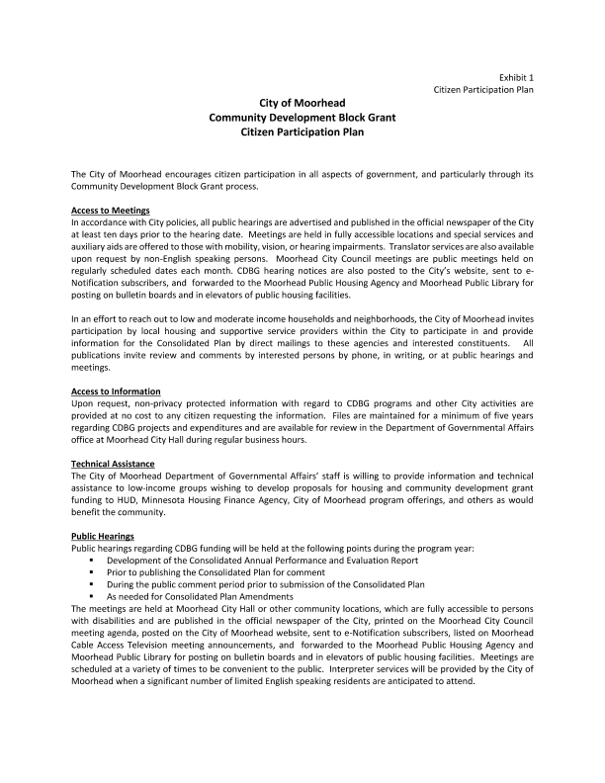
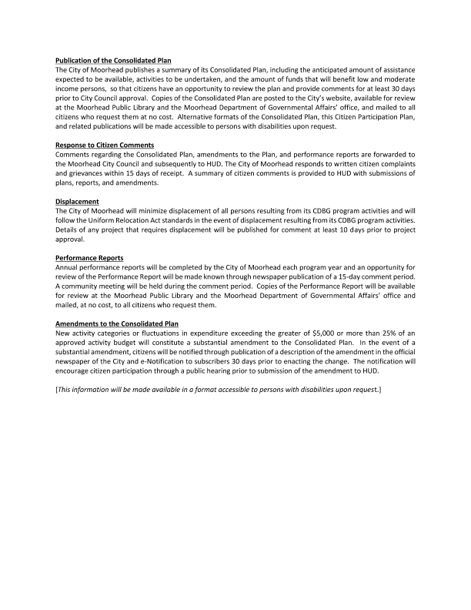
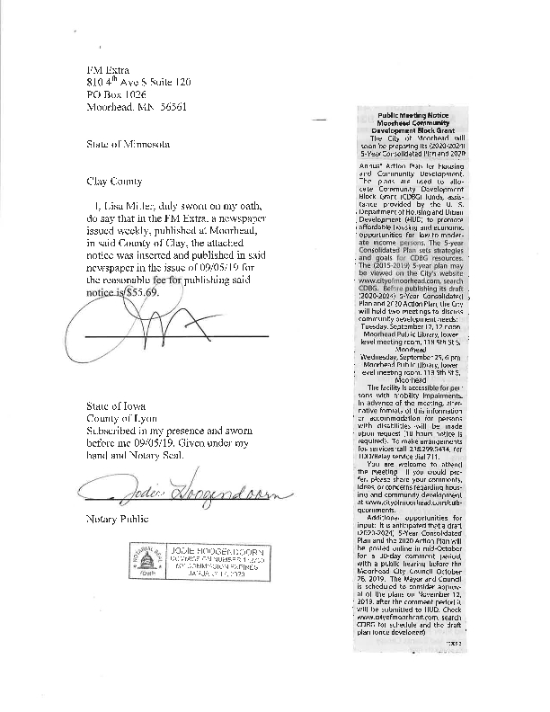
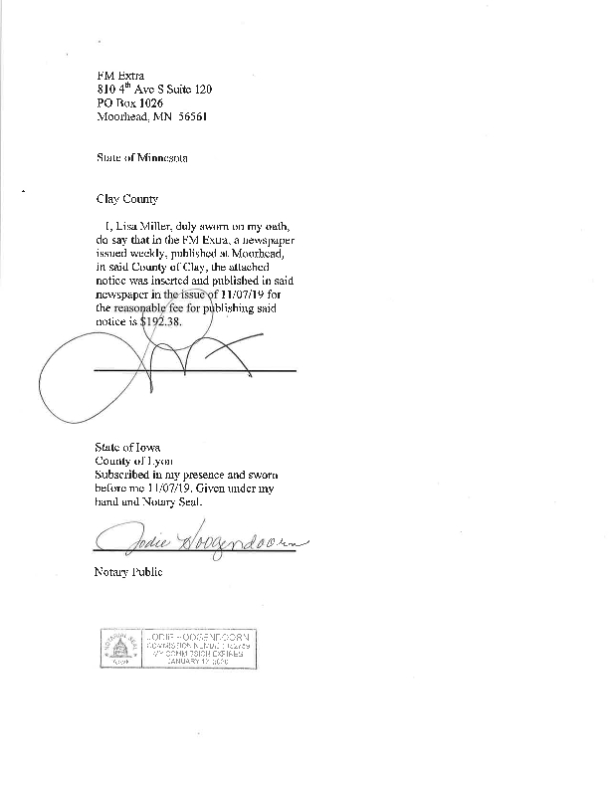
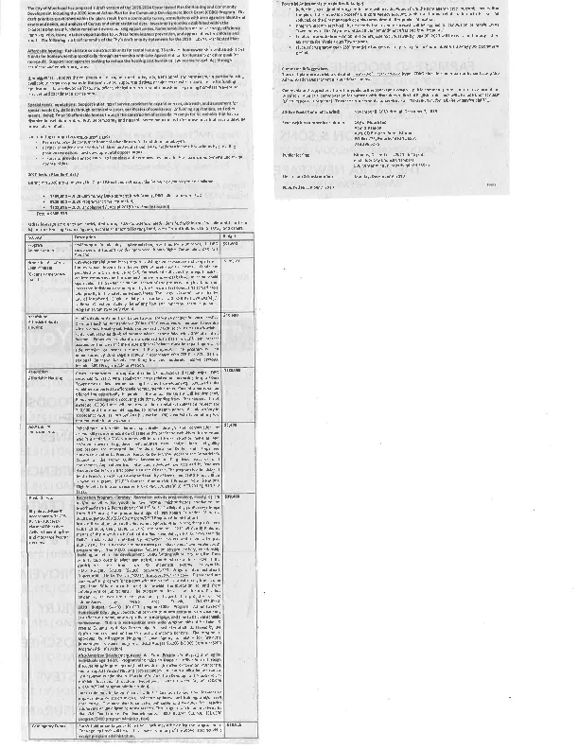
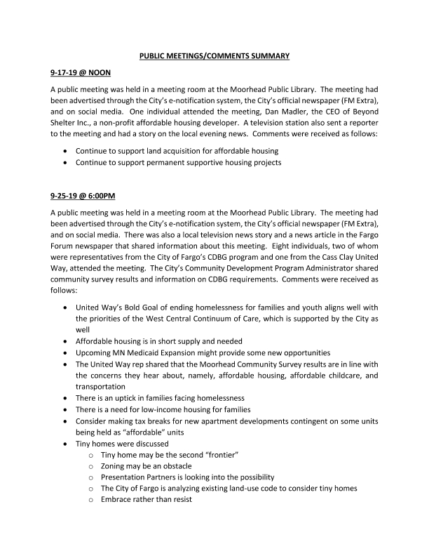
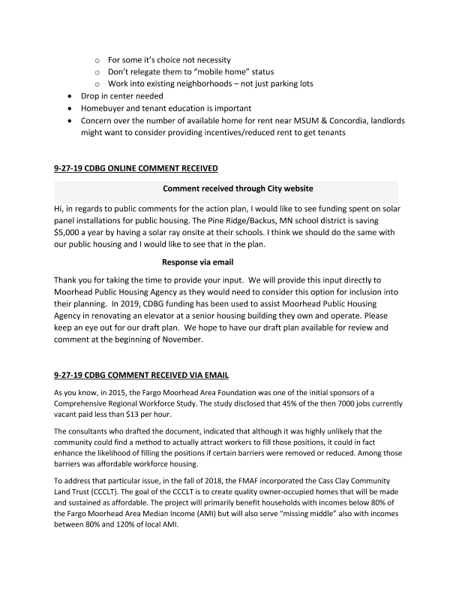
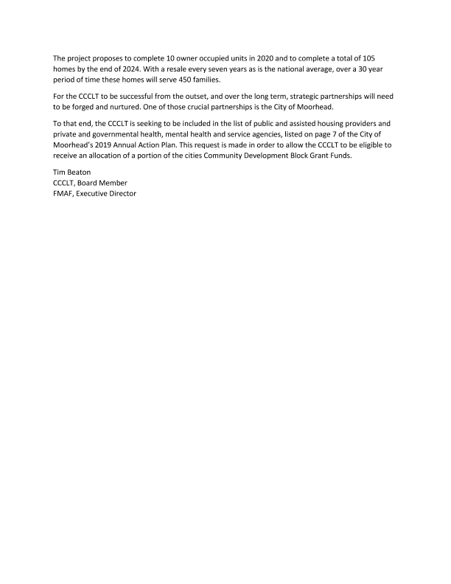

Grantee Unique Appendices
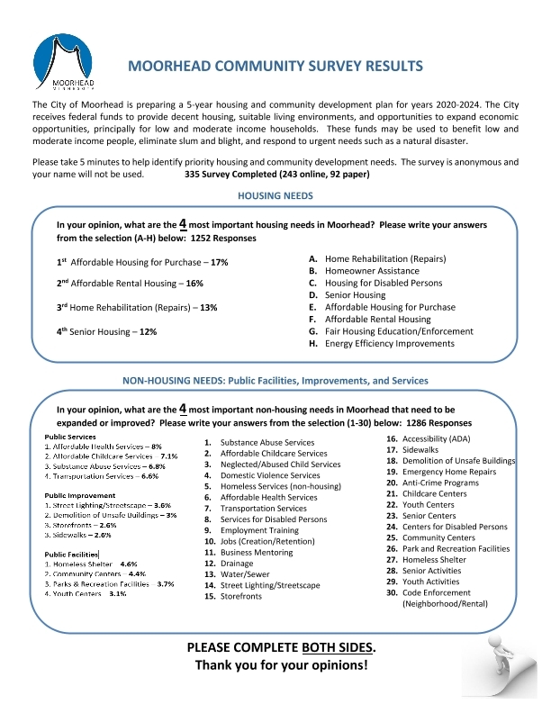
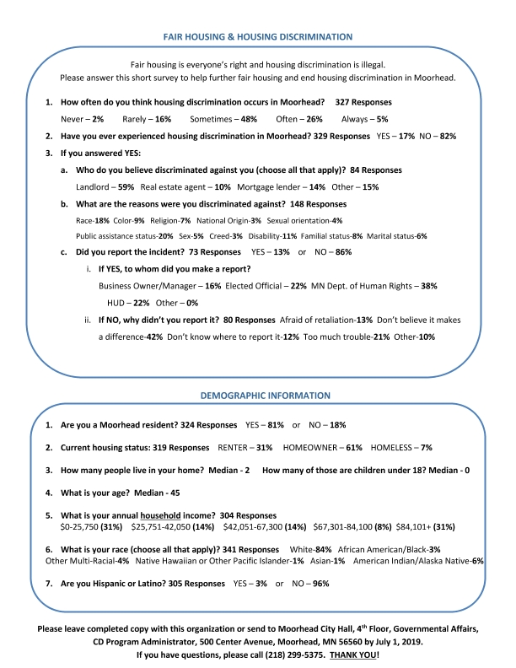

Grantee SF-424's and Certification(s)
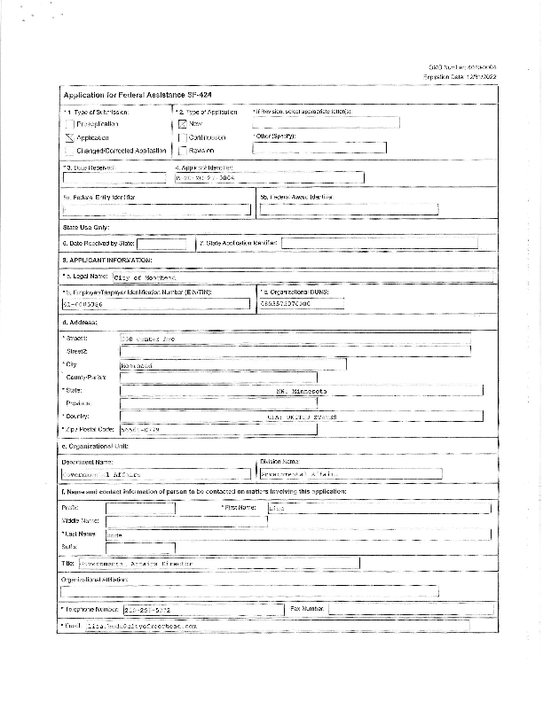
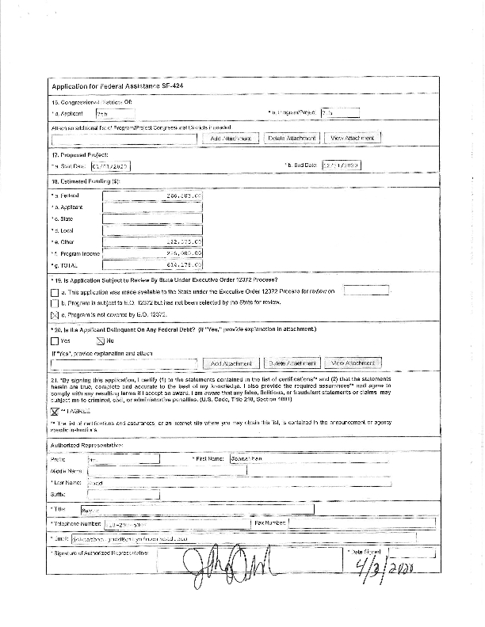
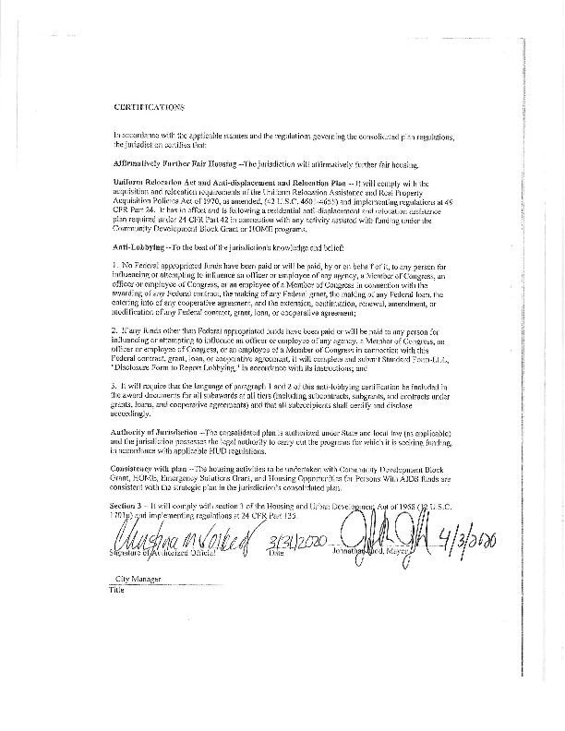
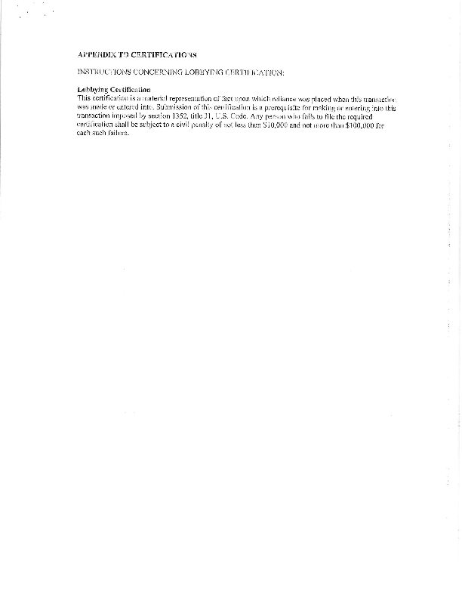
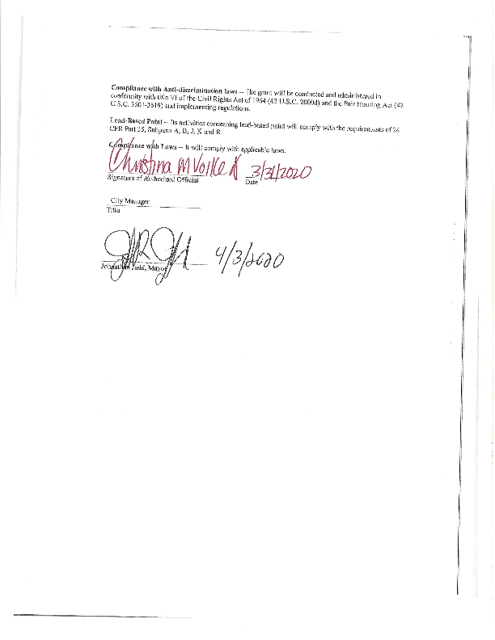
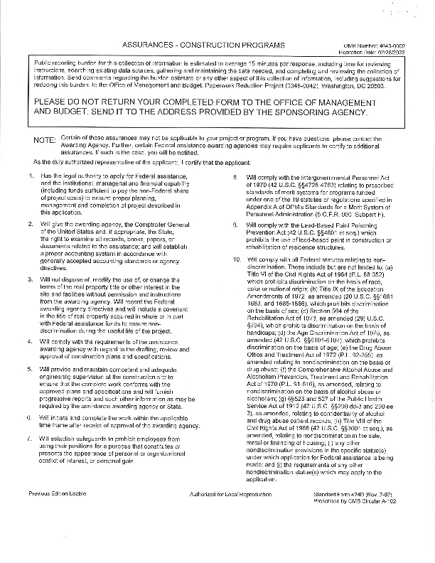
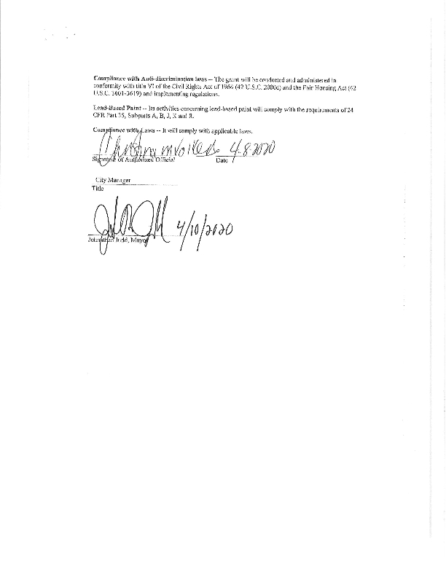
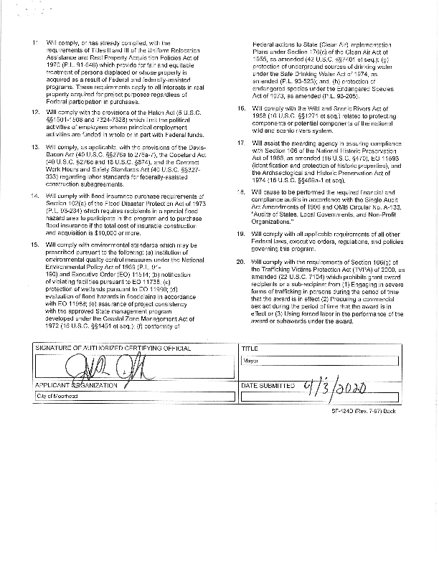

Appendixx - Alternate/Local Data Sources

1 | Data Source Name  2019 Moorhead Community Survey
List the name of the organization or individual who originated the data set.
City of Moorhead
Provide a brief summary of the data set.
Community Needs Assessment and Fair Housing inquiry
What was the purpose for developing this data set?
To encourage citizen participation and identify areas of need.
Provide the year (and optionally month, or month and day) for when the data was collected.
June 14 - July 17, 2019
Briefly describe the methodology for the data collection.
Distributed survey to service providers (i.e., mental health facilities, public housing agency, workforce center, colleges, etc.) to circulate among the community. Available in paper format and online. Advertised through eNotification/email, website, word of mouth, social media, and physical distribution.
Describe the total population from which the sample was taken.
The survey was open to all people in the Fargo-Moorhead community.
Describe the demographics of the respondents or characteristics of the unit of measure, and the number of respondents or units surveyed.
84% of respondents were White, 3% African American/Black, 1% Native Hawaiian or Other Pacific Islander, 1% Asian, 6% American Indian/Alaskan Native, and 4% Other Multi-Racial. 3% of respondents were Hispanic. 45% of the respondents earned 80% or less of the area median income. The median age of respondents was 46. 81% were Moorhead residents. 335 people completed the survey.
2 | Data Source Name  2019 West Central Minnesota Annual Homeless Count
List the name of the organization or individual who originated the data set.
West Central Minnesota Continuum of Care
Provide a brief summary of the data set.
The data is collected throughout the Clay County, MN area. The study includes counts and estimates of the number of people who are homeless. The study is required by HUD each January.
What was the purpose for developing this data set?
The purpose of the survey is to provide a snapshot or point in time count and survey of people experiencing homelessness in Clay County, MN.
Provide the year (and optionally month, or month and day) for when the data was collected.
January 2019
Briefly describe the methodology for the data collection.
CoC
Describe the total population from which the sample was taken.
The total population of Clay County, MN in 2018 was 63,955 (US Census 2018 population estimates).
Describe the demographics of the respondents or characteristics of the unit of measure, and the number of respondents or units surveyed.
A total of 216 people were interviewed. Women accounted for 50% of the population, men were 49%, transgender were .5% and gender non-conforming were .5%. The racial composition was 60% White, 15% Black or African American, 12.5% American Indian or Alaska Native, .5% Asian, .5% Native Hawaiian or Other Pacific Islander, and 11% were two or more races, 13.4% of all races combined were Hispanic or Latino.
3 | Data Source Name  State of Homelessness in Fargo-Moorhead Metro
List the name of the organization or individual who originated the data set.
The FM Coalition to End Homelessness in collaboration with the United Way of Cass-Clay
Provide a brief summary of the data set.
The report utilizes data from a number of sources: two Continuums of Care, local homeless service providers, homeless shelters, an Everyone Counts Survey, and the Homeless Management Information which showed that 3,283 individuals received homeless services in 2018.
What was the purpose for developing this data set?
The purpose of the report is to provide an in-depth analysis of who is experiencing homelessness in the Fargo, ND-Moorhead, MN area and to identify what their needs are.
How comprehensive is the coverage of this administrative data? Is data collection concentrated in one geographic area or among a certain population?
This administrative data is extremely comprehensive. Data collection included most of the population of Cass County, North Dakota, and Clay County, Minnesota. It covers the entire Fargo-Moorhead Metro area and focused specifically on those experiencing homelessness.
What time period (provide the year, and optionally month, or month and day) is covered by this data set?
Data in the report covers 2018 and January-May of 2019.
What is the status of the data set (complete, in progress, or planned)?
Complete

